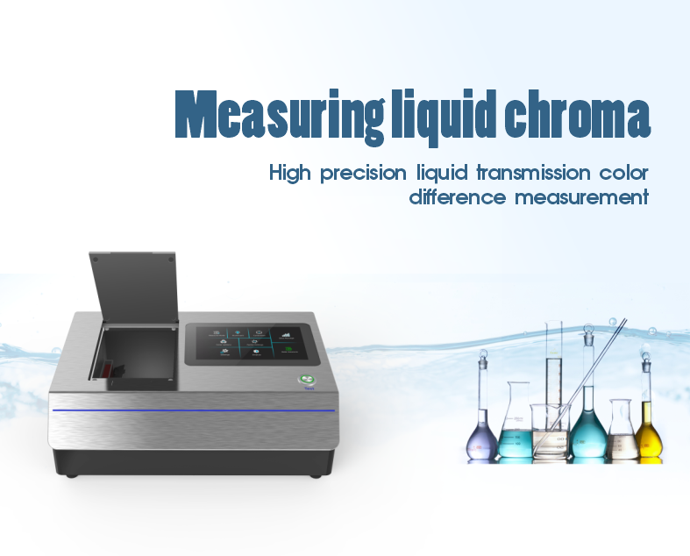

The liquid colorimeter TS4020 is a highly accurate color analysis tool designed for liquid colorimetric measurement using innovative core technology. Using D/0 optical structure, equipped with all-band LED light source and high-performance test system, to provide a variety of chromaticity indicators, including transmittance, chromaticity, color difference, platinum cobalt index, Gardner, Seibert index, oil color scale, pharmacopoeia chromaticity, support micro transmission measurement, measurement speed. Widely used in the chemical industry, food and beverage, petrochemical, pharmaceutical industry and other fields of colorimetric measurement needs.

Liquid colorimeter TS4020 Features:
1, D/0 geometric optical structure
The D/0 geometric optical structure can provide a more comprehensive chroma analysis to ensure that your products meet the quality standards :GB/T 3978,GB/T 18833,GB 2893 ASTM D1003/1044,CIE No.15,ASTM E308,DIN5033 Teil7. 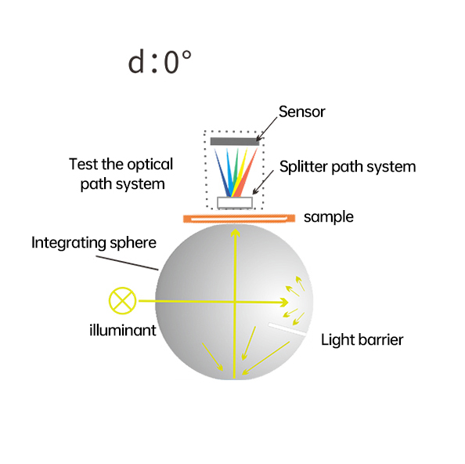
2, combined full spectrum LED light source
The combined full spectrum LED light source is used as the lighting source, covering the wavelength range of 360 ~ 780nm, ensuring the high stability of the test.
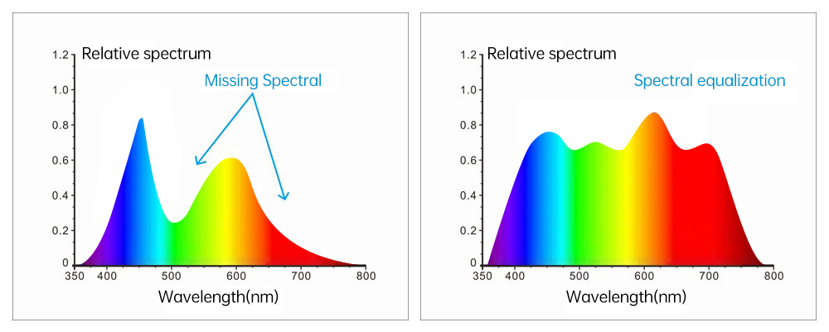
3, high-performance dual array sensor
Equipped with high-performance silicon photodiode dual 40 array sensor to ensure measurement speed and accuracy, improve work efficiency.

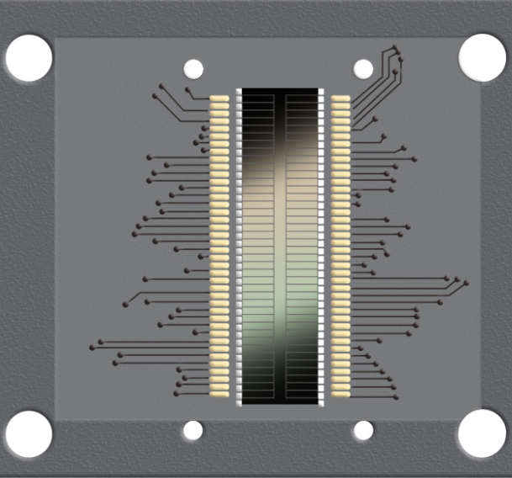

4, excellent repeatability and difference between stations
The repeatable spectral transmittance is within 0.05%, the chroma value is within 0.015, and the difference between stations is within 0.25, ensuring that the measurement results between multiple devices are highly consistent, and escorting the quality control in mass production.

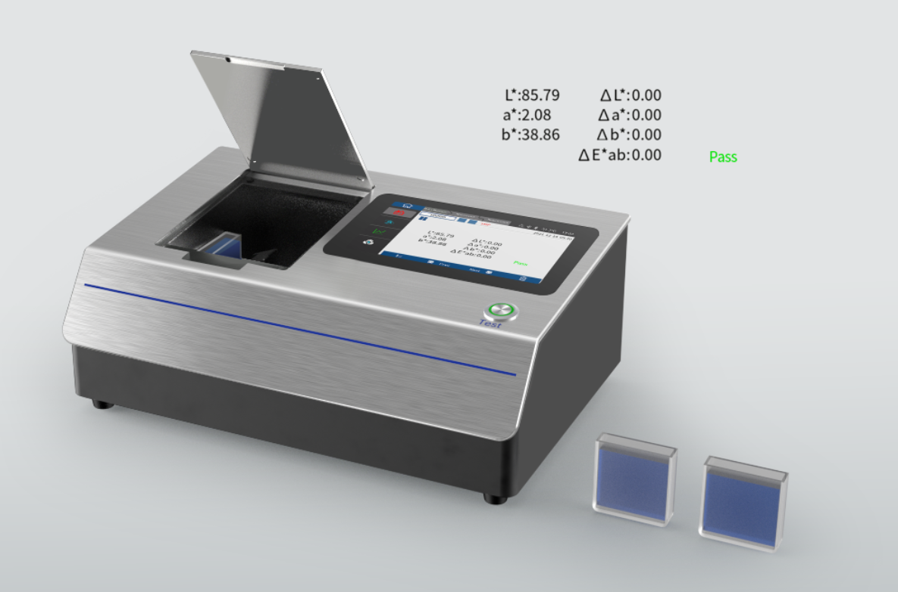

5, intelligent zero calibration
Intelligent zero calibration technology is adopted to reduce the influence of external interference, adapt to different measurement environments, and ensure the accuracy and reliability of measurement data.
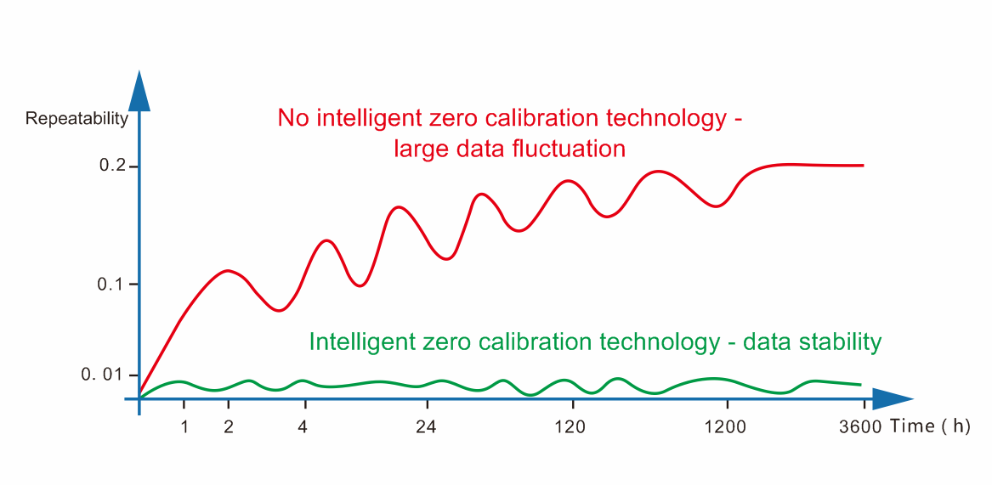

6, multiple light source simulation
A range of International Lighting Commission approved standard light sources are built in to ensure that your products can accurately measure color under different light sources.

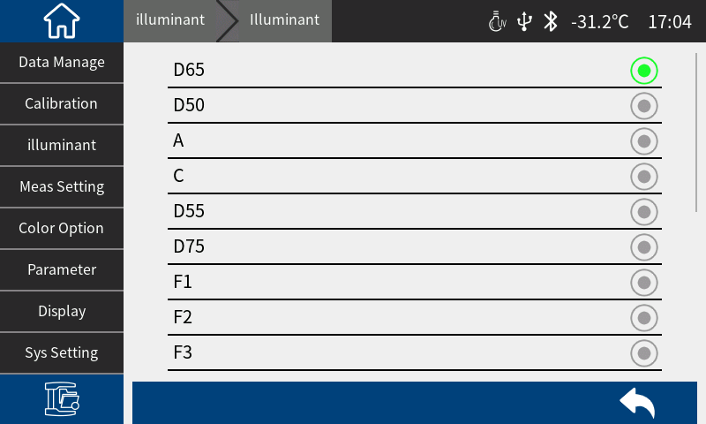

7, color index rich
In addition to the commonly used color index measurement, it can also provide transmittance, oil color scale (ASTM D1500), platinum cobalt index, Gardner index, Saybolt index, Pharmacopoeia (Chinese Pharmacopoeia, European Pharmacopoeia, European Pharmacopoeia). Us Pharmacopoeia), EBC (beer Color), ICUMSA Color(sugar color) and other color indicators to meet the needs of diverse industries.

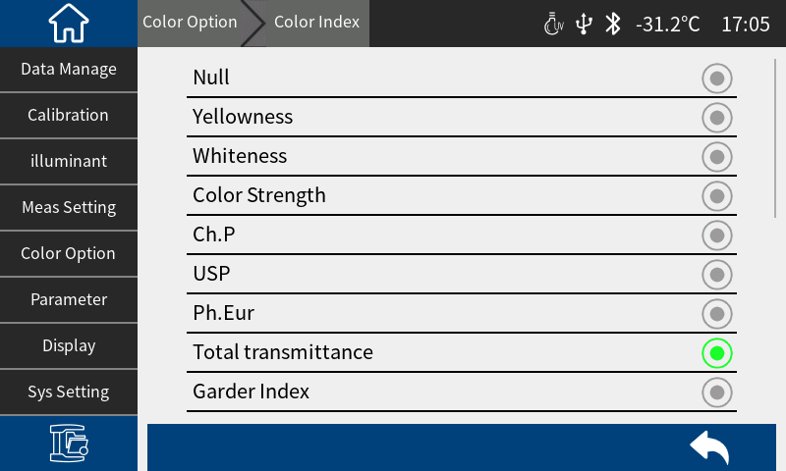

8, support micro transmission measurement
With a more sophisticated optical design, the transmission direction of the light can be precisely controlled, and the minimum liquid addition can be reduced to 1ml, enabling micro transmission measurement.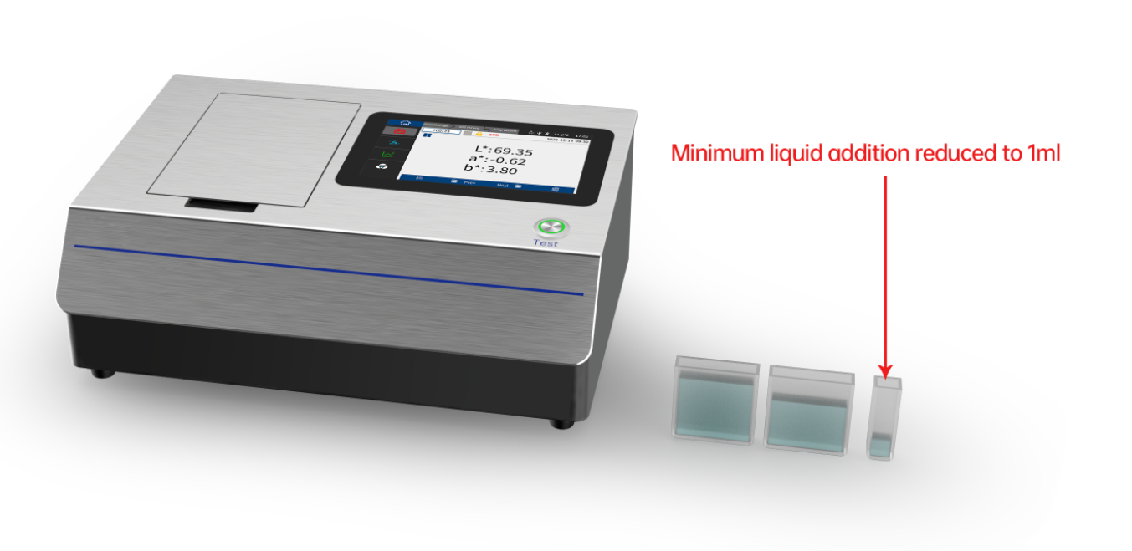

9, powerful display and interaction capabilities
Equipped with 7-inch true color capacitive touch screen, large screen navigation operation, can display a variety of chrominance indicators such as spectrum, color difference value/chart, color simulation and color deviation, and achieve fast and accurate color analysis and judgment.

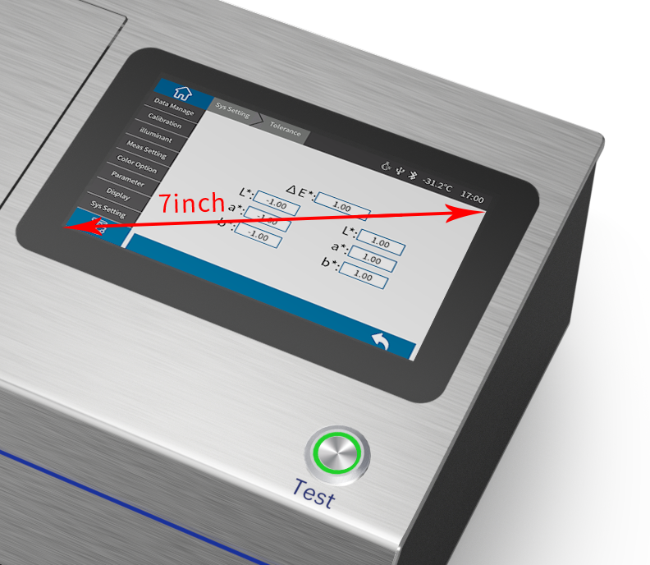

10, PC quality management software
Provide powerful analysis software, suitable for quality management in various industries, and generate test reports from users' test results to facilitate customer customization and management.

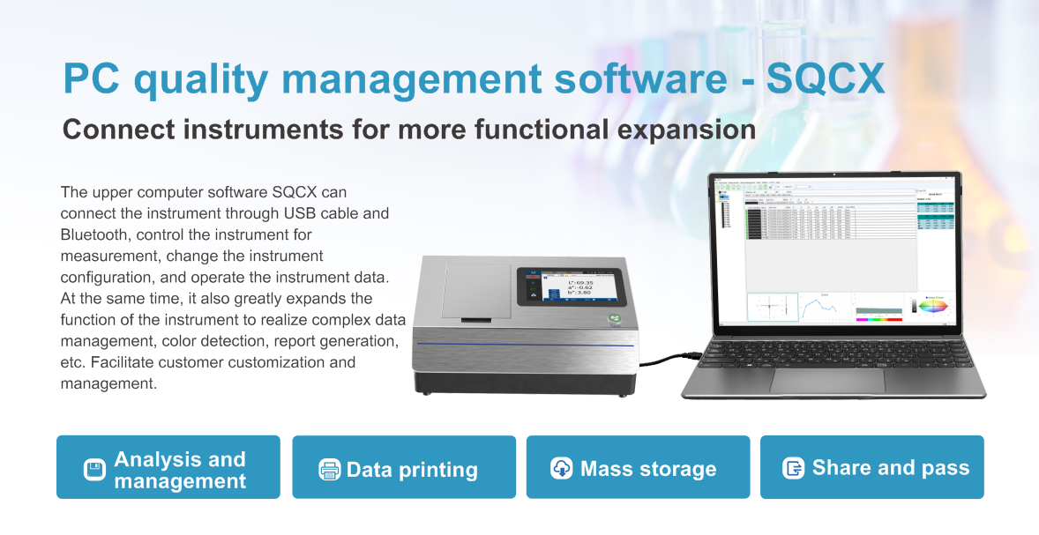

Optional accessories
Meet the different measurement needs of customers
This product is equipped with a variety of accessories; Such as micro printer, 30mm colorimetric dish, 100mm colorimetric dish, heating controller, etc., to meet the different needs of customers.
Meet the different measurement needs of customers.

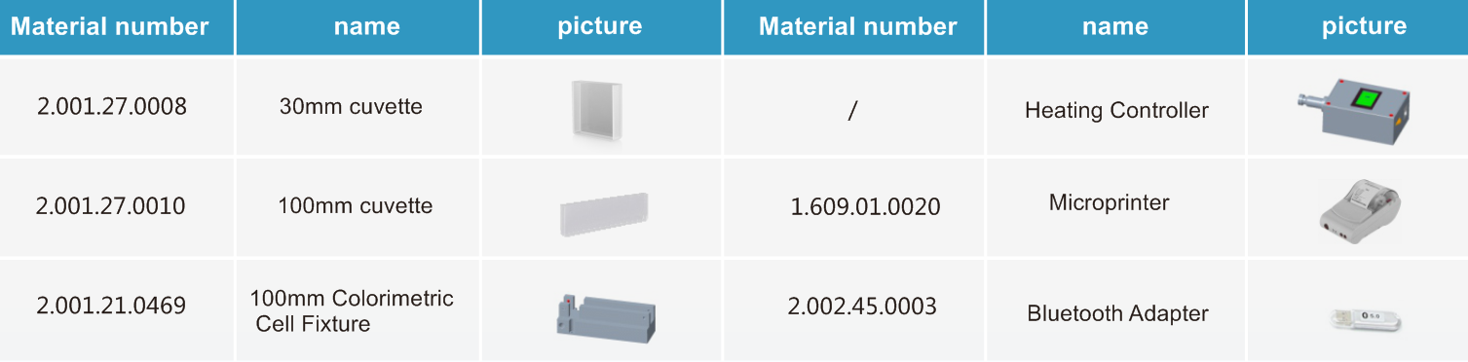

Liquid colorimeter TS4020 Application areas:

The instrument is widely used in various solvents, drugs, petroleum, industrial oil, cosmetics, food and beverage and other fields. Colorimetric analysis and transmittance testing are also widely used in glass processing, plastic processing, film, display processing, packaging industry, liquid and pharmaceutical analysis and other industries.
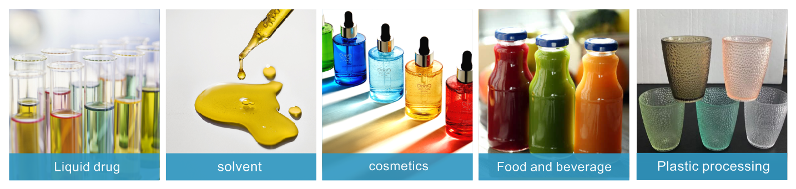

Technical parameters of liquid colorimeter TS4020

Product model | TS4020
Lighting mode | Transmission: D/0 (diffuse illumination, 0° direction reception);Approximate CIE15 provisions 0/0 (parallel light illumination /0 degree reception);Standards :GB/T 3978,GB/T 18833,GB 2893 ASTM D1003/1044,CIE No.15,ASTM E308,DIN5033 Teil7
peculiarity | National Standard Pharmacopoeia color measurement, glass processing, plastic processing, film, display processing, packaging industry, liquid pharmaceutical analysis and other industries chroma analysis, transmittance test are widely used, support micro transmission measurement
Integrating Sphere Size | Φ40mm
Lighting source | Combined full spectrum LED light source
Spectroscopic method | Planar grating spectroscopy
Sensor | Silicon photodiode array (double row 40 groups)
Wavelength Range | 360-780nm
Wavelength Interva | 10nm
Semiband Width | 5nm
Transmittance  measurement range | 0~200%
Color Space | CIE LAB,XYZ,Yxy,LCh,CIE LUV,Musell,s-RGB,HunterLab,βxy,DIN Lab99 ,CMYK(The above part is realized by the upper computer)
Color Difference Formula | ΔE*_{ab},ΔE*_{uv},ΔE*₉₄,ΔE*_{cmc(2:1)},ΔE*_{cmc(1:1)},ΔE*₀₀, DINΔE₉₉,ΔE_{(Hunter)},ΔE*_{CH}
Other Colorimetric Index | The transmittance T, WI (ASTM E313, CIE/ISO, AATCC, Hunter, Taube, Berger, Stensby), YI (ASTM D1925, ASTM 313),TI(ASTM E313, CIE/ISO), isochromatic index Mt, color fastness, color changing fastness, absorbance,APHA/Hazen/Pt-Co (platinum-cobalt index), Gardner Index, iron-Cobalt index, Saybolt (Seibert Index),ASTM D1500 Color scale, Pharmacopeia(Chinese Pharmacopoeia, European Pharmacopoeia, American Pharmacopoeia),EBC (Beer color), ICUMSA Color(sugar color)
Observer Angle | 2°/10°
Illuminant | D65,A,C,D50,D55,D75,F1,F2,F3,F4,F5,F6,F7,F8,F9,F10,F11,F12,CWF,DLF,TL83,TL84,TPL5,U30，B,U35,NBF,  ID50,ID65,LED-B1,LED-B2,LED-B3,LED-B4,LED-B5,LED-BH1,LED-RGB1,LED-V1,LED-V2,LED-C2,LED-C3,LED-C5(41 light sources in total,part achieved via software in PC)
Displayed Data | Spectrogram/Values, Samples Chromaticity Values, Color Difference Values/Graph, PASS/FAIL Result, Color Simulation, Color Offset
Measuring Time | Fast mode approx. 0.8s
Repeatability | Spectral transmittance: standard deviation within 0.05% (360~780nm: within 0.04%);Chroma value: within ΔE*ab 0.01 (after preheating correction, measured at an interval of 5S);
Inter-instrument Error | ΔE*ab≤ 0.2
Dimension | L*W*H=370X300X200mm
Weight | Approx.9.6kg
Power | AC 24V, 3A Power adapter power supply
Illuminant Life Span | 5 years, more than 3 million times measurements
Display | 7-inch TFT color LCD, capacitive touch screen
Data Port | USB, print serial port,Bluetooth
Data Storage | 1000 standards, 20000 samples; Host computer mass storage
Special function | Intelligent zero calibration
Language | Simplified Chinese, Traditional Chinese,English
Operating Environment | 0~40℃（32~104°F）
Storage Environment | -20~50℃（-4~122°F）
Standard Accessory | Power adapter, manual, quality management software (download from official website), data cable, transmission blackboard, 10mm colorimetric dish, 50mm colorimetric dish, 50mm colorimetric dish fixture, microporous (4mm) transmission test fixture assembly
Optional Accessory | Micro printer, 30mm cupola,100mm cupola,100mm Colorimetric Cell Fixture,Bluetooth Adapter, Heating Controller
Note: | Subject to change without prior notice

