STEADY-STATE SOLAR SIMULATOR

Technical Specification
Model: LC-LED-AAA-2400

Chapter 1: Product Overview

1.1 Test Items and Conditions
- Test Standard: IEC 61215-2:2021 MQT-2
- Test Conditions:
- Temperature: 25°C
- Irradiance: 800-1200 W/m²

1.2 Applicable Standards
- IEC 60904-9:2020 - "Photovoltaic devices – Part 9: Classification of solar simulator characteristics"

Chapter 2: Technical Specifications
No. | Parameter | Specification
1 | Solar Simulator Classification | Class AAA
2 | Spectral Match (AM1.5G) | Class A+
3 | Irradiance Spatial Non-uniformity | ±2% (Class A)
4 | Irradiance Temporal Instability (Long-term) | ±2% (Class A)
5 | Irradiance Intensity | 1000 W/m²
6 | Effective Illumination Area | 2400mm × 1200mm
7 | Light Source Type | Metal Halide Lamp (MHL)
8 | Optical Path Length | >10m
9 | Light Emission Direction | Side lighting
10 | Light Source Cooling | Forced air cooling
11 | Module Temperature Control | Independent temperature control in test zone
12 | Total Power | Approx. 100 kW

System Design
The system employs a side lighting design with independent air-conditioned temperature control zones on both sides.
Full-area simultaneous illumination designed for large-format PV module testing.

Chapter 3: Key Technical Implementation

3.1 Light Source (MHL)
Spectral Performance:
- Wavelength range: 300nm - 1200nm
- Meets IEC 60904-9:2020 Class A requirements
- 6-segment spectral match: Class A

Spectral Distribution:
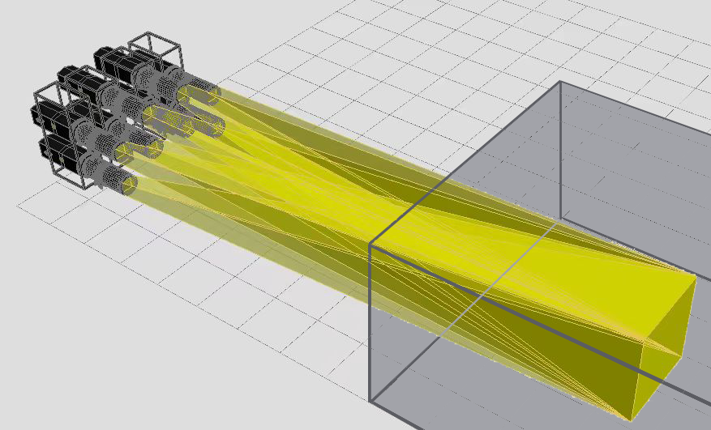

Spectral Match Table (AM1.5G Standard):
Wavelength Range (nm) | AM1.5G Reference (%) | Achieved Match | Class
300-470 | 16.61 | Within tolerance | A
470-561 | 16.74 | Within tolerance | A
561-657 | 16.67 | Within tolerance | A
657-772 | 16.63 | Within tolerance | A
772-919 | 16.66 | Within tolerance | A
919-1200 | 16.69 | Within tolerance | A

3.2 Collimation and Irradiance Uniformity
Technology:
- Concentrated light projection with overlapping layers
- Achieves Class A (±2.0%) irradiance non-uniformity

Uniformity Test Results:
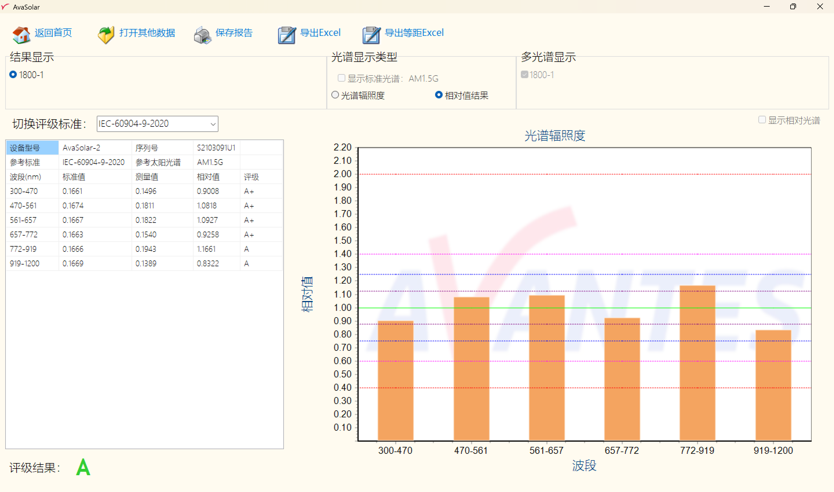
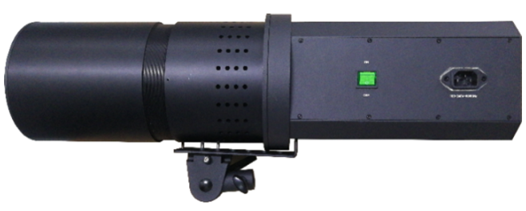

Key Advantages:
- Overlapping Projection Method: Avoids non-uniformity caused by light spot overlap in tiled array configurations; Eliminates light energy loss from edge light spillage
- Optimized Light Spot Design: Each light source projects a 2:1 rectangular spot; Projection area: 2400mm × 1200mm; Overlapping projection achieves cumulative irradiance ≥1000 W/m²
- Long Optical Path: Effectively eliminates thermal radiation from light source to samples; Minimizes edge light loss
- Irradiance Spatial Non-uniformity: Class A

Variable Focus Projection:
Adjustable projection focus for optimal uniformity control

Assembly Workshop:
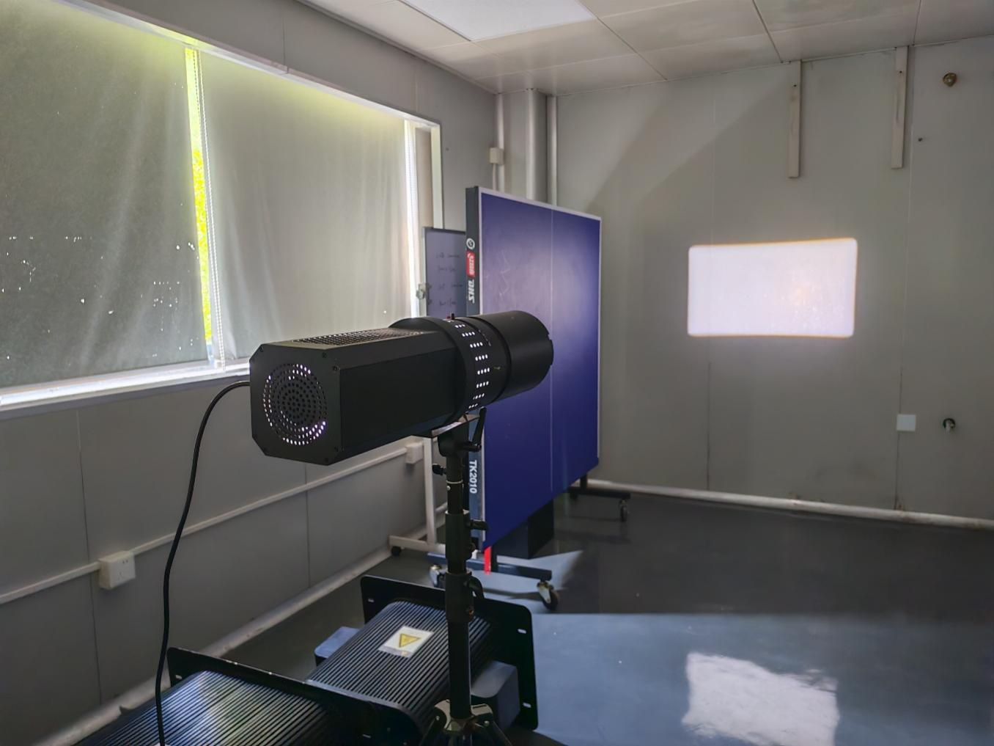

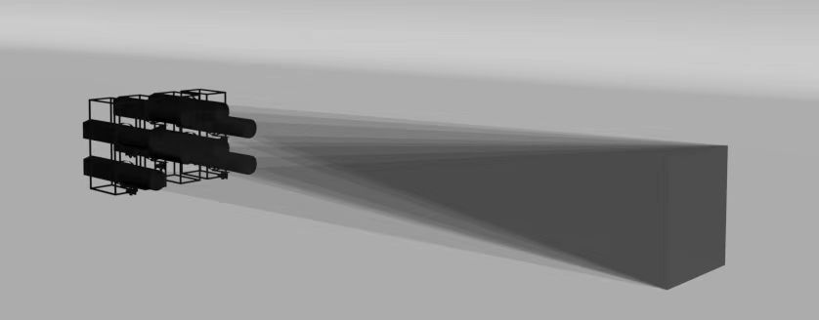

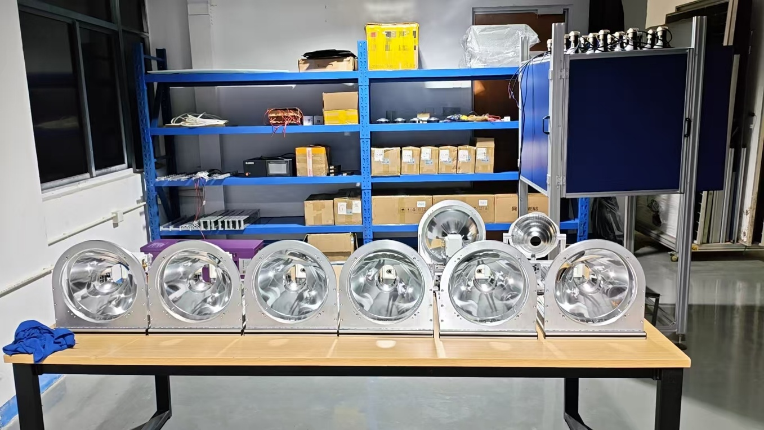

3.3 Incidence Angle Compliance
Standard Requirement:
For solar simulators used in power testing, the incidence angle shall not exceed 15°, as specified in JIS C 8933-1995(2011) "Solar simulators for amorphous solar cells and modules"
Our Design:
- Complies with incidence angle requirements
- Not limited by illumination area size
- Capable of optimizing key parameters: spectral match, non-uniformity, spectral distribution uniformity, spectral coverage, spectral deviation, spectral mismatch factor

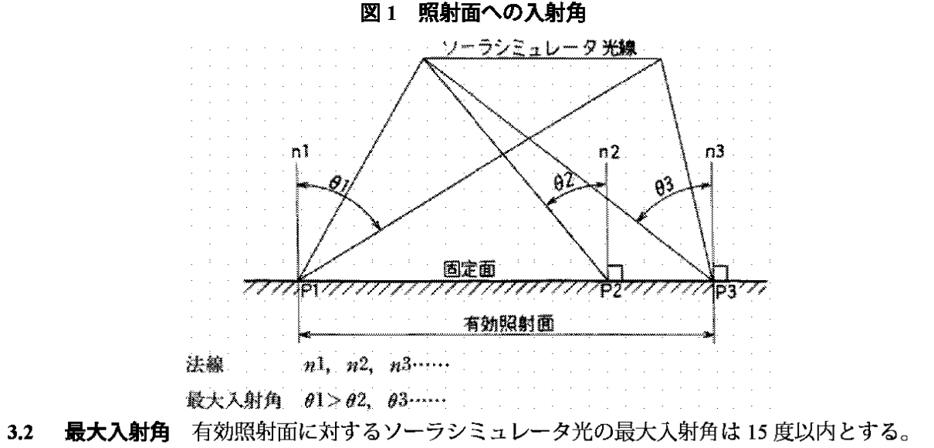

Chapter 4: System Specifications Summary

4.1 Performance Parameters
Parameter | Value
Effective Illumination Area | 2400mm × 1200mm
Irradiance Intensity | 1000 W/m² (1 sun)
Spectral Match (AM1.5G) | Class A+
Spatial Non-uniformity | Class A (≤2%)
Temporal Instability | Class A (≤2%)
Wavelength Range | 300nm - 1200nm
Optical Path | >10m
Light Source Lifetime | >1,000 hours
Total Power | ~100 kW
Cooling Method | Forced air cooling

4.2 Standards Compliance
- IEC 60904-9:2020 - ✅ Class AAA
- IEC 61215-2:2021 MQT-2 - ✅ Suitable for testing
- JIS C 8933-1995(2011) - ✅ Incidence angle compliant

4.3 Included Components
- MHL steady-state solar simulator main unit (2400×1200mm)
- Air cooling system for light source
- Temperature control system for test zone
- Control panel and remote operation interface
- Installation and operation manual
- Calibration certificate (IEC 60904-9)

4.4 Optional Accessories (Not Included)
- IV test module
- Source meter
- Data acquisition system
- Sample stage
- Environmental chamber integration

Chapter 5: Warranty and Service

5.1 Warranty
- Standard warranty: 12 months from delivery
- Covers manufacturing defects and component failures

5.2 Technical Support
- Remote technical support during warranty period
- On-site service available (travel costs apply)

5.3 Delivery and Installation
- Delivery time: To be confirmed based on production schedule
- Installation and commissioning: Included
- Training: Included

────────────────────────────────────────────────────────────
Document Version: 1.0
Date: May 2026

