**IH**igh automatic, easy operation, save costs 1 worker can control the whole sets, low failure rate 

**O**ver the past 10 years continuously improve packaging solutions, packaging experienced

**A**lso can match the paste pump

**T**he whole system is linkage control, automatic feeding, stop working without materials

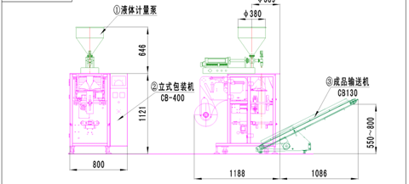

|  |  |
| --- | --- |
|  | **内容Content** |
| 包装速度Capacity | 约30包/分钟 具体视包装膜质量及物料确定  Max 30 bag/min, depending on the features of the materials |
| 计量精度Accuracy | ≤±1% |
| 包装膜宽Film width | 最大Max 320 mm |
| 制袋形式Bag type | 枕式袋Pillow bag,打孔袋 punching bag |
| 拉模皮带类型Pulling belt type | 单拉膜皮带Single-belt pulling film |
| 计量范围Filling range | 最大Max 500ml |
| 薄膜厚度Film thickness | 0.04-0.09mm |
| 包装材料Film material | BOPP/CPP，PET/AL/PE等可热复合材料  BOPP/VMCPP,PET/PE,BOPP/CPP, PET/AL/PE etc |
| 整套耗气量Air consumption | 0.8Mpa 0.5m3/min |
| 整套设备总功率Total power | 2.945 KW |
| 电压Voltage | 三相四线380 V    50 HZ |
| 空压机Air compressor | 不小于1立方Not less than 1 CBM |
| 整套设备总高Total height | 1.767 m |