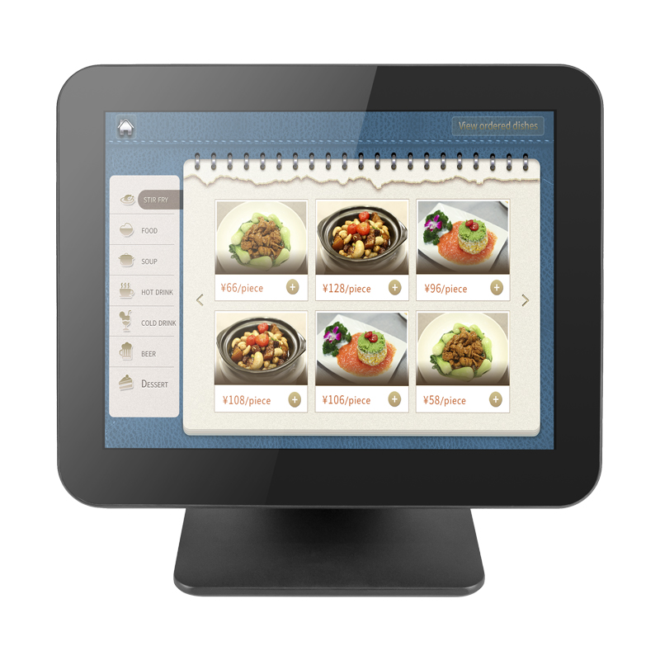

|  |  |
| --- | --- |
| CPU | Intel® Bay Trail J1900/ Intel core i3/i5/i7; (optional) |
| memory | Laptop 4G/8G DDR3/DDR4(optional) |
| HDD/SSD | 64G/128G/256G/512G SSD(optional) |
| Client Display | LED8N ,or 2 Lines x 20 VFD /9.7inch/10.1inch/11.6inch/15inch(optional) |
| Operator monitor | 15" LED (1024*768) |
| touchscreen | capacitive touchscreen |
| Optional | wifi/MSR/Bluetooth |
| Power | 12V 5A round hole power adaptor |
| interface | 1 VGA port, 2 COM port,5 USB2.0 ,1 USB3.0 port, 1 RJ45 10/100/1000M network interface, 2 audio interface |