Commode Chair DY2800

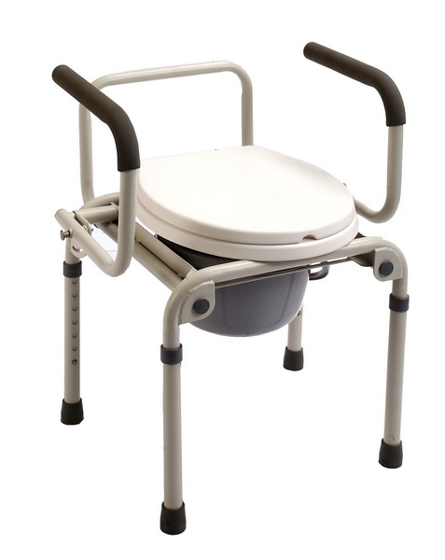

DY2800 | 47 | / | 44 | / | / | 45-60 | 61-76 | / | 44 | 35 | 100 | 57*40*36  1PC/CTN | 8.3/9.6



USER’S MANUAL

1
2
3
4
5
8
6
7
1. Backrest 2. Armrest 3. Flip Down Button
4. Adjust button 5. Leg 6. Plastic commode board
7. Commode bucket 8. rubber tip

How to Assemble and Detach the Commode Chair
1). Armrest
A. Press the flip down button with one hand and push down the armrest with the other hand.
B. To bring back the armrest, just pull the armrest back to the original position, until you hear a “snap”.
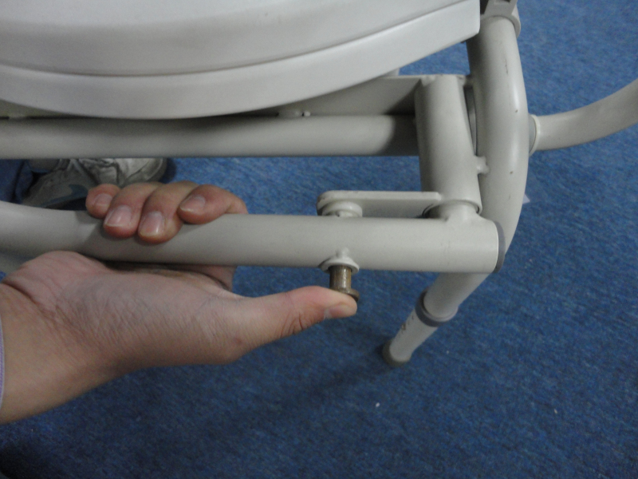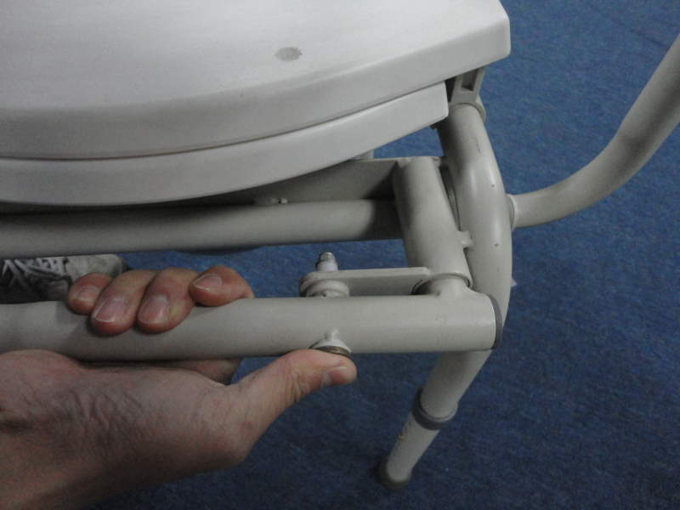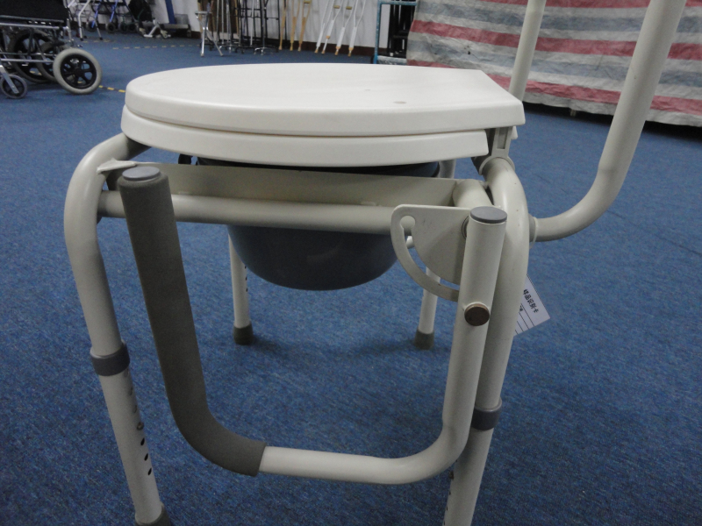
2). Backrest
A. Press the button under the seat;
B: Take out the backrest;
C. Done;
To put back, just operate the other way around.
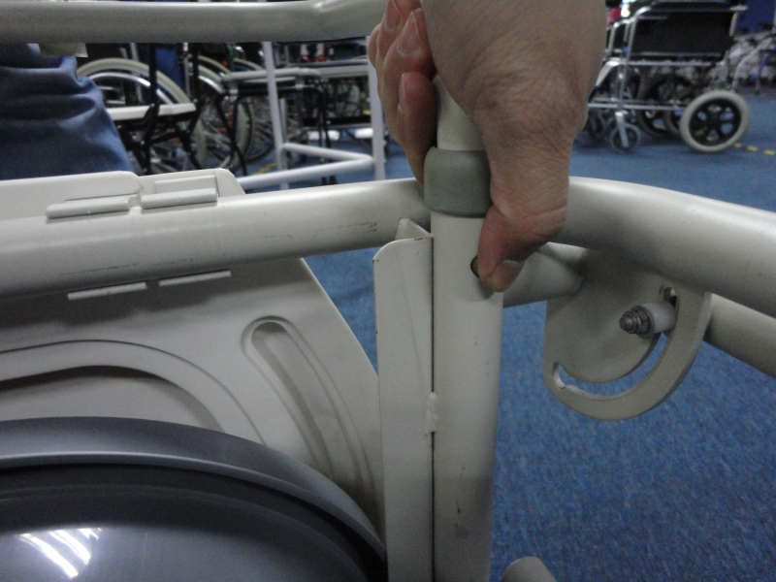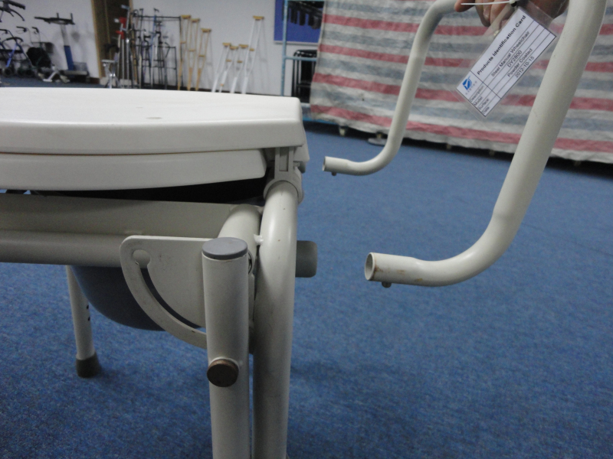

How to Adjust the Height of the Commode Chair
1). Press the height-adjust button.
2). Choose one hole in the height adjusting area, which fits your height most.
3). Turn the hole right to the place of the button. After you hear a “Snap” ,
the height is adjusted.


