Commode Chair DY2691

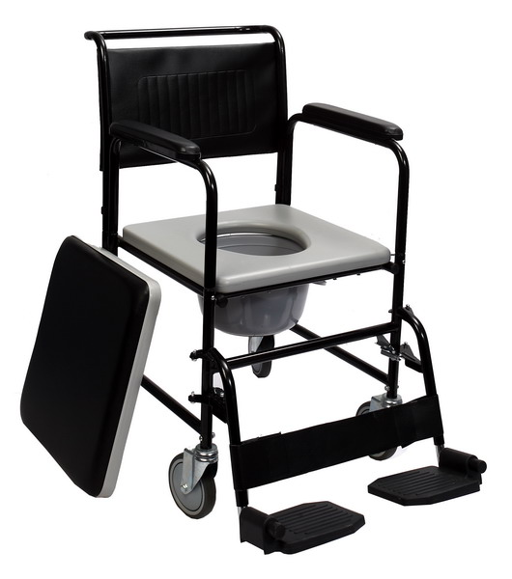

DY2691 | 54 | / | 44 | 12.5 | 12.5 | 53 | 93 | 82 | 43 | 38 | 100 | 55*53*52  1PC/CTN | 13/15



USER’S MANUAL

1
2
4
5
6
7
8
3
11
9
10
1. Push Handle 2. Backrest 3. Armrest pad
4. Detachable armrest 5. Soft Seat Board 6. Legrest
7. Fork 8. Castor 9. Plastic Seat Board 10. Commode Bucket 11. Foot Plate

How to Assemble and Detach the Commode Chair
1). Armrest
A. Press the armrest button. B. Lift Up the Armrest with both hands.
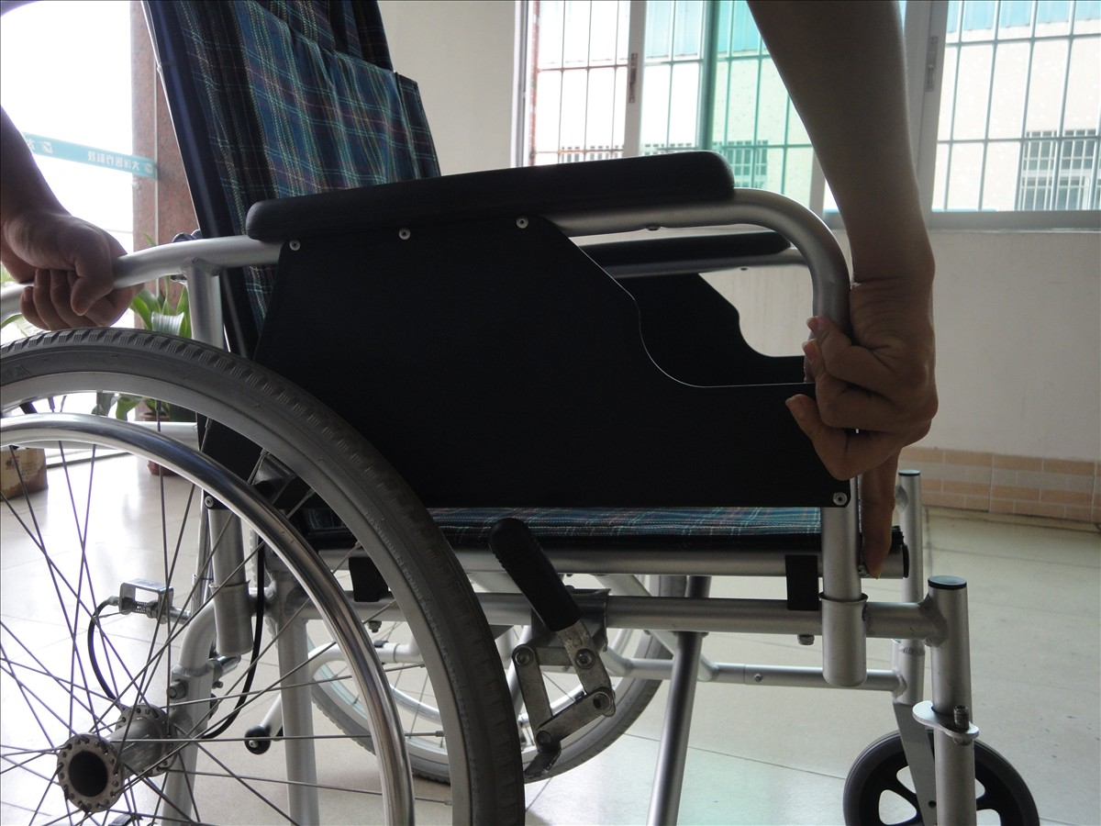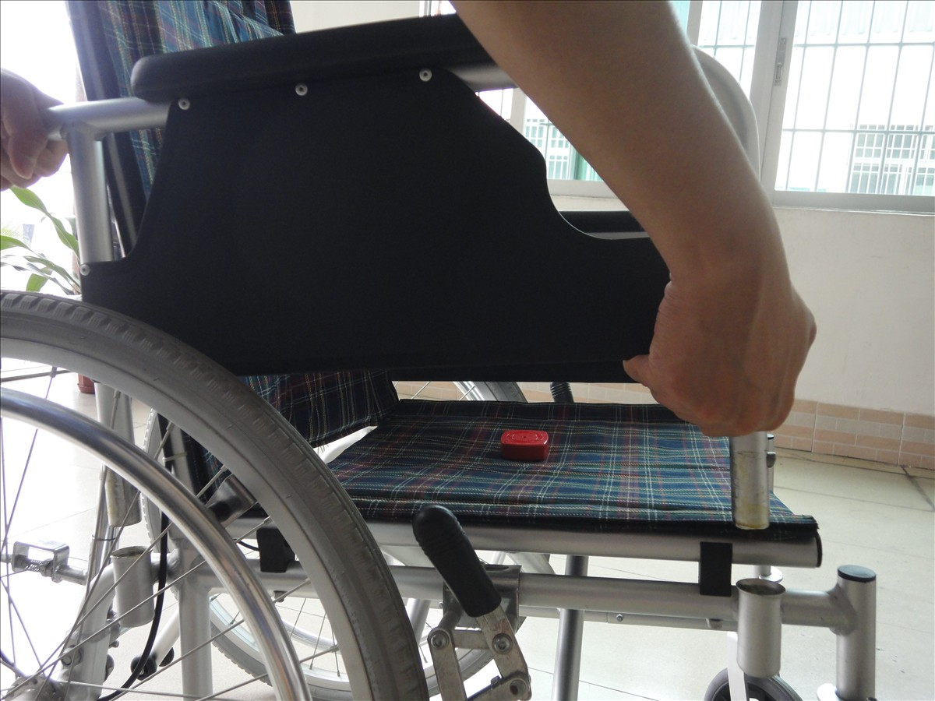
Armrest Button
2). Legrest (From Left to Right)
A. Lift up the foot plate;
B: Pull the Swing Pin to the opposite side;
C. Turn the legrest as the blue arrow indicates;
D. Lift Up the Legrest.
E. Done.
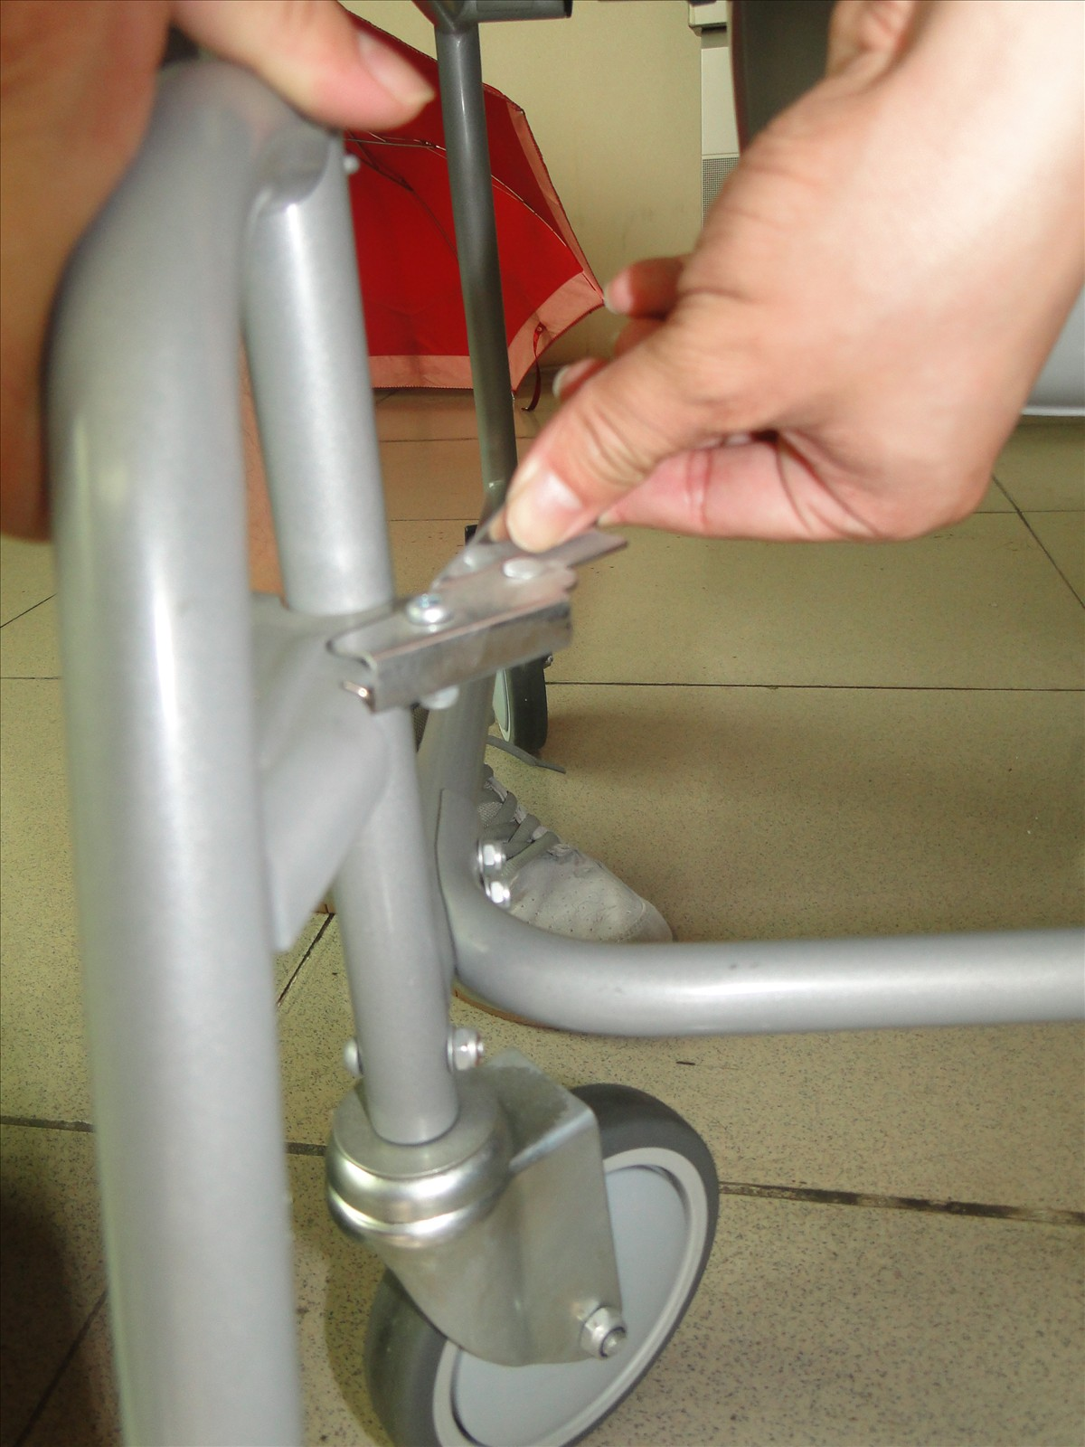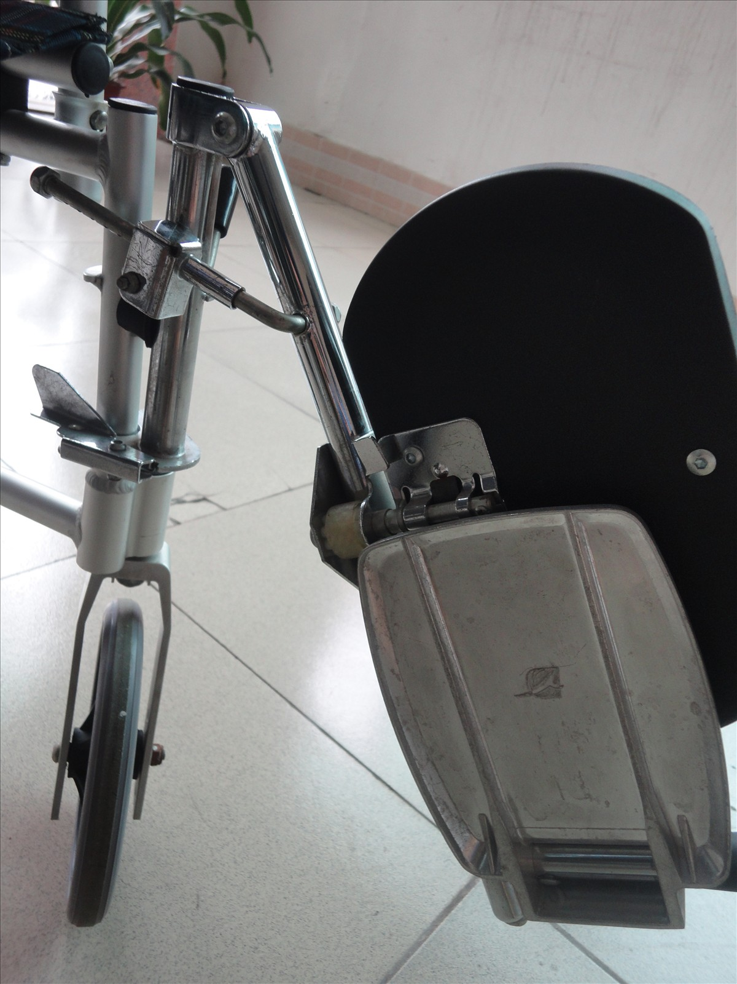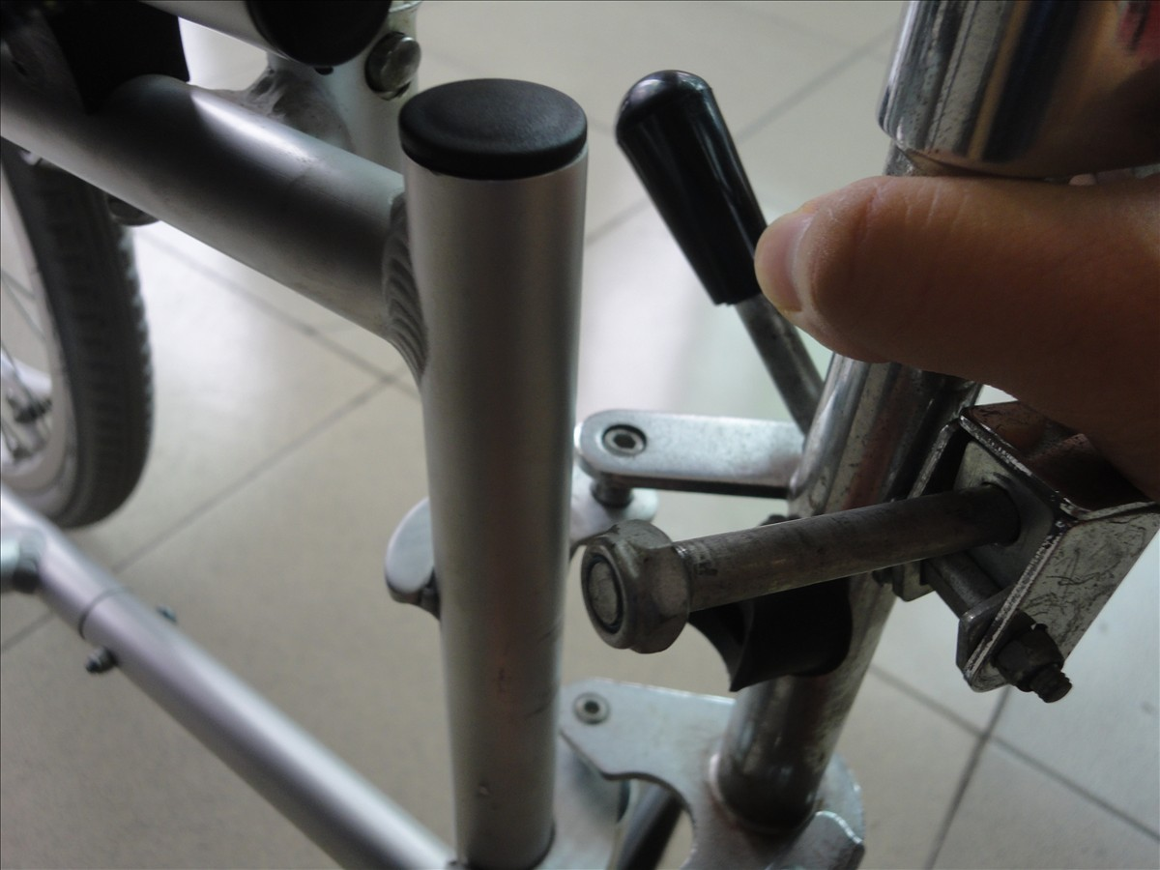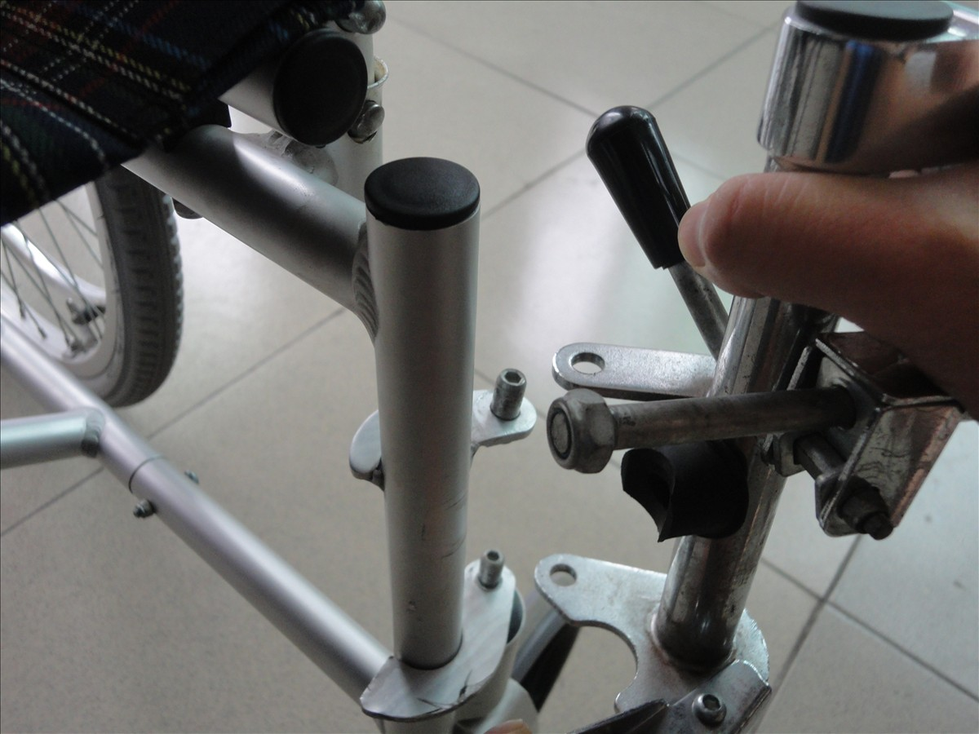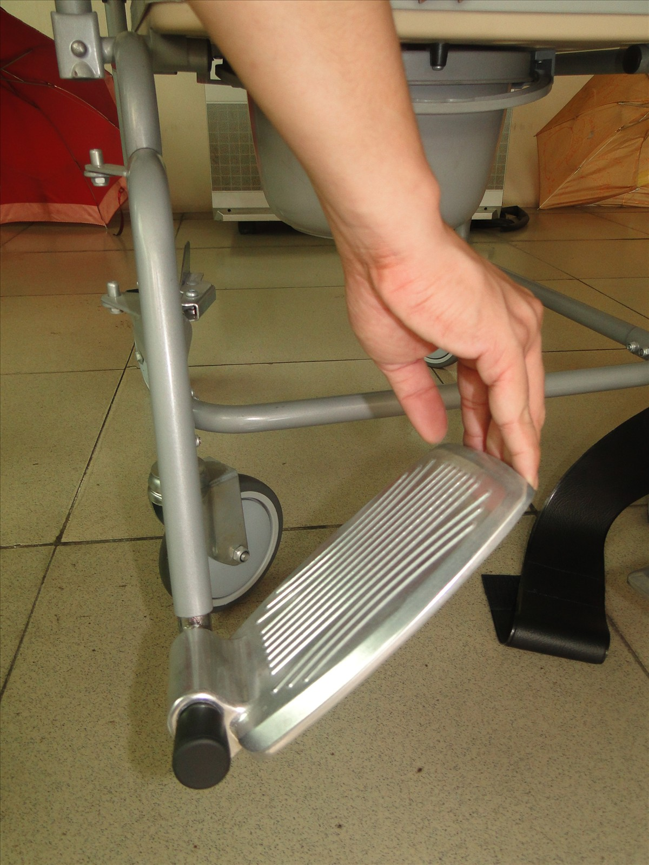
Swing Pin

3). Backrest
A. Take out the locking pins in both sides;
B. Take out the whole backrest as the blue arrow indicates;
C. Done.
To put back the backrest, just operate the other way around.
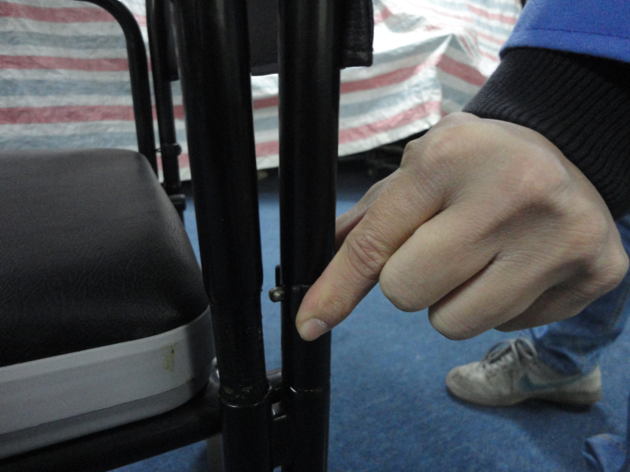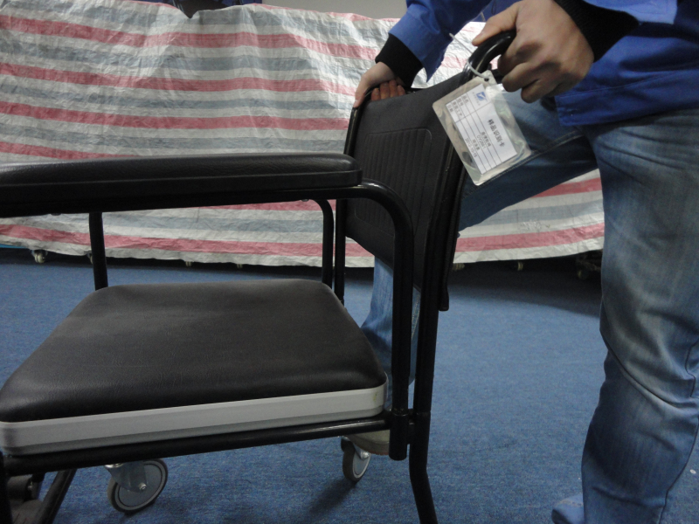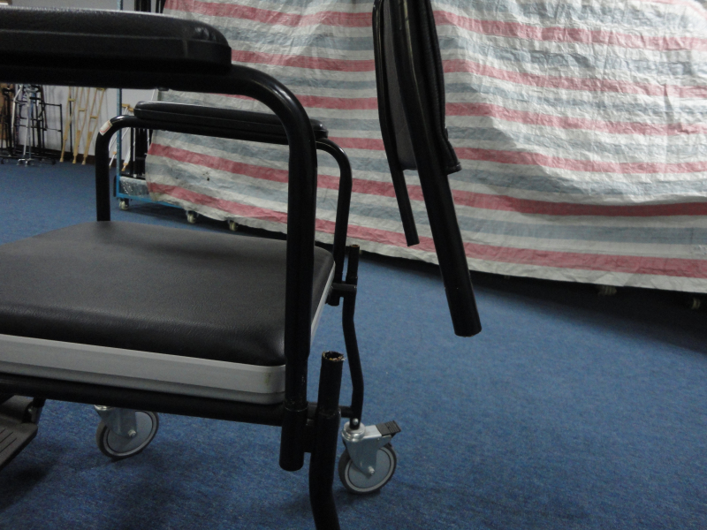
How to Lock and Unlock the Commode Chair
It is very important to lock the Wheelchair when using on it.
Lock: Step on the lock pin in the direction as the blue arrow indicates,
when you hear a “snap”, the commode chair is lock.
Unlock: Lift up the lock pin in the direction as the red arrow indicates.
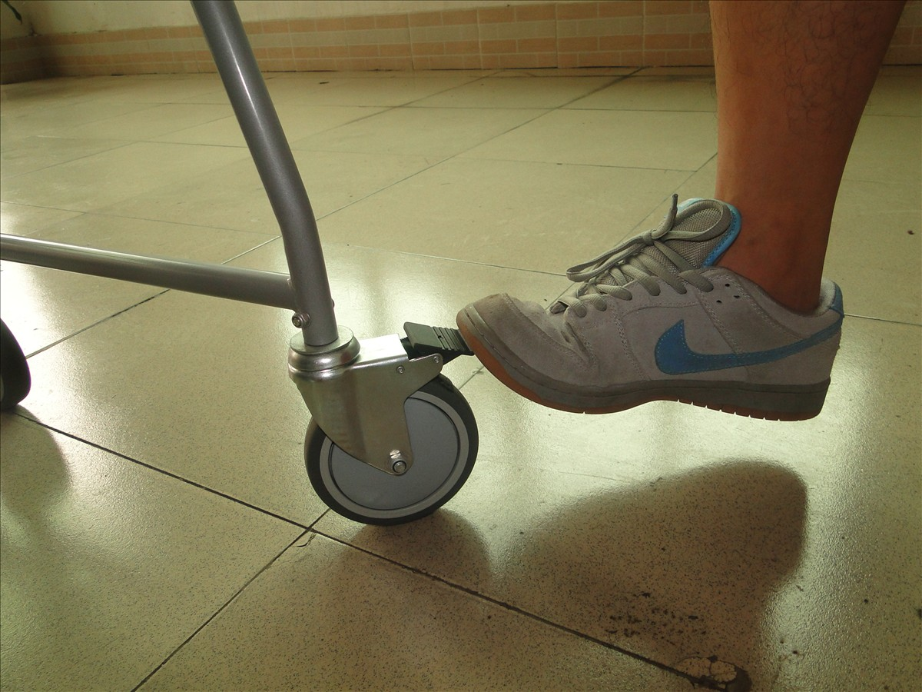

How to use the commode chair properly
A. Take out the square soft foam seat.
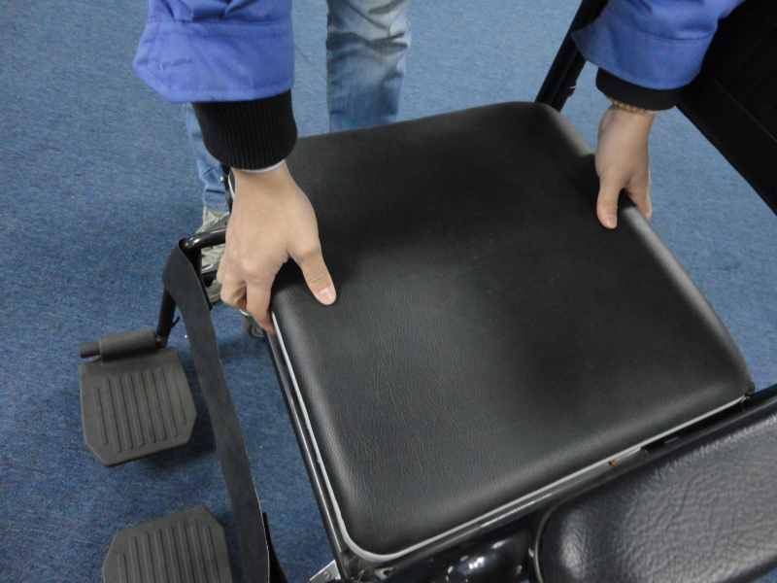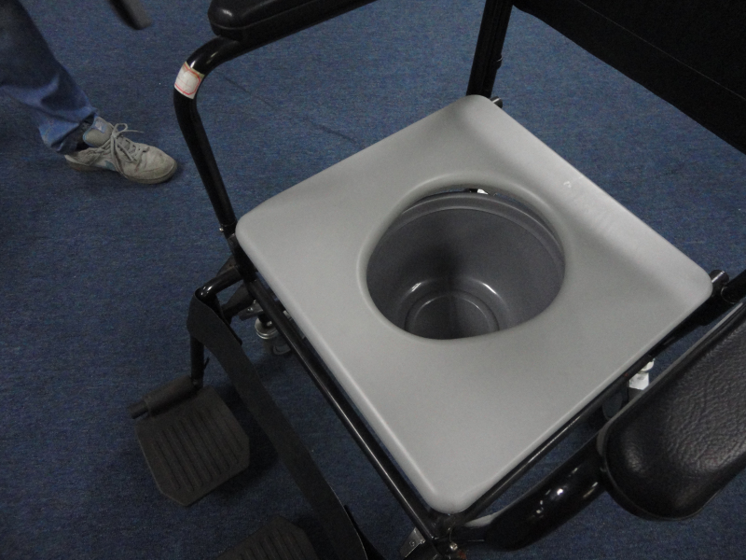
B. Take out the commode bucket under the seat, and take away the lid.
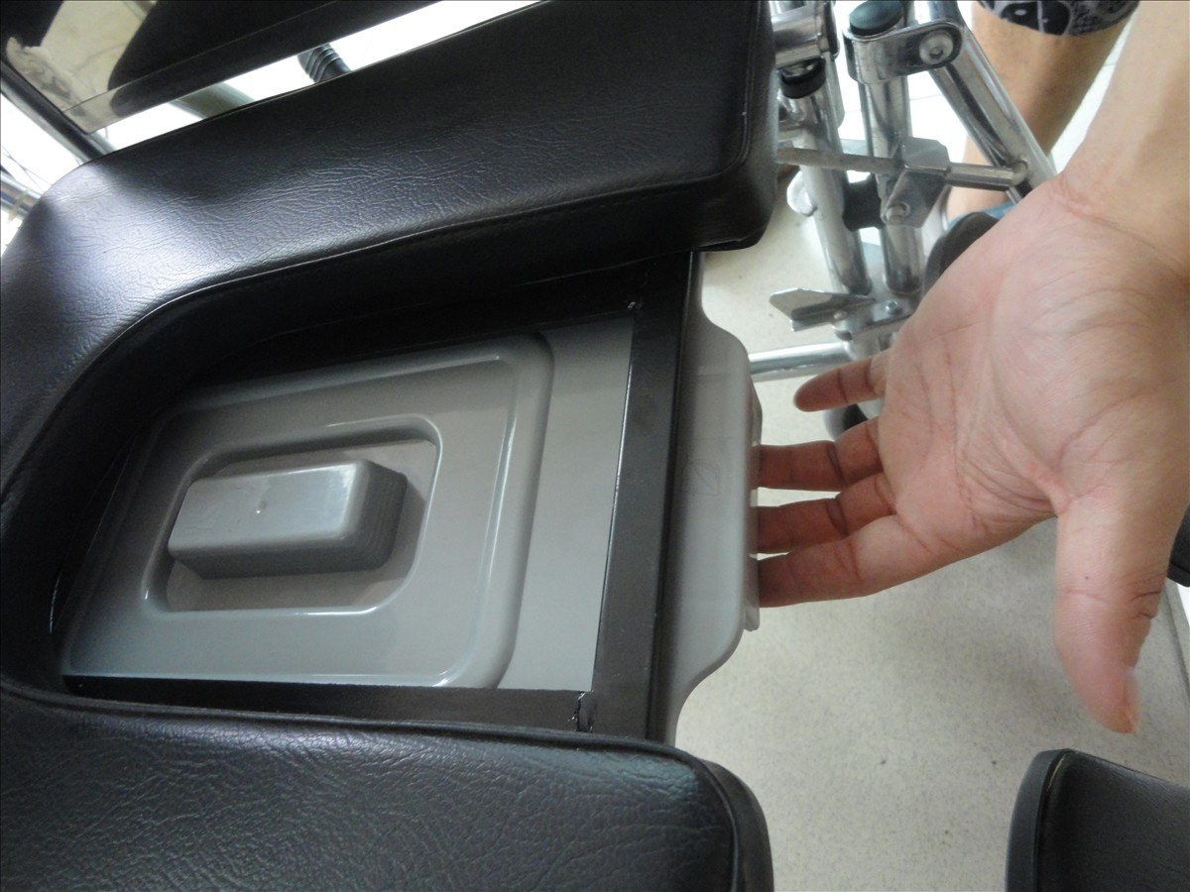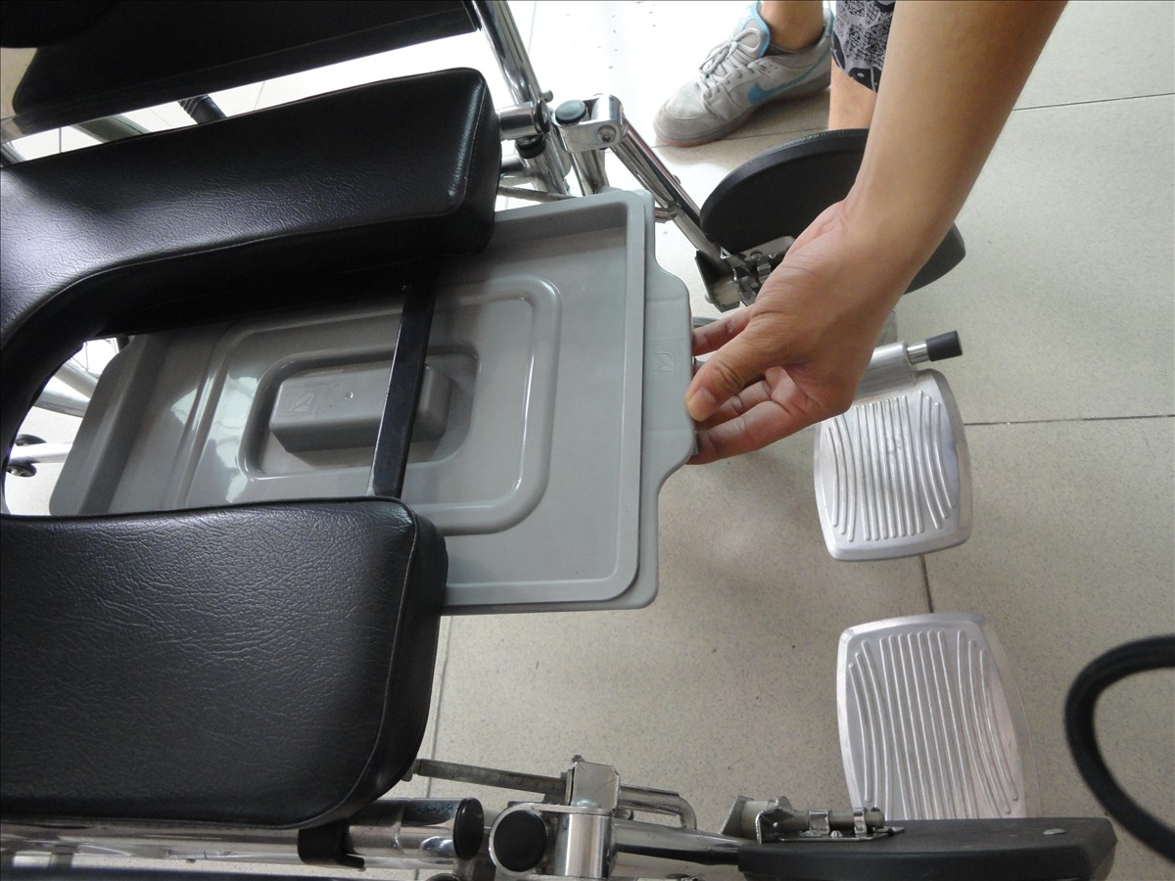
C. After taking away the lid, put back the commode bucket.
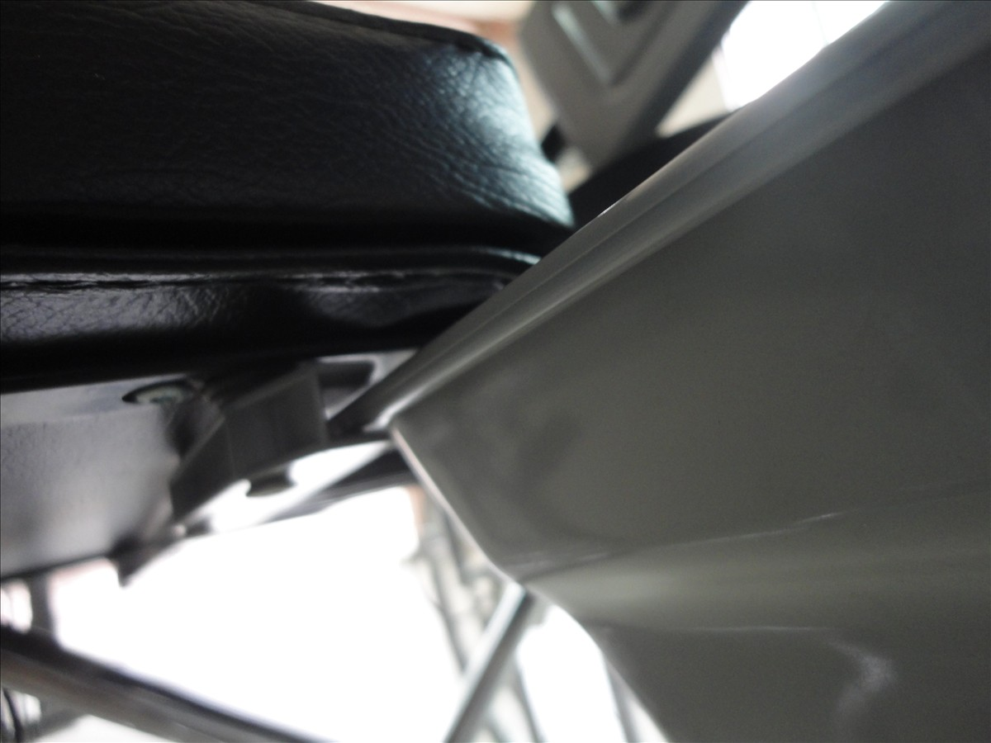
D. Done.

