Wheelchair DY1903GC



DY1903GC | 66 | 36 | 46 | 60 | 20 | 50-71 | 121 | 122 | 40 | 74 | 100 | 97*35*87  1PC/CTN | 26/28



USER’S MANUAL

1
17
16
15
14
13
12
11
100
9
8
7
6
5
4
3
2
1. Pillow 2. Headrest 3. Hand Grip
4. Reclining lever 5. Backrest 6. Armrest pad
7. Side Panel 8. Detachable armrest 9. Rear Wheel
10. Brake Lever 11. Hand rim 12. Adjust Handle
13. Cross Tube 14. Legrest 15. Foot Plate
16. Fork 17. Front Castor

How to Assemble and Detach the Wheelchair
1). Armrest
A. Press the armrest button. B. Lift Up the Armrest with both hands.
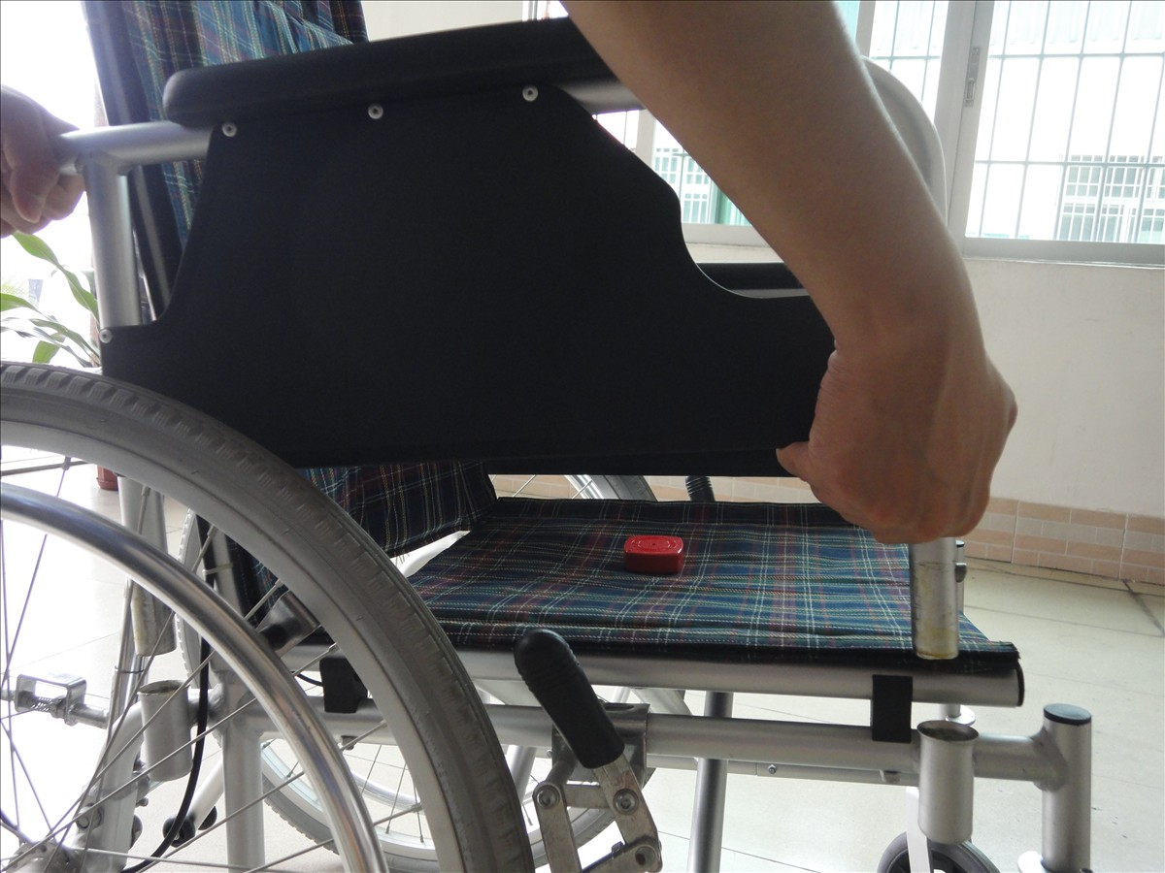
Armrest Button
2). Legrest (From Left to Right)
A. Lift up the foot plate;
B: Pull the Swing Pin to the opposite side;
C. Turn the legrest as the blue arrow indicates;
D. Lift Up the Legrest.
E. Done.
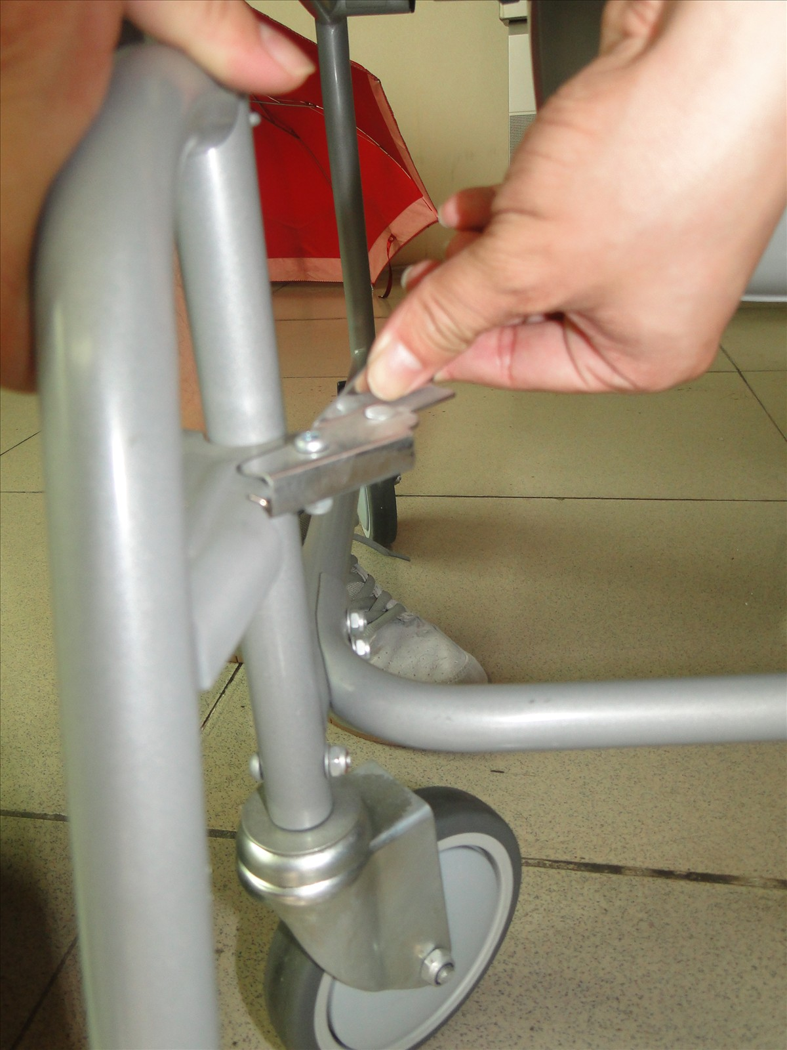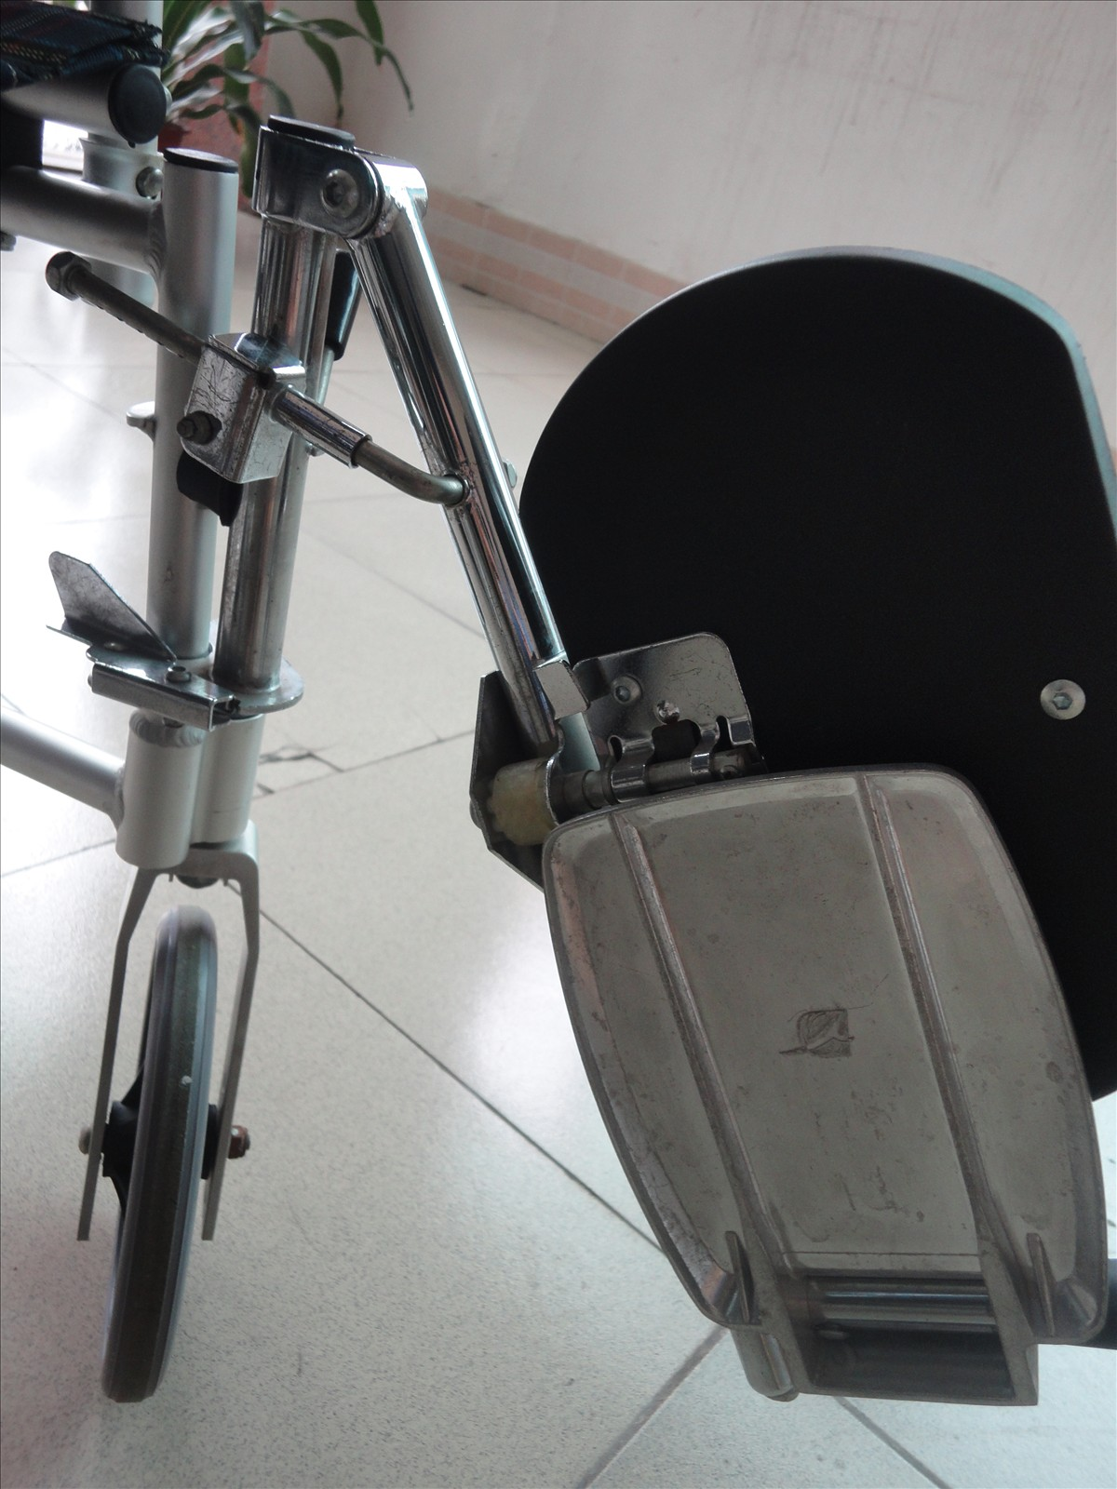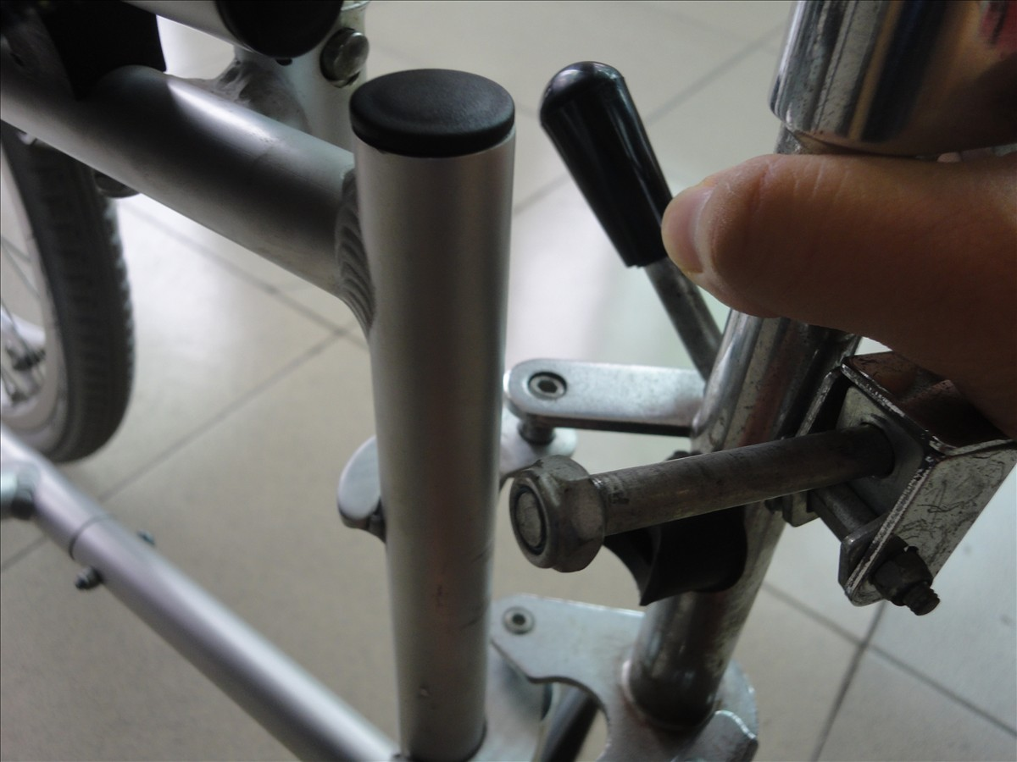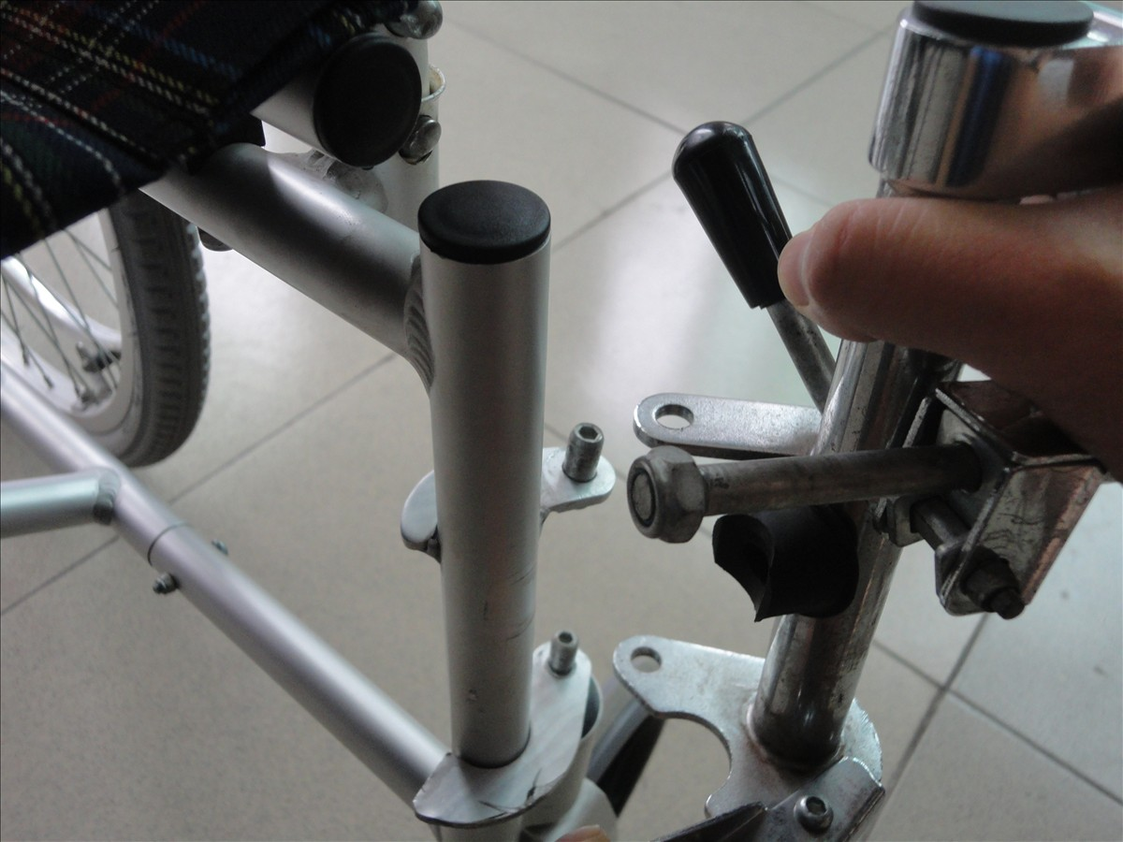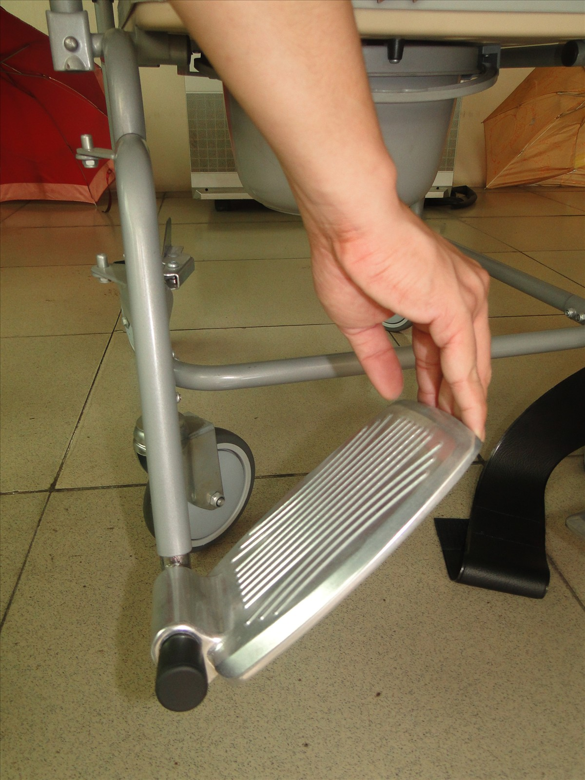
Swing Pin

3). Head Rest
A. Lift up the Head Rest Directly to take out the head rest.
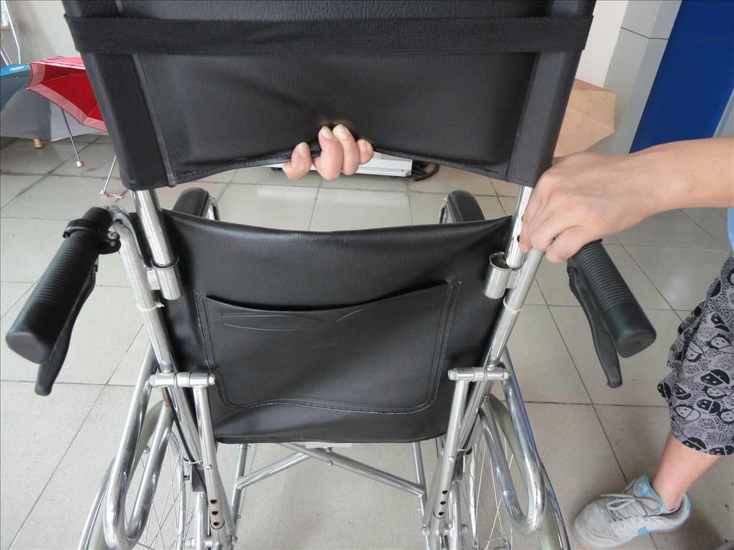
How to Adjust the Height of the Foot Rest
1). Footrest Pad （From Left to Right）
A. This is the original Position.
B. Move the Footrest pad as arrow indicates;
C. Move the footrest pad up or down according to your actual need;
D. After choosing the right position, move the footrest back to the original position.
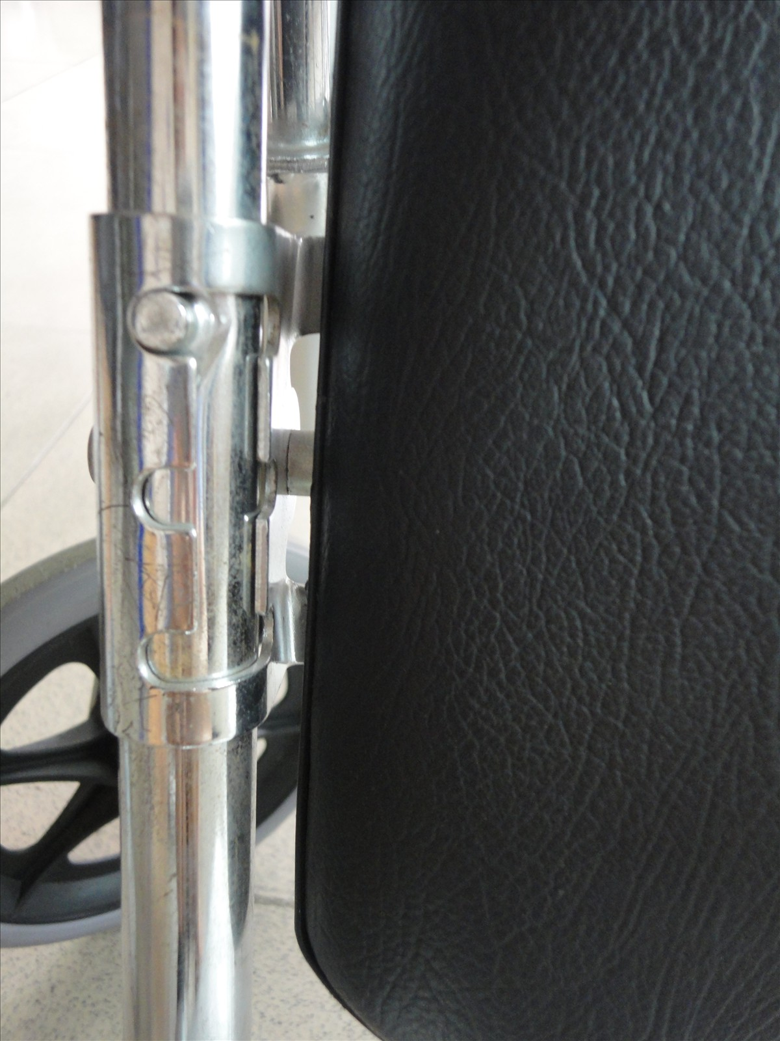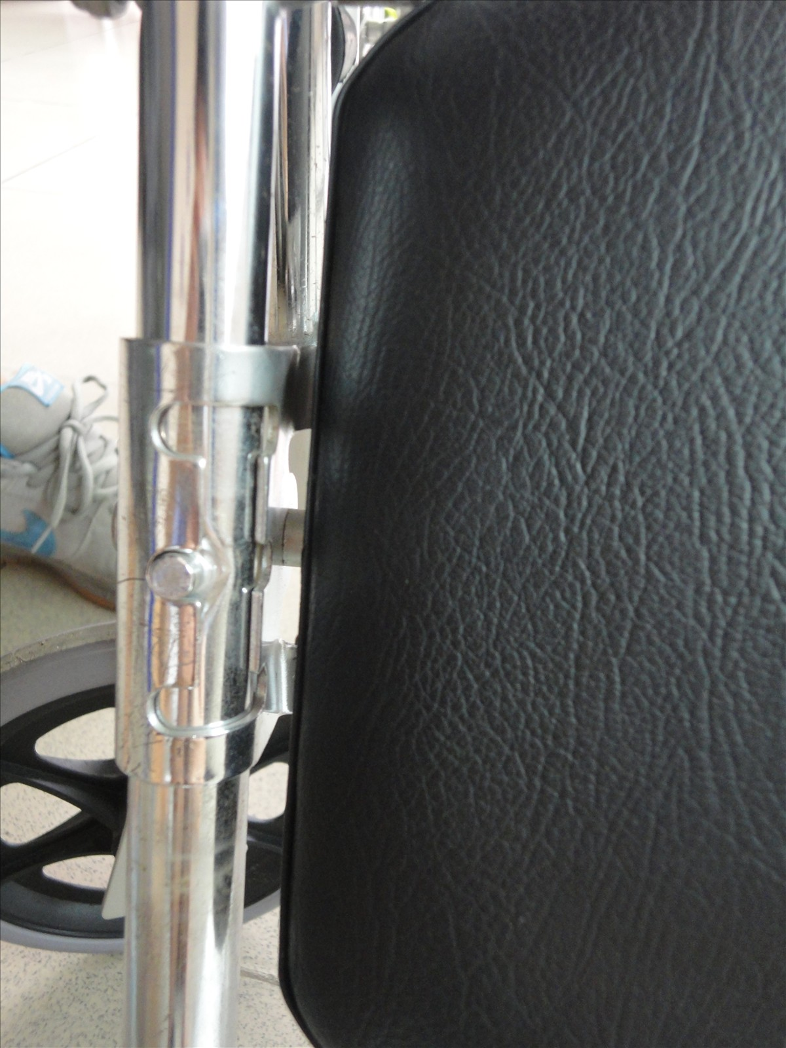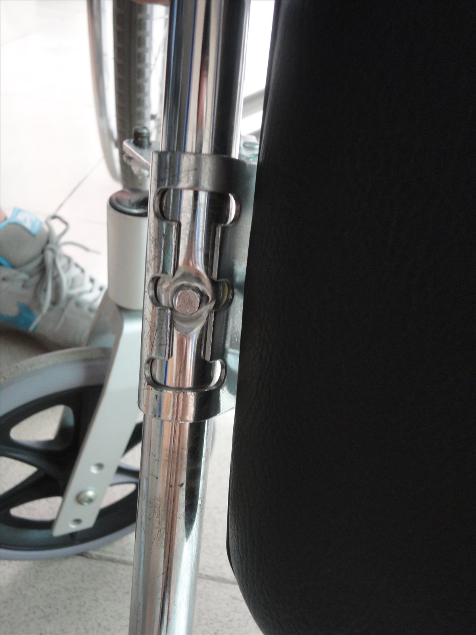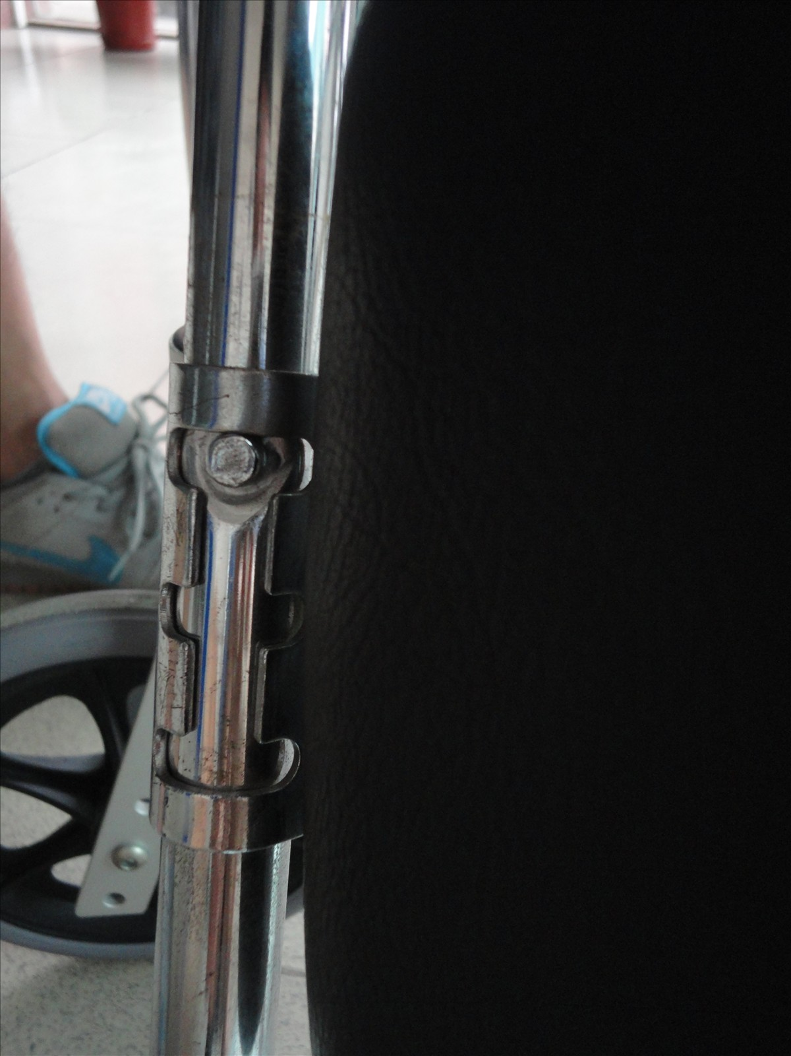
2). Foot Rest
A: This is the Original Position.
B: Lift up the footrest as the arrow indicates to the comfortable position.
C: This is the highest position the foot rest can reach.
D: When putting down the foot rest, push back the adjust handle slowly as the arrow indicates.
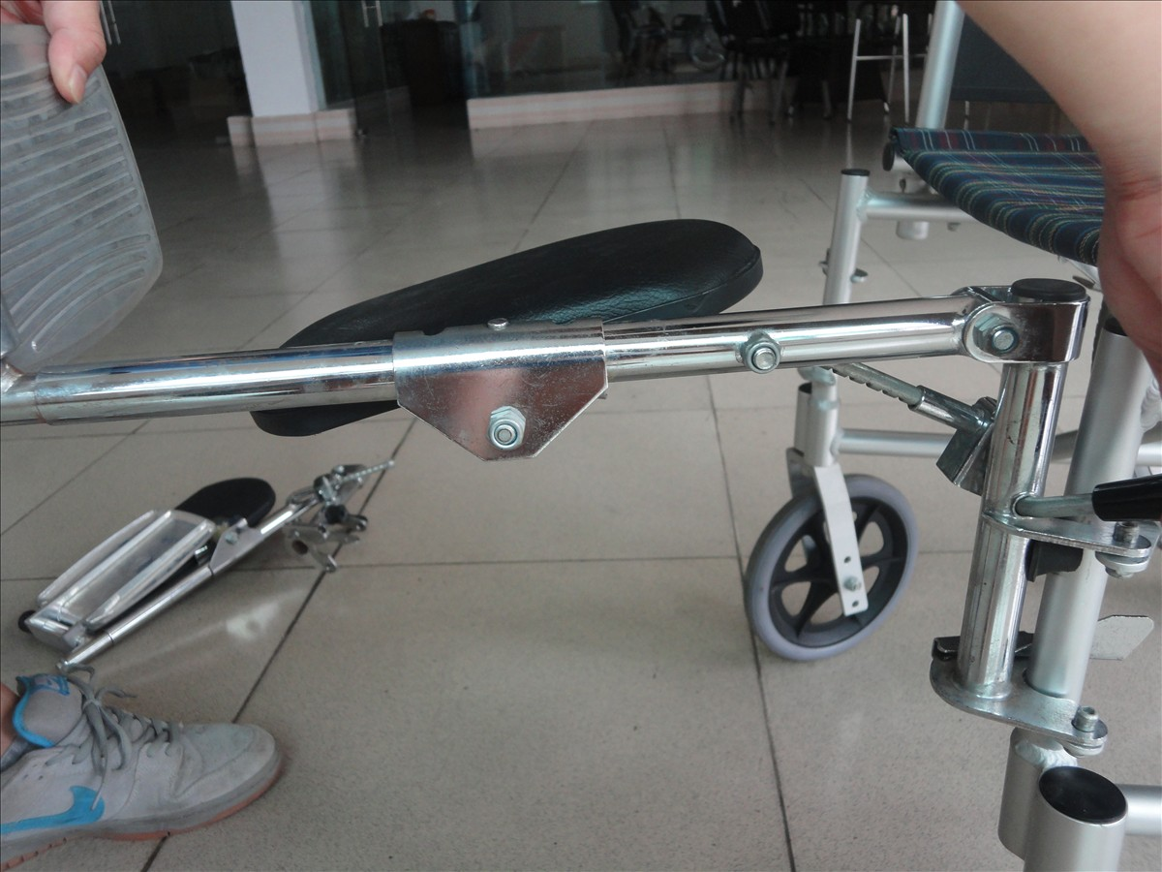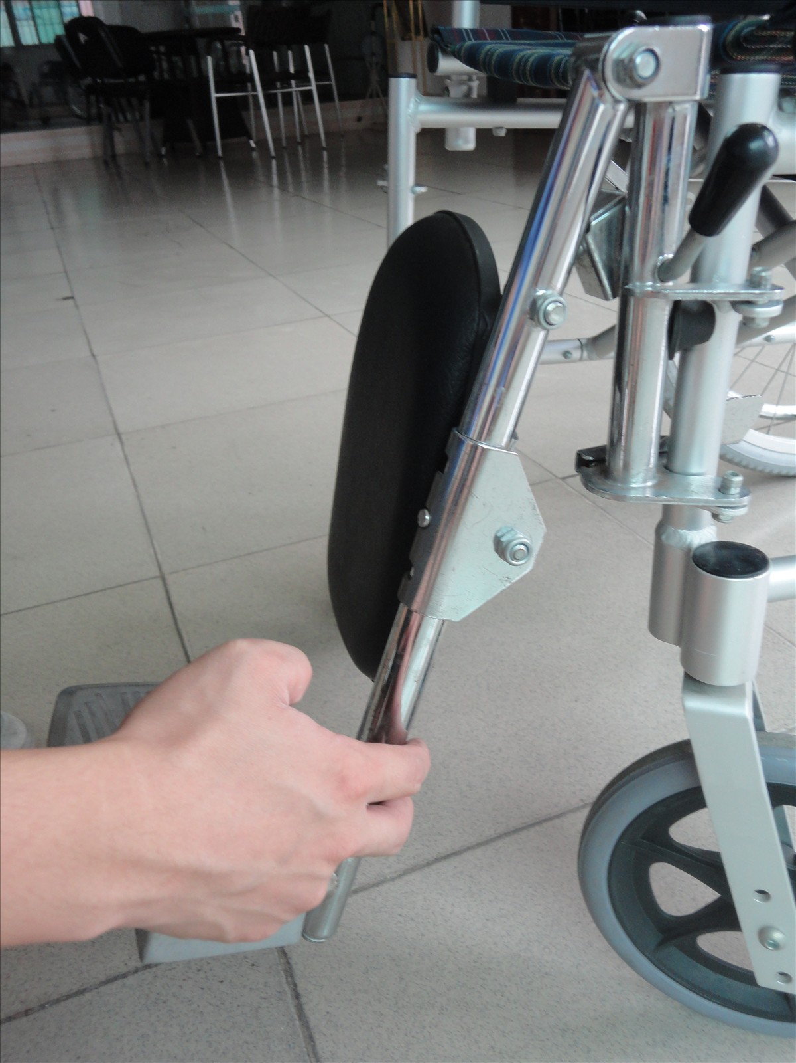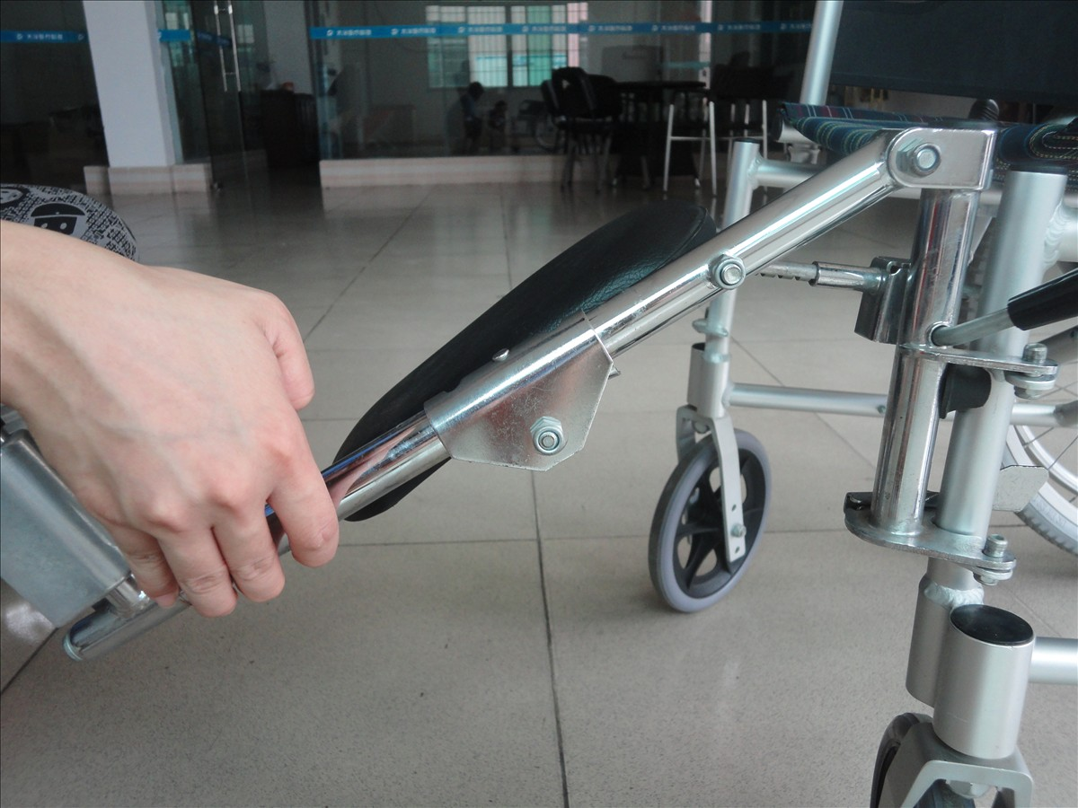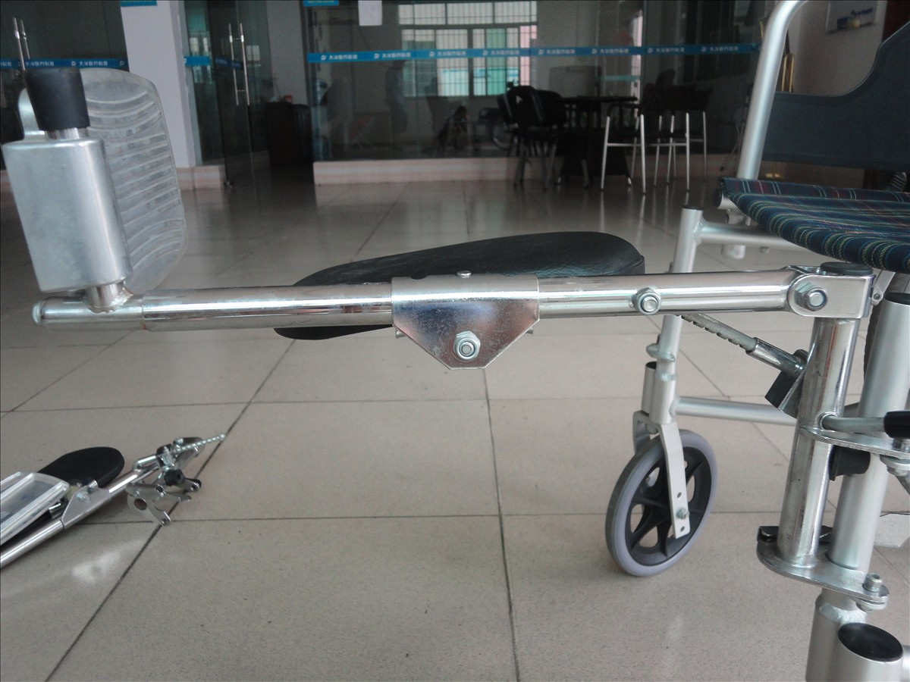
How to Lock and Unlock the Wheelchair
It is very important to lock the Wheelchair when simply sitting on it.
A. This is how the brake looks like when the wheelchair is unlocked.
B. Hold the brake lever and move it forwarder, as the arrow indicates.
C. When you hear a “Snap”, the wheelchair is locked.
D. This is how the brake looks like when the wheelchair is locked.
To unlock the wheelchair is operate the other way around.
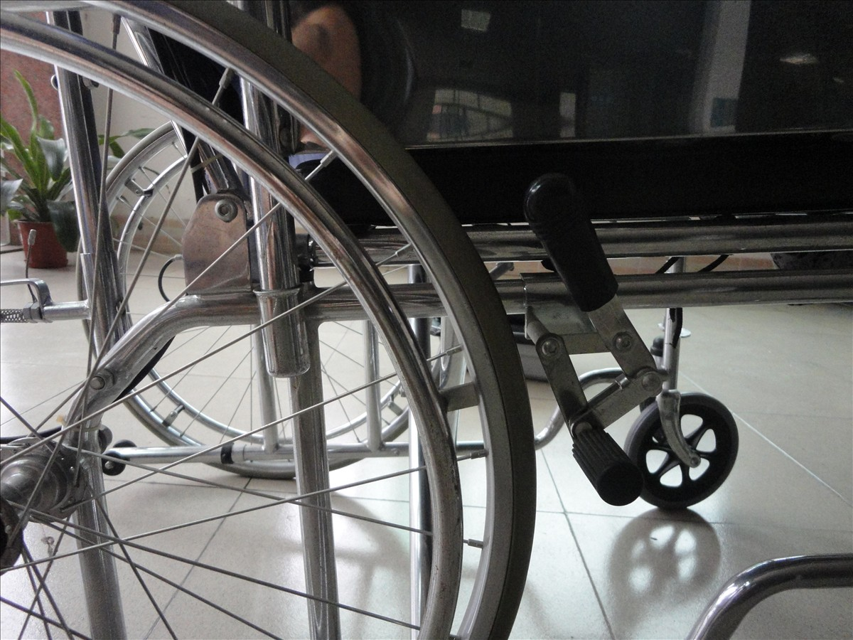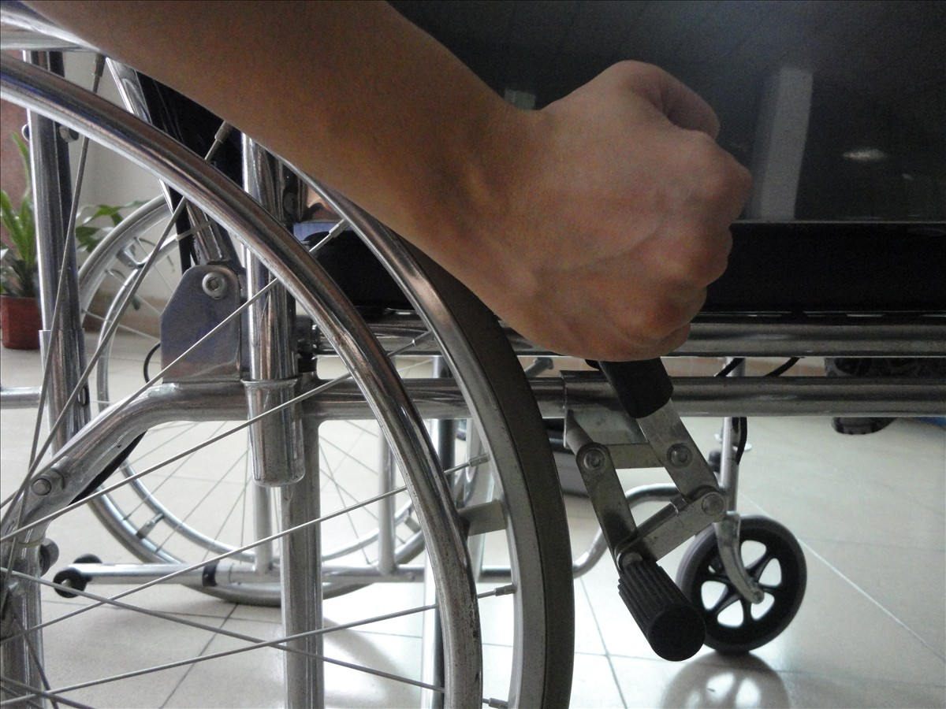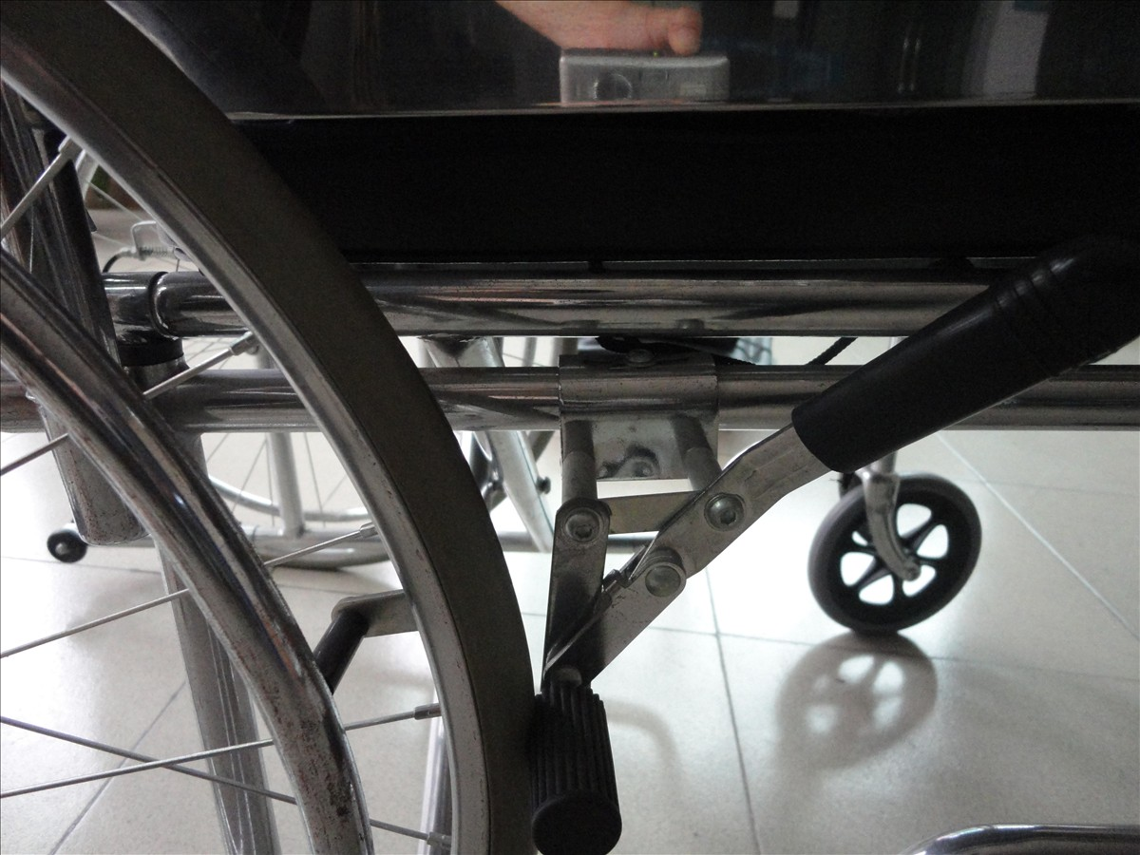
How to Recline the Wheelchair
A. Lift up the brake handles at both sides and pull down the backrest slowly.
B. There are in total three reclined position of this wheelchair that the user can adjust.
Picture A is the first Position with straight backrest. And Picture B is second position.
C. Picture C is how the wheelchair looks like when the backrest completely reclined.
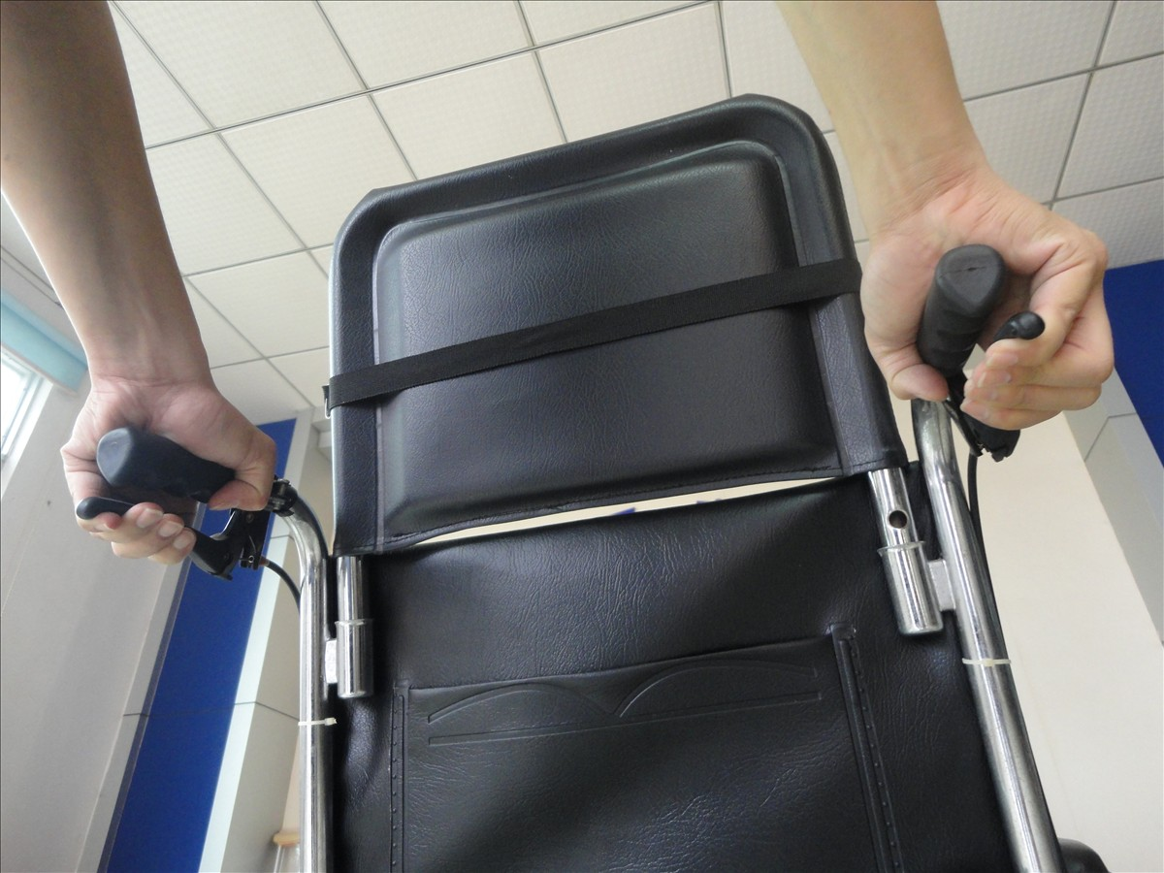
How to fold the Wheelchair
- Take out the head rest and footrest before you fold the wheelchair.
- Pull up the string on both sides of the seat frame, and the wheelchair will fold as you pull.
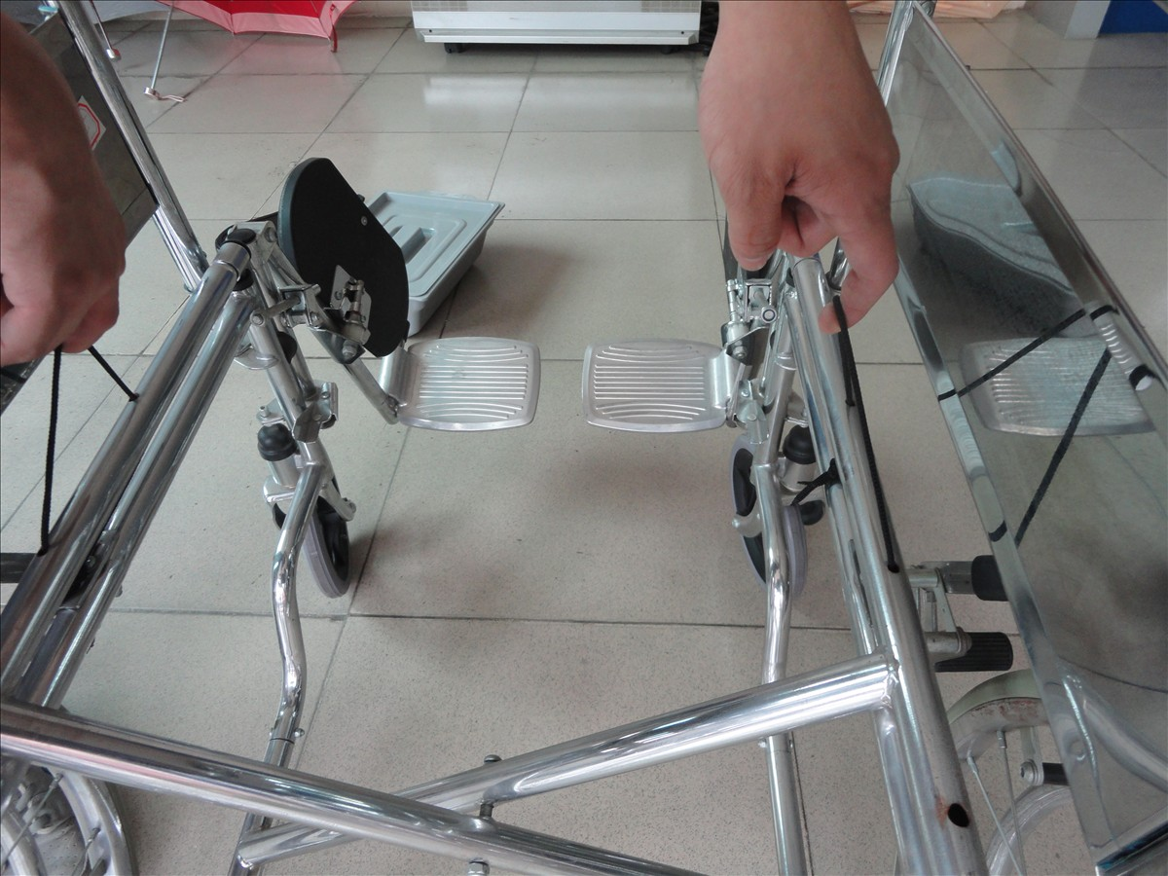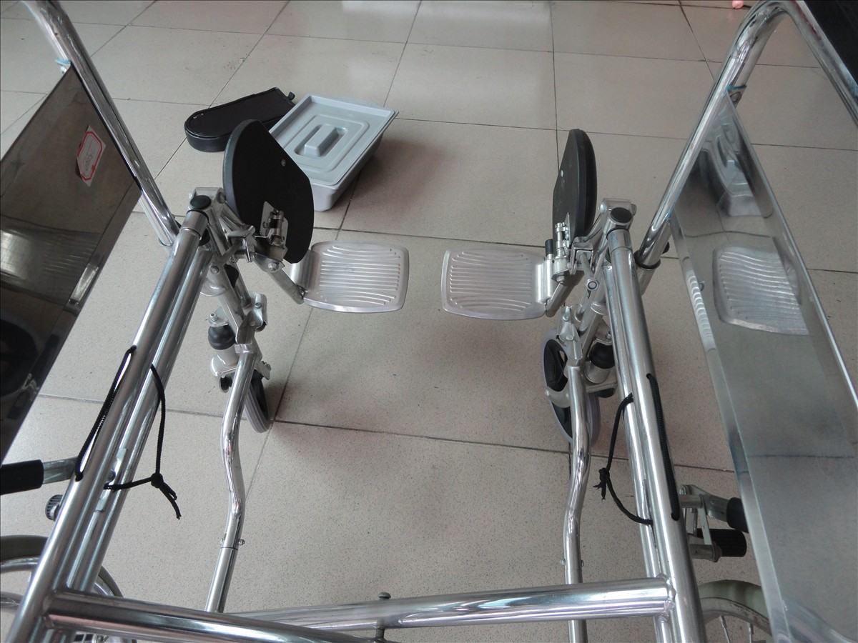
String

