Wheelchair DY1868LJ



DY1908LAJQ | 64 | 29 | 46 | 60 | 15 | 48 | 93 | 104 | 40 | 43 | 100 | 80*28*74  1PC/CTN | 14.5/16.5



USER’S MANUAL

1
2
4
5
6
7
8
9
10
3
11
12
13
14
1. Hand Grip 2. Backrest 3. Armrest pad
4. Flip-Up armrest 5. Hand rim 6. Brake Lever
7. Rear Wheel 8. Legrest 9. Fork
10. Front Castor 11. Side Panel 12. Cross Tube
13. Foot Plate 14. Auto-lock United Brake
How to Lock and Unlock the Wheelchair
It is very important to lock the Wheelchair when simply sitting on it.
A. This is how the brake looks like when the wheelchair is unlocked.
B. Hold the brake lever and move it forwarder, as the arrow indicates.
C. When you hear a “Snap”, the wheelchair is locked.
D. This is how the brake looks like when the wheelchair is locked.
To unlock the wheelchair is operate the other way around.
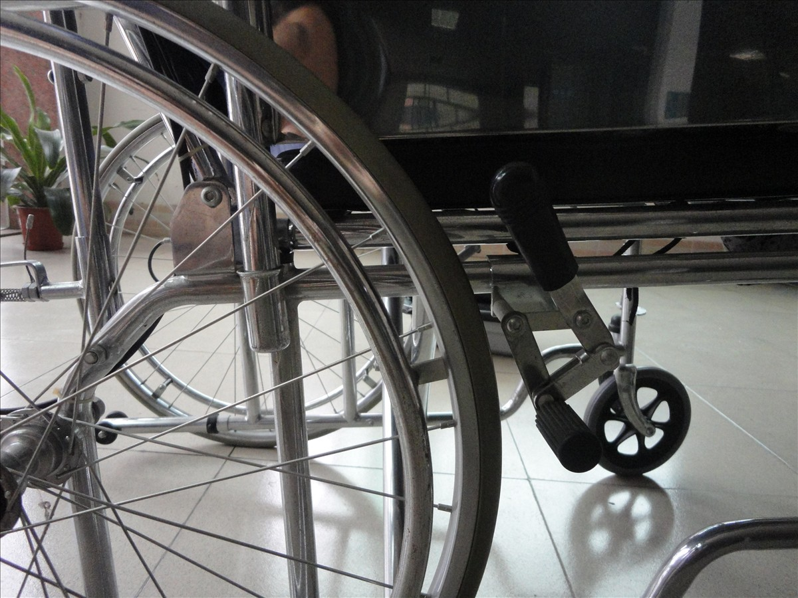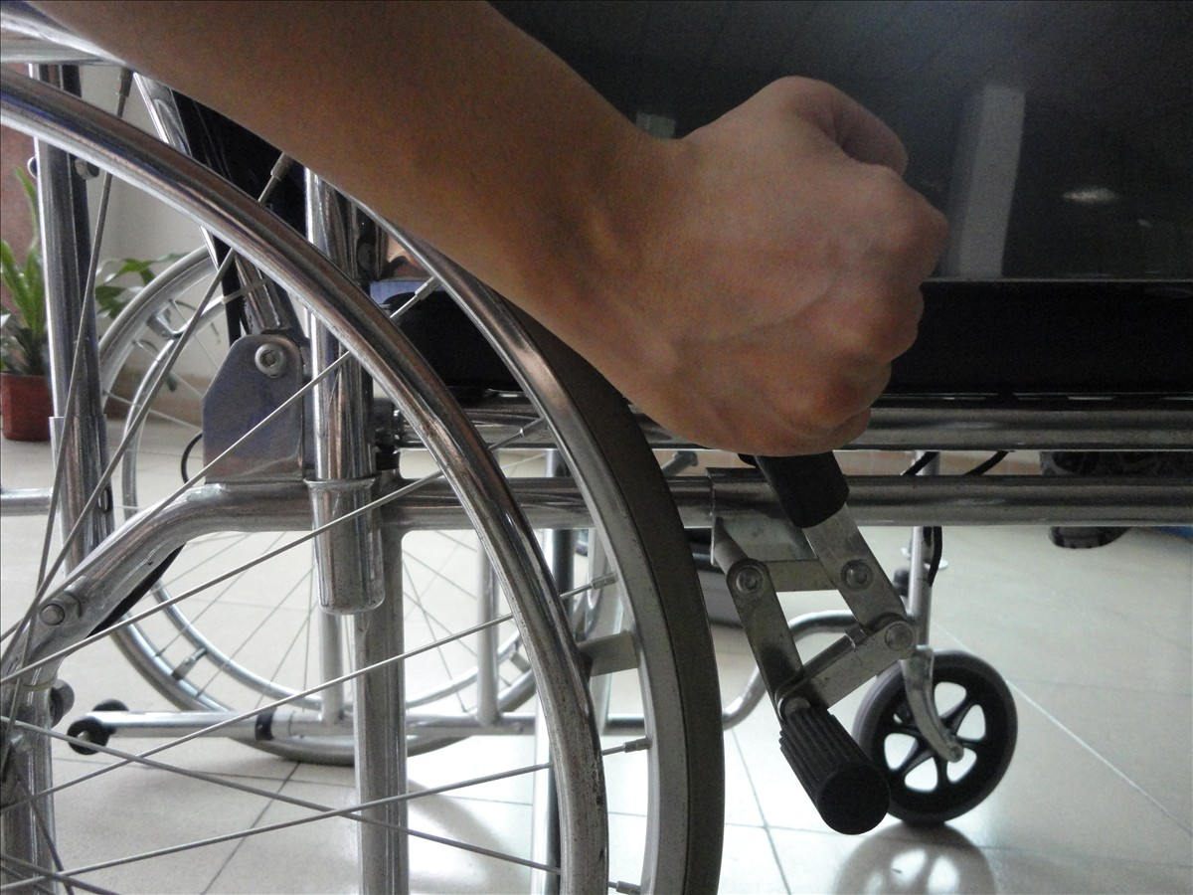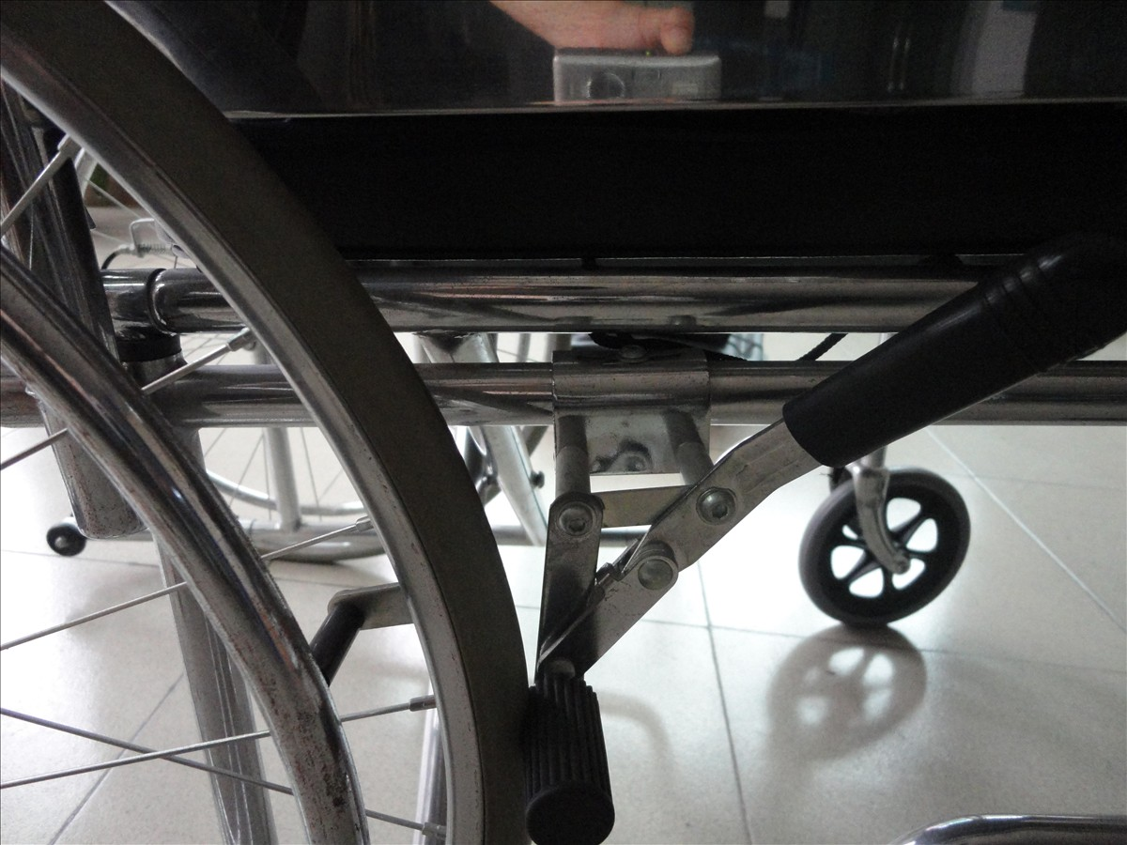

How to Use United Brake
- This is how the brake looks when it is release;
- Lift the long bar until you hear a “snap”, in this case, the brake is locked;
- This is how the brake looks when it is locked;
- Lift the short bar until you hear a “snap”, in this case, the brake is released.
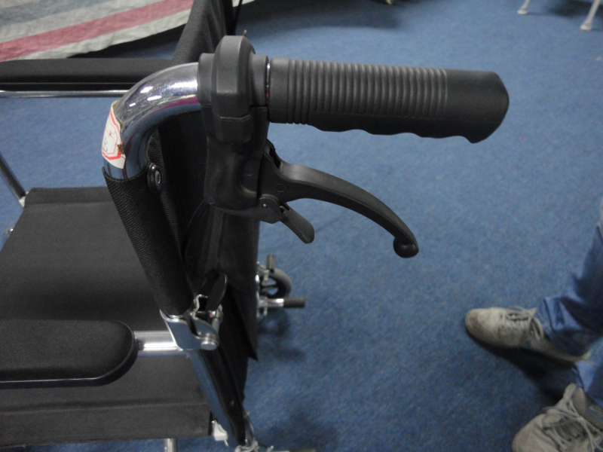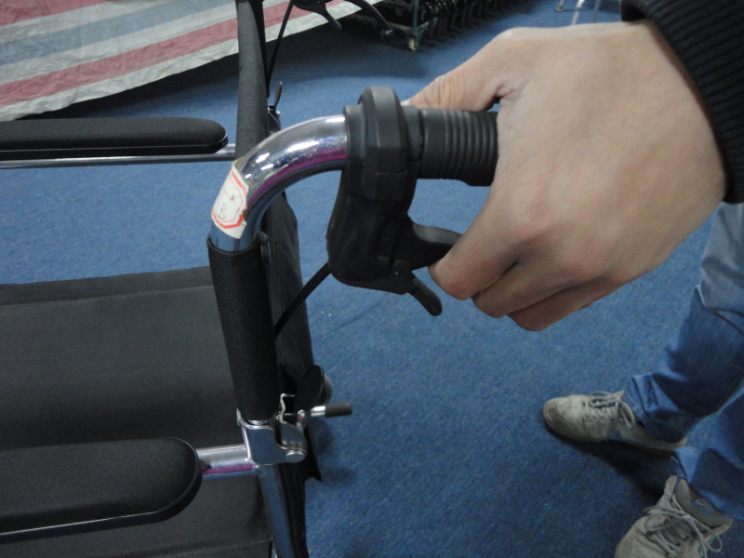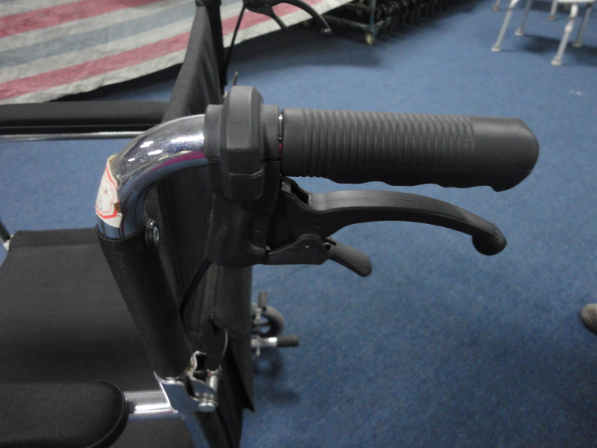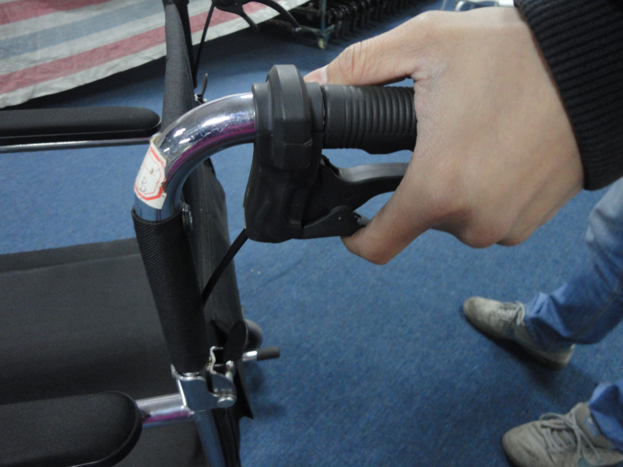

How to fold the Wheelchair
- Take out the head rest and footrest before you fold the wheelchair.
- Pull up the string on both sides of the seat frame, and the wheelchair will fold as you pull.
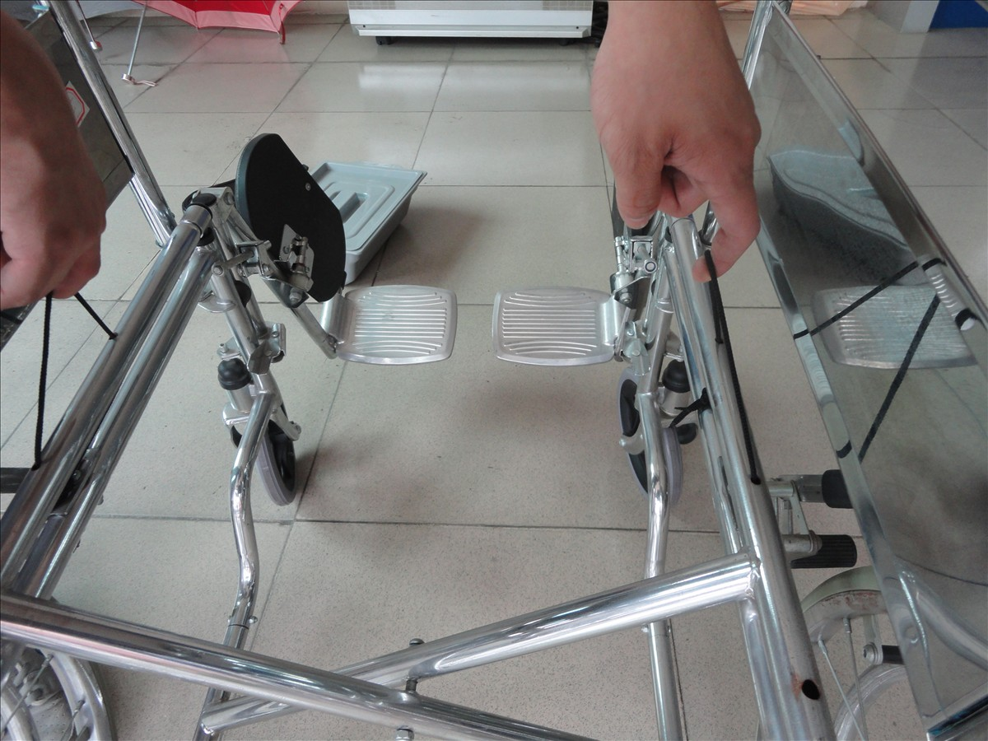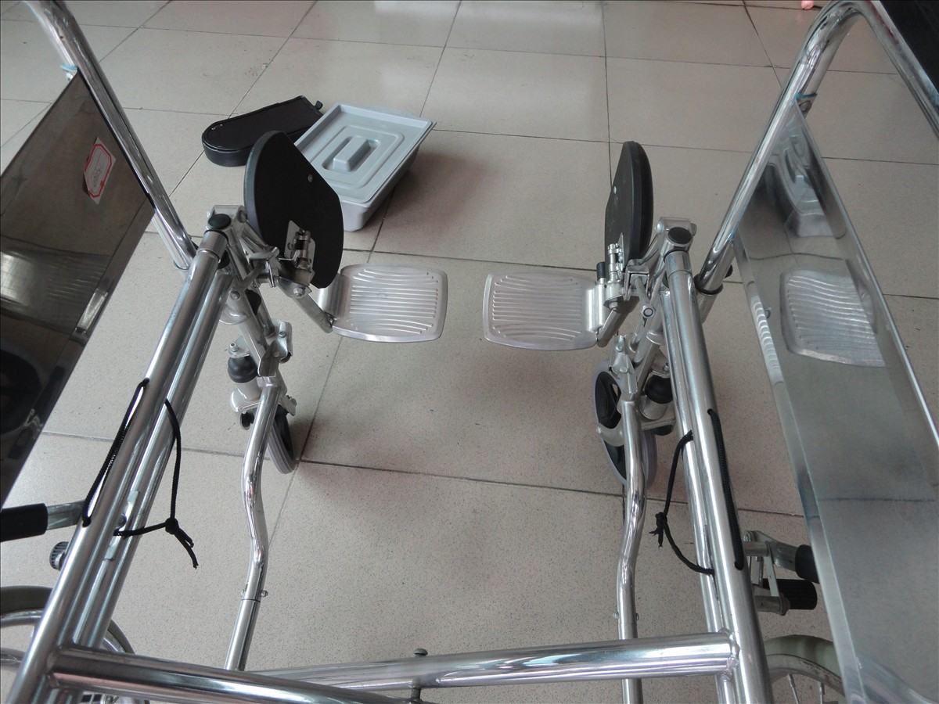
String

