Rollator DY049144L

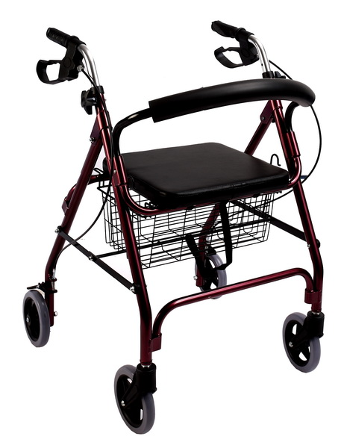
DY9146L | 62 | / |  | 15 | 15 |  | 90-96 |  | / | / | 100 | 63*23*83 1PC/CTN | 7/8



USER’S MANUAL
1
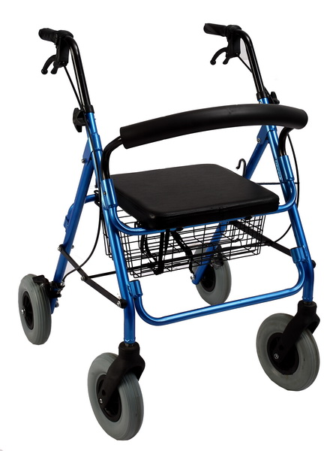
3
6
5
4
7
2
8
1. Handle 2. Auto-Lock united brake 3.Height adjusting screw 4. Backrest 5. Seat 6. Basket 7. Fork 8. Castors

How to Walk with the Rollator

1). Put your rollator about one step ahead of you, making sure the legs of your rollator are level to the ground.
2). With both hands, grip the top of the rollator for support and walk into it, stepping off on your injured leg. Touch the heel of this foot to the ground first, then flatten the foot and finally lift the toes off the ground as you complete your step with your good leg.
3). Don't step all the way to the front bar of your rollator. Take small steps when you turn.
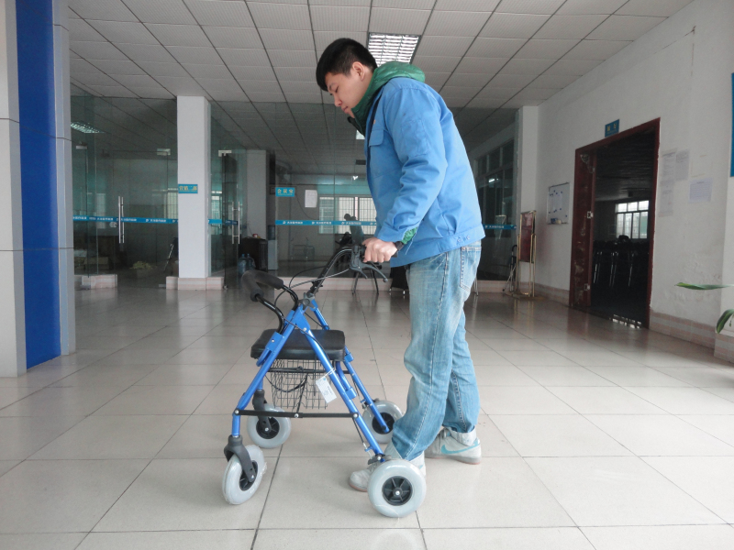

How to Sit and Stand with the Rollator
1). Turn your back to the Rollator slowly. Grasp the hand grip with both hands and bend yourself forward a little bit.
2). Then slowly sit down on the soft foam seat, rest your back on the soft foam backrest. Hands still keep holding on the hand grip. When sitting, make sure your gravity is still at the front, otherwise the walker will fall back.
3). When Standing, sit straight first. Then slightly take one step with your good leg. Push down the hand grip and slowly stand up at the same time.
4). After standing up, slowly turn yourself around and face to the walker.

Tip: Make sure the rollator is locked before you sit and stand.
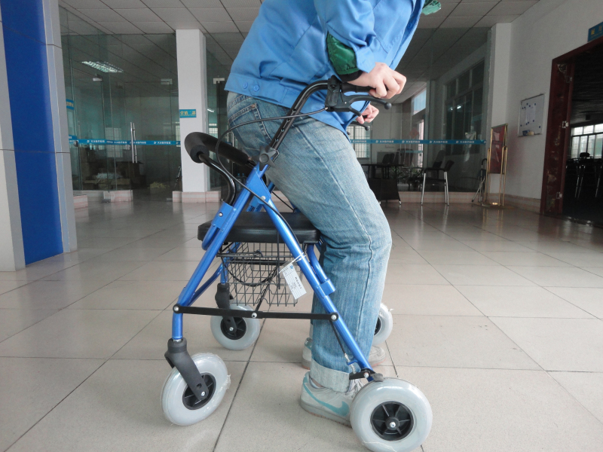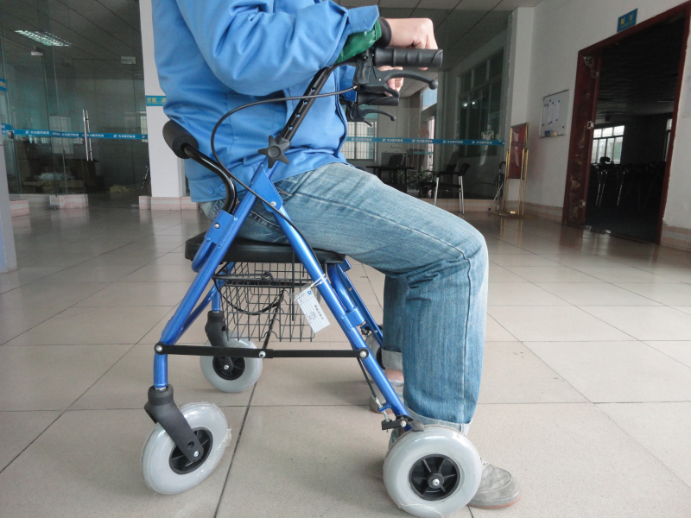

How to Fold the Rollator
1). Lift the seat and take out the bastket.
2). Pull the strip with one hand and hold the rollator grip with the other hand, to make sure the rollator will not fall down when you are folding it.
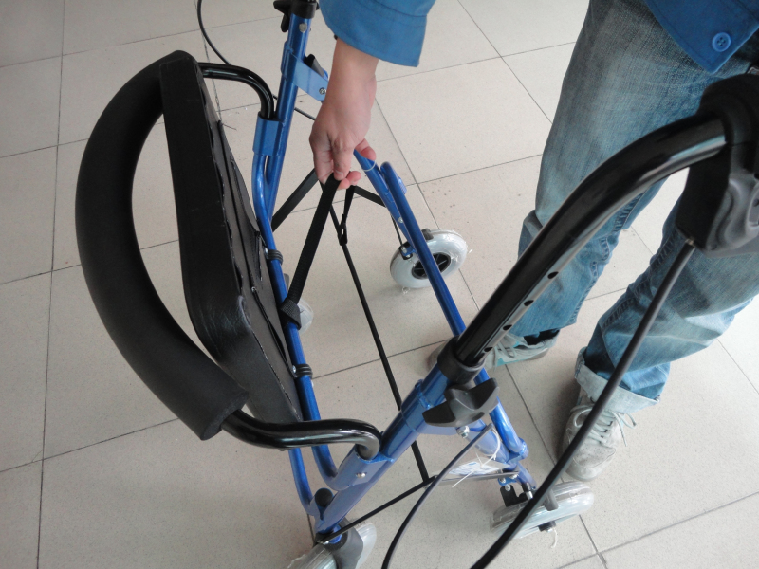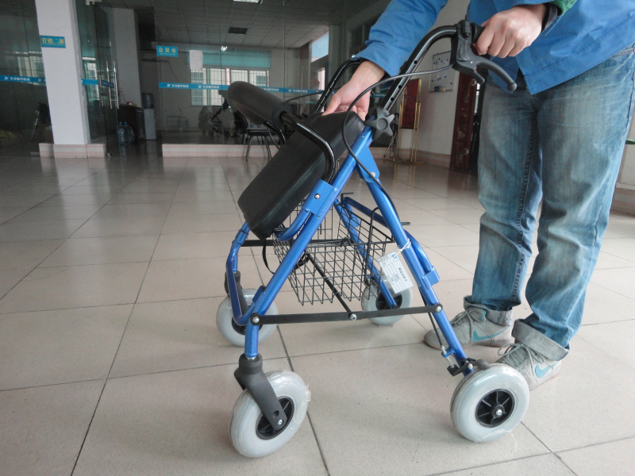
How to Adjust the Height of the Rollator
1). Turn the star-shaped height adjusting screw under the hand grip.
2). After taking out the screws, choose one hole which is the most suitable height for you, then screw back the screw.


