Report number: HGCJ190804001

TEST REPORT

Sample Description: NANO SINK

Applicant:

Test Type: Internal Inspection

Date of inspection: 2019-8-2～8-16




FOSHAN SHUNDE HIGOLD HARDWARE PRODUCT MANUFACTURING CO., LTD.

DECLARATION

- The test report is invalid without the official stamp of the testing institute.
- The test report is invalid without the signatures or stamps of the testing.
- The test report is invalid if scribbled or altered.
- Any partial photocopy of the test report is not allowed without written permission of the testing institute. Any modification, improper or illegal use of the test report is prohibited.
- Any dispute of the test result must be raised to the testing institute within 15 days after receiving, otherwise it is taken as no objection (except otherwise stipulated).
- The result of the commission test is only corresponding to the sample(s).

FOSHAN SHUNDE HIGOLD HARDWARE PRODUCT MANUFACTURING CO., LTD.
TEST REPORT

Report Number: HGCJ190804001 Page 1 of 9
Product Name | Pressed Sink |  | Production Date | 2019-7-30
Model Specification |  |  | Batch No. or Lot No.
Applicant |  |  | Test Type | Commission Inspection
Applicant Address |  |  | Number of Samples | 1
Manufacturer |  |  | Sampling Base | 1
Sampling Mode  Sender/Sampler | Sample Delivery |  | Date of Sampling | 2019-7-30
Place of Sampling |  |  | Date of Inspection | 2019-8-16
Sample Characteristics and Status |  | Sample is intact
Inspection and Judgment Basis |  | HIGOLD standards and requirements on Nano Sink.
Test Results |  | According to HIGOLD standards on Nano Sink, all tested items meet the requirements.
Remarks |  | 1.“ ” means not applicable;  2. Inspection date: 2019-8-2~8-16.
Main Inspector: Jinghui Zou  August 16, 2019 |  | Testing Unit: Test Laboratory of FOSHAN SHUNDE HIGOLD HARDWARE PRODUCT MANUFACTURING CO., LTD.
Verifier: Guibin Liao
August 16, 2019
Approver: Julin Yu
August 16, 2019
FOSHAN SHUNDE HIGOLD HARDWARE PRODUCT MANUFACTURING CO., LTD.
TEST REPORT
Report Number: HGCJ190804001 Page 2 of 9
No. | Inspection Item | Inspection Basis and Requirements | Terms | Test Results | Analysis and Judgment
1 | Visual inspection | The nano-coating is dense, without bottoming and scratch-free; the coating thickness and surface distribution are uniform, no yellowing, blackening, and color difference; smooth hand feeling, no pitting, no rust. From the top view and 45° squint, the surface color and the stainless steel sink surface form excessive color difference | 9.1 | No obvious defect | Qualified
2 | Oleophobic test | Cleaning Ink Scratch Test: The oil pen scratches, dried for 2 minutes, with a dry towel, wipe paper towel, respectively, may be substantially clear traces of ink, you may be allowed to remain with a faint trace, and then use one hundred clean cloth deep cleaning, vaguely Ink traces can be completely cleared | 10.4 | There is residue after wiping the paper towel. The residue disappears after the scouring pad is deeply cleaned. | Qualified
3 | Easy cleaning test | Dip oil cleaning effect: After using cooking oil, it can be cleaned with dry towel and paper towel without leaving any obvious marks. | 10.6 | Clean, no residue, easy to remove | Qualified
4 | Acid salt spray test | After the 96-hour acid salt spray test, the sink products shall meet the requirements of Grade 9 (inclusive) of the appearance standard in GB/T 6461 according to the standard GB/T 10125. | 10.6 | No corrosion on the surface level 10 | Qualified
5 | Corrosion resistance test | Apply evenly on the surface of the coating with a 20% concentration of cleaning essence. Apply once every 24H to observe the surface rust condition. For 7 smears, record the surface rust formation, and then clean the rust with a towel or sponge. Clearly qualified; if a steel ball or white scouring cloth is to be used, the coating should not be damaged after being wiped with a steel ball or a white scouring cloth. | 10.7 | No surface rust is generated. | Qualified
6 | Hundred grid test | Use a tungsten carbide steel knife and a steel ruler or a hundred-square knife to cut a 10×10mm square on the surface of the workpiece to be tested. When the grid is cut, the edge is perpendicular to the surface of the coating. The scratch spacing is 1mm. The depth should be enough to penetrate the coating. The plating layer will not be embedded in the substrate. The surface of the scratched part will be wiped off, and then adhered to the cutting surface of the workpiece to be tested with 3M tape (adhesion force (10±1)N/25mm), and rubbed with an eraser or a finger. Press and hold the tape against the surface of the workpiece being tested. After 1 min, the tape was pulled away quickly in the direction of 45° from the surface of the workpiece.  View the workpiece and rate it according to Table 4. Referring to Figure 1, the required level must be level 1 or above. | 10.8 | Level 1 | Qualified

FOSHAN SHUNDE HIGOLD HARDWARE PRODUCT MANUFACTURING CO., LTD.
TEST REPORT
Report Number: HGCJ190804001 Page 3 of 9
No. | Inspection Item | Inspection Basis and Requirements | Terms | Test Results | Analysis and Judgment
7 | Pencil hardness test | A set of pencils with a pencil (hardness 4H-9H) is cut, that is, one end of the wood is cut about 5mm ~ 6mm, carefully operated to leave the original, unscratched, smooth cylindrical pencil refill ( as shown in picture 2). The used pencil tip can be flattened (at a right angle) on the sandpaper (grain size 400), and the edge of the refilled core is free of debris and notches at a 45° angle to align the tip to the surface of the workpiece being tested. Next, a straight line segment distance of at least 7 mm is pushed toward the front (in the direction away from the operator) by a force (about 750 g load force) at a speed of 0.5 mm/s to 1 mm/s. The hardness is increased sequentially by 4H-9H until a scratch of at least 3 mm is present. After 30 seconds, the pencil marks on the workpiece are wiped clean with a soft cloth or an eraser. The hardness of the coating is expressed by the hardness of the hardest pencil which does not cause scratches of 3 mm or more on the plating film. If the pencil with the lower hardness is not scratched on the workpiece to be tested, and the pencil with the higher hardness is scratched, the hardness of the workpiece to be tested is the hardness of the pencil of the lower level, such as the 2H pencil is not scratched, and If the 3H pencil is scratched, the hardness of the workpiece coating is 2H. | 10.9 | 9H | Qualified
8 | Abrasion resistance test | Rubbing with a steel ball, applying 20N force at a 45-degree oblique angle, rubbing back and forth once for one cycle, testing a total of 10 cycles, the coating should not be destroyed, and peeling, bubbles, and wrinkles should not occur. | 10.10 | Slight scratches but no peel, bubbles, wrinkling phenomenon | Qualified
9 | Temperature resistance test | 1) High temperature resistance: high temperature 150 ° C insulation 2 H no yellowing, blackening, coating cannot appear peeling, foaming, wrinkling.  2) Low temperature resistance: 24H stored at a low temperature of -20 degrees, the coating should not be peeled, foamed or wrinkled. | 10.11 | Yellowing, blackening, no peeling, blistering, wrinkling of the coating. | Qualified
10 | Resistance to weather fastness test | The metal nano-products were placed in a constant temperature and humidity at -20 ° C ± 1 ° C for 2 hours, then rapidly transferred to 140 ° C ± 1 ° C for 2 hours for a test cycle, continuous 32 cycles of thermal cycle impact test, The coating should not peel, blister or wrinkle. | 10.12 | The coating did not show peeling, foaming, and wrinkling. | Qualified
FOSHAN SHUNDE HIGOLD HARDWARE PRODUCT MANUFACTURING CO., LTD.
TEST REPORT
Report Number: HGCJ190804001 Page 4 of 9
Annex Photos:

Test Item | Test Process Photo | Result
Visual inspection | 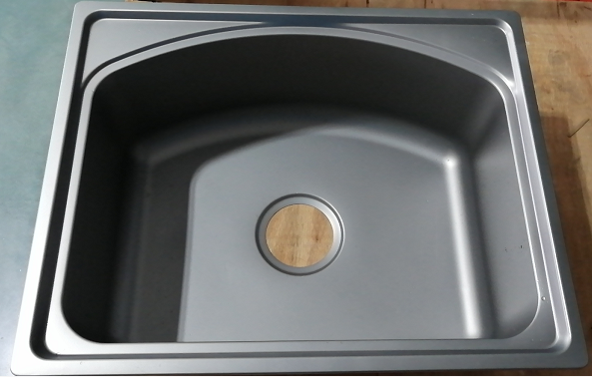 | Qualified
Oleophobic test | 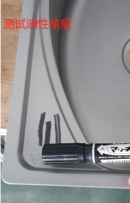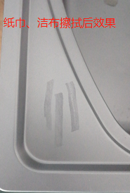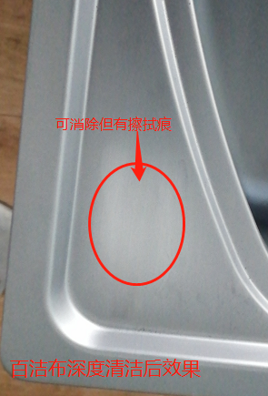 | Qualified

FOSHAN SHUNDE HIGOLD HARDWARE PRODUCT MANUFACTURING CO., LTD.
TEST REPORT
Report Number: HGCJ190804001 Page 5 of 9
Annex Photos:
Test Item | Test Process Photo | Result
Easy cleaning test | 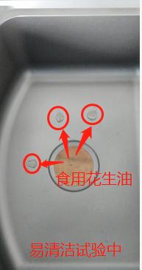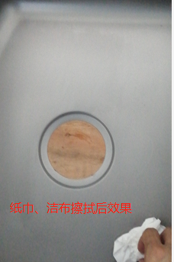 | Qualified
Acid salt spray test | 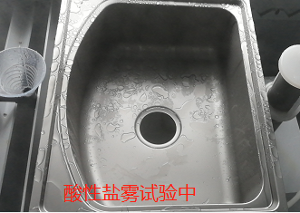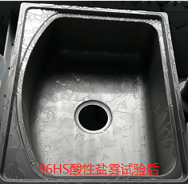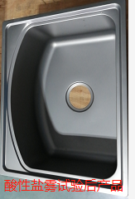 | Qualified
Corrosion resistance test | 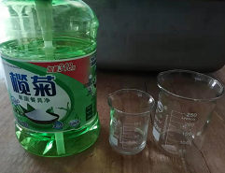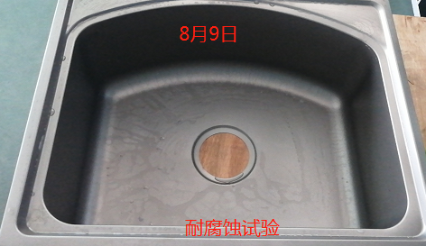 | Qualified

FOSHAN SHUNDE HIGOLD HARDWARE PRODUCT MANUFACTURING CO., LTD.
TEST REPORT
Report Number: HGCJ190804001 Page 6 of 9
Annex Photos:
Test Item | Test Process Photo | Result
Corrosion resistance test | 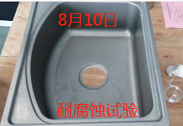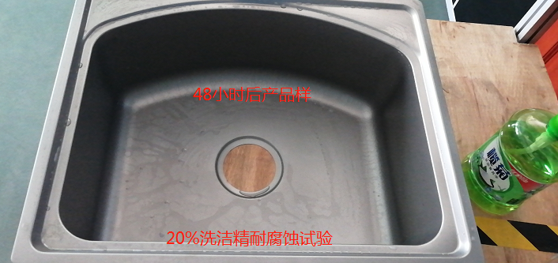 | Qualified
Corrosion resistance test | 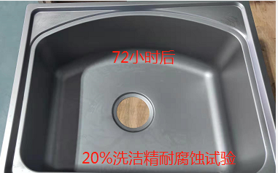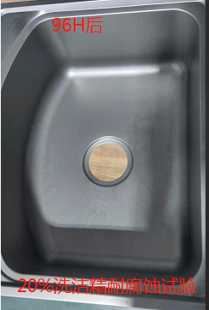 | Qualified
Hundred grid test | 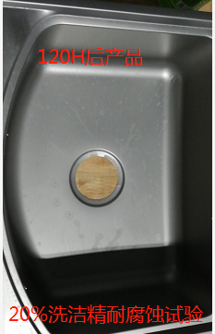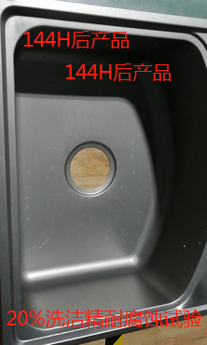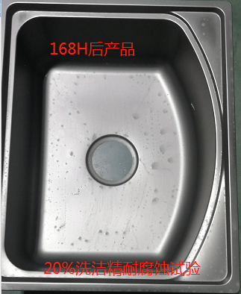 | Qualified

FOSHAN SHUNDE HIGOLD HARDWARE PRODUCT MANUFACTURING CO., LTD.
TEST REPORT
Report Number: HGCJ190804001 Page 7 of 9
Annex Photos:
Test Item | Test Process Photo | Result
Pencil hardness test | 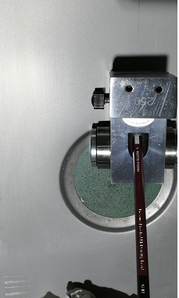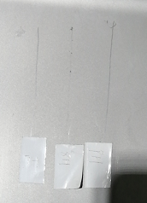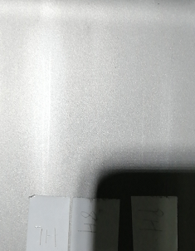 | Qualified
Abrasion resistance test | 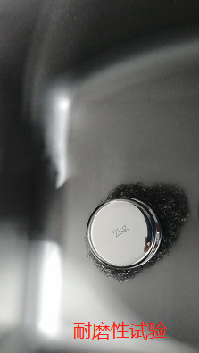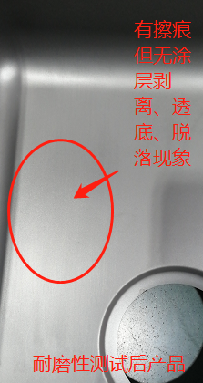 | Qualified
Temperature resistance test | 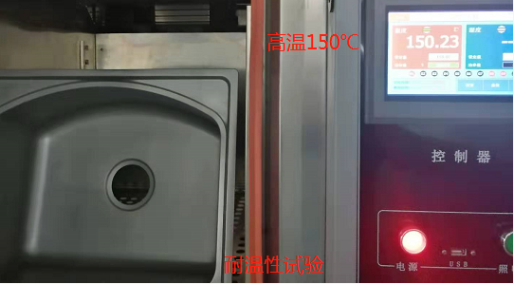 | Qualified

FOSHAN SHUNDE HIGOLD HARDWARE PRODUCT MANUFACTURING CO., LTD.
TEST REPORT
Report Number: HGCJ190804001 Page 8 of 9
Annex Photos:
Test Item | Test Process Photo | Result
Temperature resistance test | 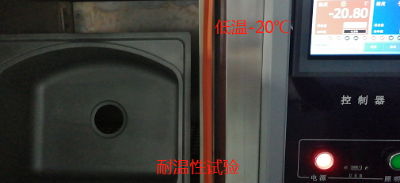 | Qualified
Thermal shock test | 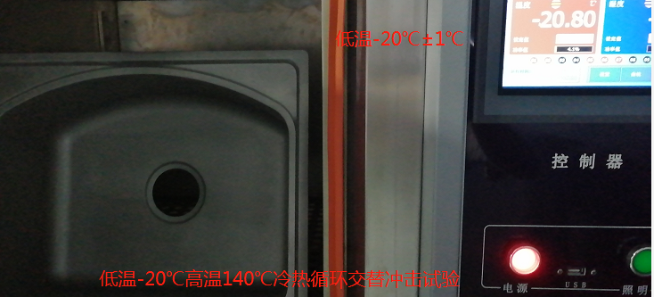 | Qualified
Resistance to weather fastness test | 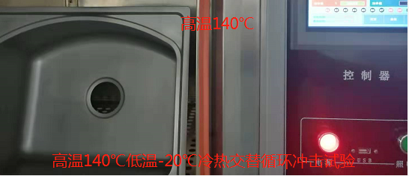 | Qualified

FOSHAN SHUNDE HIGOLD HARDWARE PRODUCT MANUFACTURING CO., LTD.
TEST REPORT
Report Number: HGCJ190804001 Page 9 of 9
Annex Photos:
Test Item | Test Process Photo | Result
Resistance to weather fastness test | 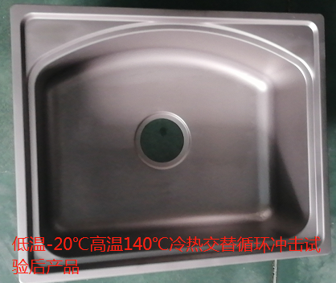 | Qualified

