I.
Service Performed: | SA |  | 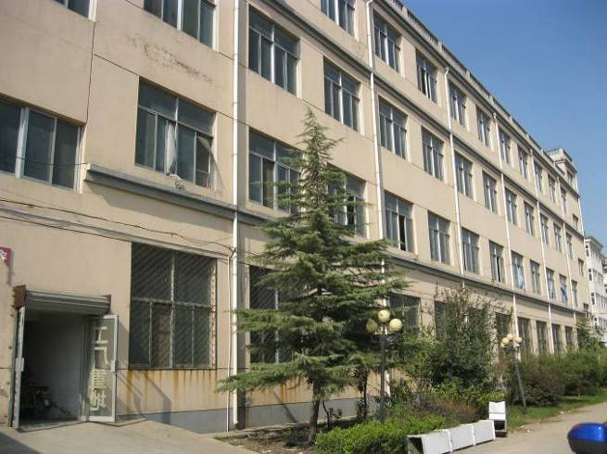
Supplier: | Xuzhou Golden Eagle Silk Home Textile Factory
Factory: | Xuzhou Golden Eagle Silk Home Textile Factory
Factory Person: | Asa Zhao
Factory tel.: | 0516-82660184
Audit Location: | Xuzhou City, Jiangsu Province
Auditor: | Frank Fang
Audit Date: | 2014-1-23

II. SUMMARY
Field |  | Max. Score |  | Actual Score |  | Weight (%) | Weighted Score
A | Factory Profile | 15 |  | 12 |  | 5 | 60
B | Child Labor & Young Labor | 7 |  | 6 |  | 10 | 60
C | Forced & Compulsory Labor | 9 |  | 7 |  | 5 | 35
D | Health & Safety | 29 |  | 18 |  | 25 | 450
E | Freedom of Association & Right to Collective Bargaining | 10 |  | 8 |  | 5 | 40
F | Discrimination | 10 |  | 9 |  | 5 | 45
G | Disciplinary Practices | 10 |  | 10 |  | 5 | 50
H | Working Hours | 10 |  | 4 |  | 15 | 60
I | Remuneration | 13 |  | 8 |  | 15 | 120
J | Environmental | 3 |  | 1 |  | 5 | 5
K | C-TPAT | 10 |  | 6 |  | 5 | 30
Total: |  | 126 |  | 89 |  | 100 | 955
Final Score: (Total Weight score/∑ (Max score x Weight) |  |  |  |  | 75/100

Time of Starting from home: | 7:00 | Time of Arrival at Factory: | 11:00
Lunch Time: | 12:00-12:30 | Time of Leaving factory: | 17:30

III. SPECIAL ATTENTION
Strength:
Mr. Ren shenglong, the owner of the factory, who had been engaged in silk home textile for more than 10years.
The factory had 120sets sewing machines including 20sets computerized sewing machines. Mr. Ren claimed that they are purchasing another 20sets computerized sewing machines to replace the original machines and It will make the sewing more precisely and effectively.
Most of the workers had 3years experience in this field and the interviewed workers enjoyed working in this factory.
The factory showed great interest on establishing relationship with client and willing to take the corrective action to improve their defected areas.
Weakness:
No ID copies and personnel records were kept by the factory.
No written valid laws and regulations on forced labor.
No employment contracts were signed.
No written policy about health, safety, environment and working conditions.
No safe certificate of building from local government.
No security personnel were trained.
No injury or illness record and no corrective actions taken to prevent recurrence of work related accidents.
No fire inspection certificate by local fire service authority.
No fire drills were conducted.
No metal gloves for cutting workers.
No fist aid kit.
No workers were trained for first aid.
No written valid laws and regulations on trade union and freedom of association.
No written hiring policy without any discrimination.
No written policy about working hours and no attendance record.
No written policy about wages and compensations.
No social insurance for the workers.
No waste management plan and waste handling record.
No written policy /procedure on C-TPAT.
No written procedures for visitor access to the facility.
No security awareness training was conducted.

PRE

IV.
75/100
Approved by: | Andrew Chiang, Operation Manager

Auditor & Report Reviewer:
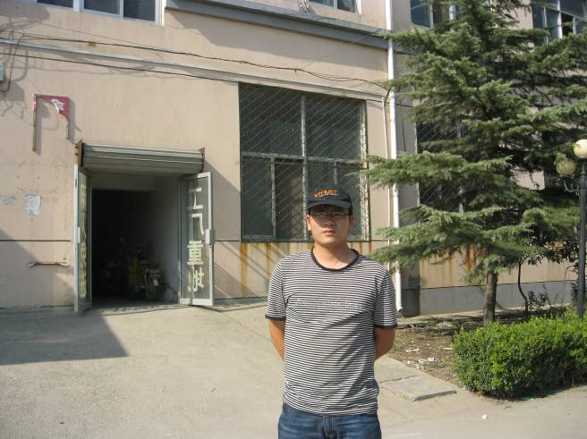
Auditor(s): Frank Fang |  |  | Report Reviewer:

Note: The auditors verified the processes in the company for conformity with the PRC Legal Laws and/or SA8000:2008 and the customer criteria. This verification was performed on a sampling basis; by interview the workers, review of the corresponding documentation, and observation of the individual processes. Due to the sampling nature of the auditing exercise, absence of findings during an assessment does not assure the full compliance of the facility nor does it guarantee that violations may not appear in the future. V-Trust do not accept responsibility for conditions at other locations that may be used in the supply chain of the relevant product or service since this report covers the production site listed under “audited company’’ only.

V. Corrective Action Plan (CAP)
This Corrective Action Plan summarizes the critical violations. These findings are valid for the site / date’s covered by the audit and is subject to the limited number of interviews and documentary checks imposed by time constraints, as well as the accuracy of data and information provided by the factory. This Corrective Action Plan is the basis for the audit closing meeting with the factory management.

The principal who ordered this audit may reconsider certain reported conclusions and corrective actions and pursue their implementation directly with the factory, as appropriate. The principal can return the Corrective Action Plan with his confirmation / comments as appropriate. Reliable and sustainable implementations of corrective actions are crucial for the continual improvements.

If an uncontrollable delay occurs in the implementation of the CAP, such delays must be immediately reported to client. Failure to report delays in a timely manner will be considered a failure to implement the CAP. The purpose of this CAP is to formally communicate to factory management the violations found during the factory audit conducted at this factory on the above date, and the necessary corrective actions that must be taken in order to comply with client’s expectations.

Corrective Action Details
Section | Non-Confirmation Description | Corrective And Preventive Action | Finished Date/Comment
B.4 | No ID copies and personnel records was kept by the factory | The factory will make the personnel record and ID copies for the workers in written form | In one week
C.1 | No written valid laws and regulations on forced labor | The factory will learn from related laws and make the written regulations on forced labor | In one week
C.2 | No employment contracts was singed | The factory will sing the employment contracts with each worker legally and make double copies of the contract | In one week
D.1 | No written policy about health, safety, environment and working conditions | The factory will make the written policy and | In one week
D.5 | No safe certificate of building from local government | The factory will apply for the certificate of building from local government | In one month
D.10 | No security personnel was trained | The factory will arrange some workers to have the security training | In one month
D.11/12 | No injury or illness record and no corrective actions taken to prevent recurrence of work related accidents | The factory will take measures to record any injury or illness and take corrective actions to prevent recurrence of work related accidents | From now on
D.13 | No fire inspection certificate by local fire service authority | The factory will apply for the fire certificate from local fire authority | In one month
D.14 | No fire drills was conducted | The factory will conduct the fire drill for all workers and keep the record | In one month
D.19 | No metal gloves for cutting workers | The factory will buy the metal gloves for the cutting worker | In one week
D.31 | No fist aid kit | The factory will prepare the first aid kit | In one week
D.32 | No workers were trained for first aid | The factory will arrange some workers go to the local hospital for first aid training and get the certificate | In one month
E.1.3 | No written valid laws and regulations on trade union and freedom of association | The factory will make the written policy about trade union and freedom of association and let the workers understand that | In one week
F.1 | No written hiring policy without any discriminations | The factory will make the equal hiring policy and promotion policy and publish for all the workers | In one week
H | No written policy about working hours and no attendance record | The factory will make the working hours policy legally and start to use time recording machine to record the working hours for each worker | In one week
I.1.2 | No written policy about wages and compensations | The factory will make the written policy about wages and compensations and communicate to workers | In one week
J.6.7 | No waste management plan and waste handling record | The factory will make the waste management plan and keep the waste handling record from now on | In one week
K.1 | No written policy /procedure on C-TPAT | The factory will make the C-TAPT policy | In one week
K.2 | No written procedures for visitor access to the facility | The factory will make the written procedures and post at the factory gate | In one week
K.8 | No security awareness training was conducted | The factory will conduct the security awareness training and keep the record | In one month

\

Please find our audit details from next page (Part A – K).

Part A Factory Profile

Factory general information
1 | Date of foundation |  |  | 2007-11-13
2 | Legal Status |  |  | Private
3 | General Manager /Factory Manager |  |  | Ren shenglong
4 | Management Representative |  |  | /
5 | Workers' Representatives |  |  | /
6 | Business License |  |  | Certificate No.: |  |  |  |  |  |  | 320303000007153
 |  |  |  | Legal Representative: |  |  |  |  |  |  | Ren shenglong
 |  |  |  | Date issued: |  |  |  |  |  |  | 2007-11-13
 |  |  |  | Expiration: |  |  |  |  |  |  | Annual issued
 |  |  |  | Register Capital: |  |  |  |  |  |  | RMB500000
7 | Tax Registration Certificate |  |  | Date issued: |  |  |  |  |  |  | 2007-11-15
 |  |  |  | Certificate No.: |  |  |  |  |  |  | 320300668979650
8 | Export License |  |  | Register No.: |  |  |  |  | 00389026
 |  |  |  | Expiration: |  |  |  |  | Annual issued
9 | Company code |  |  | Code: |  |  |  |  | 668979650
 |  |  |  | Date issued: |  |  |  |  | 2011-7-12
 |  |  |  | Expiration: |  |  |  |  | 2015-07-11
10 | Annual turnover for the past year |  |  | 2010 |  |  |  |  | RMB10000000
11 | Factory contact information |  |  | Location: |  |  | Jinshanqiao Development Zone, Xuzhou Cit,Jiangsu Province, China
 |  |  |  | Tel.: |  |  | 0516-82660184 |  |  |  |  | Fax: |  | 0516-82388838
 |  |  |  | E-mail: |  |  | silktextile@hotmail.com |  |  |  |  | Homepage: |  | www.estosie.com
 |  |  |  | MSN: |  |  | silktextile@hotmail.com |  |  |  |  | SKYPE: |  | asa.zhao

Main products/Major customer recommendations / Reference
Main products |  | Market location | Major customer |  | Yearly order quantity (%) |  |  | Business history (year) |  | Contact info.
Pillowcase |  | America | Next Product |  | 10 |  |  | 3 |  | /
Silk nightgown |  | Germany | Royalbeach |  | 10 |  |  | 4 |  | /
Bedding sets, pajamas, silk bedding, silk quilt, silk sheet, garments |  | Europe | / |  | 80% |  |  | 3 |  | /

Main product production process
Cloth cutting

Sewing

Trimming and ironing
Packing

Factory organization chart
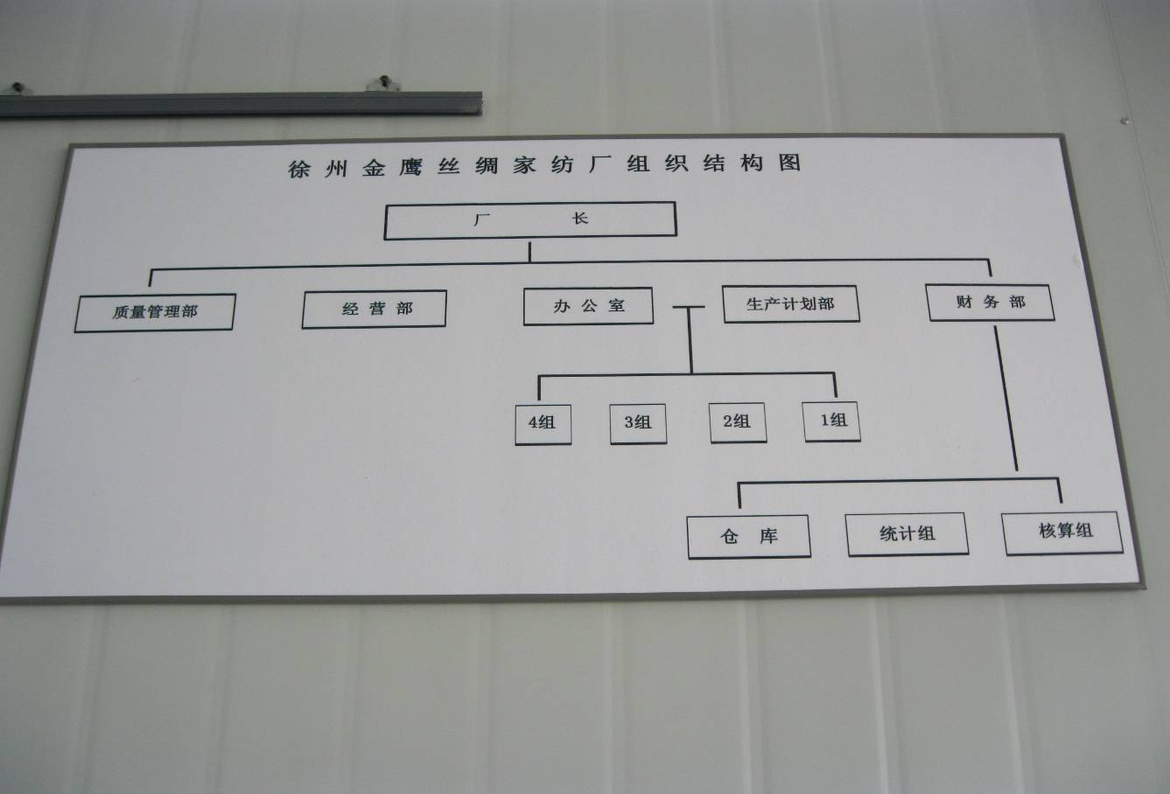

Human resource
Department |  |  |  |  |  |  | No. of Employees (males) |  |  |  |  |  | No. of Employees (females)
Administration Management |  |  |  |  |  |  | 2 |  |  |  |  |  | 0
Merchandising / Sales |  |  |  |  |  |  | 0 |  |  |  |  |  | 6
Finance / Accounting |  |  |  |  |  |  | 0 |  |  |  |  |  | 2
Production |  |  |  |  |  |  | 5 |  |  |  |  |  | 60
Engineering / Maintenance |  |  |  |  |  |  | 2 |  |  |  |  |  | 0
Quality Assurance |  |  |  |  |  |  | 0 |  |  |  |  |  | 6
Others |  |  |  |  |  |  | 0 |  |  |  |  |  | 0
Total: |  |  |  |  |  |  | 83

Factory building chart

(Photo)
Does the Business License/certificate well prepared? |  |  |  | 3 Business License, Tax Registration Certificate & Company code are well prepared and in effective
 |  |  |  | 0 No license/certificate provided or license/certificates are expired.
Does the Organizational Chart have defined roles and responsibilities? |  |  |  | 1 Clear function and responsibilities in the organizational chart
 |  |  |  | 0 No organizational chart or organizational chart is simply, or key function is not included in the organizational chart.
Does the factory provide this audit needed information completely? |  |  |  | 3 Satisfactory
 |  |  |  | 1 Not completely
 |  |  |  | 0 Poor
Did the facility allow employee interviews to be conducted? |  |  |  | 1 Yes  0 No  N/A
Did the facility allow the health and safety walkthrough to occur? |  |  |  | 1 Yes  0 No  N/A
Did the facility allow access to requested documents? |  |  |  | 1 Yes  0 No  N/A
Does the facility employ home workers? |  |  |  | 0 Yes  1 No  N/A
Does the facility require subcontractors to complete production orders? |  |  |  | 0 Yes  1 No  N/A
Does the factory well cooperated & supported with this audit? |  |  |  | 3 Yes, well cooperated & supported
 |  |  |  | 1 Average
 |  |  |  | 0 Poor
Score= |  |  |  |  |  | 12/15
Related Photos:
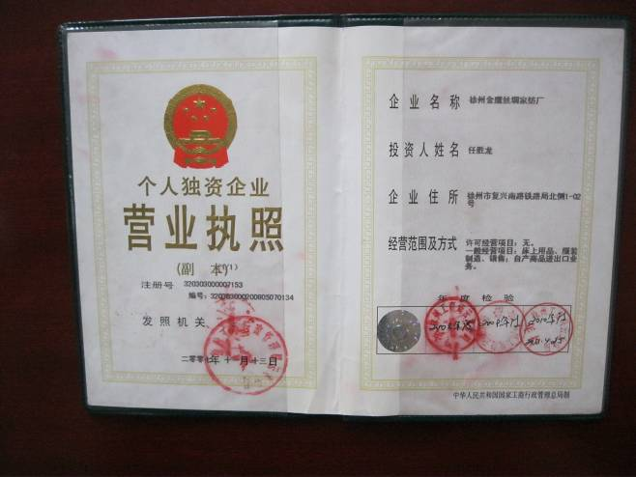 |  |  |  |  |  | 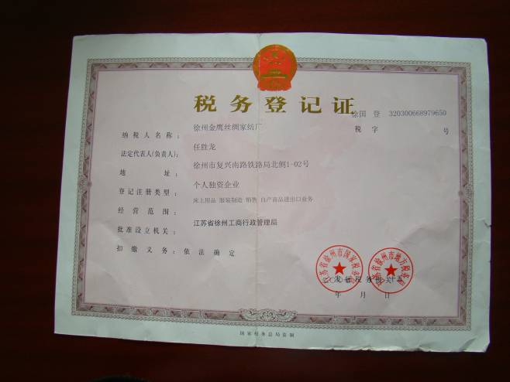
Business license |  |  |  |  |  | Tax register
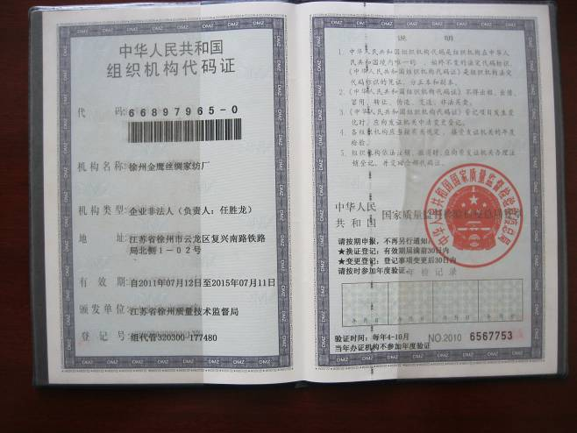 |  |  |  |  |  | 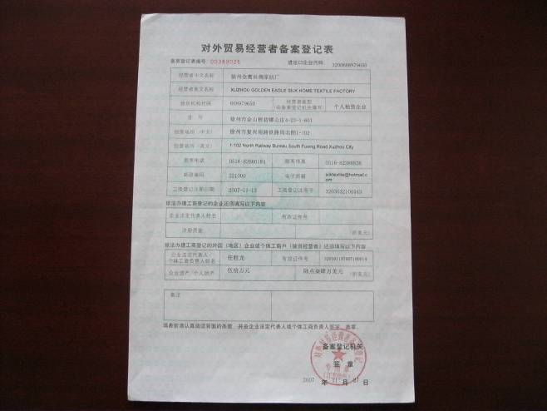
Company code |  |  |  |  |  | Export license
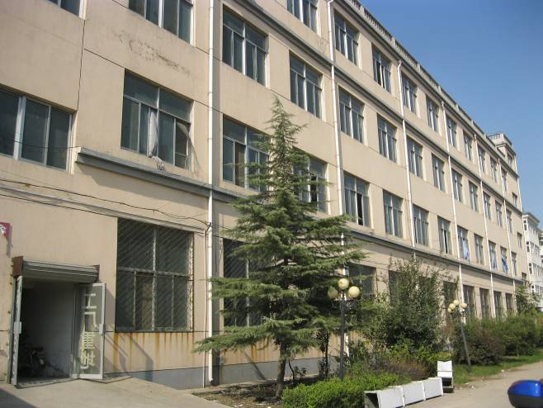 |  |  |  |  |  | 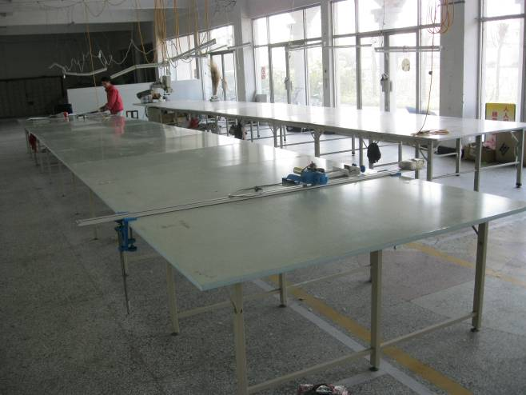
Factory exterior view |  |  |  |  |  | Cutting workshop
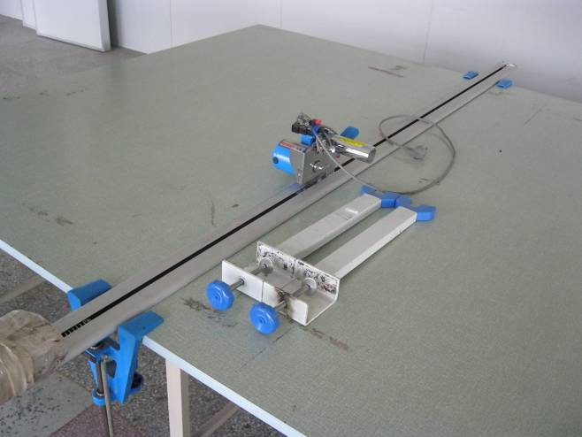 |  |  |  |  |  | 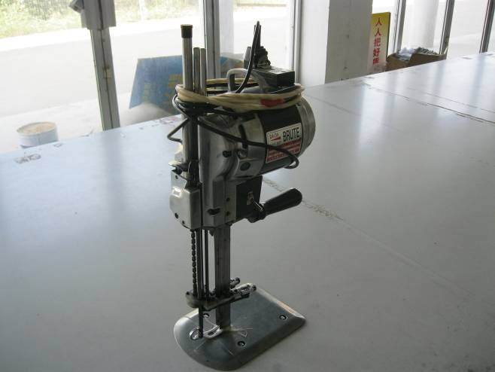
Cutter |  |  |  |  |  | Cutter
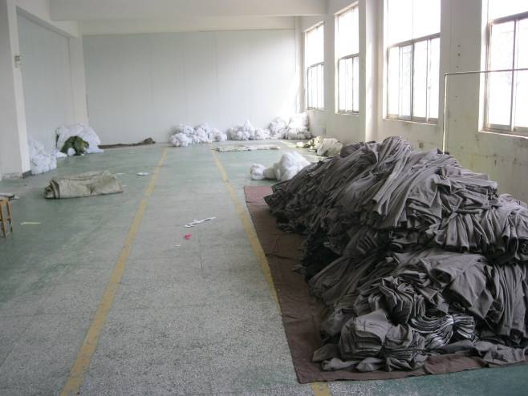 |  |  |  |  |  | 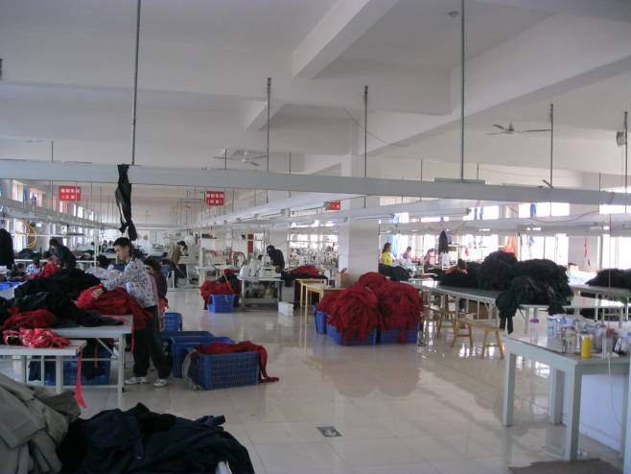
Warehouse |  |  |  |  |  | Sewing workshop
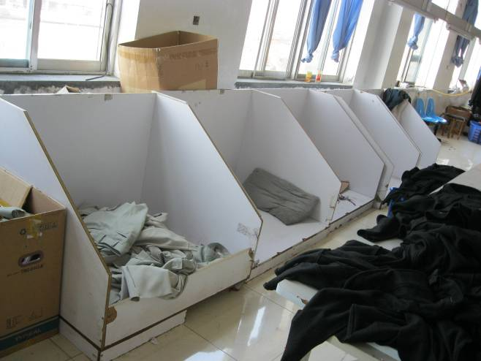 |  |  |  |  |  | 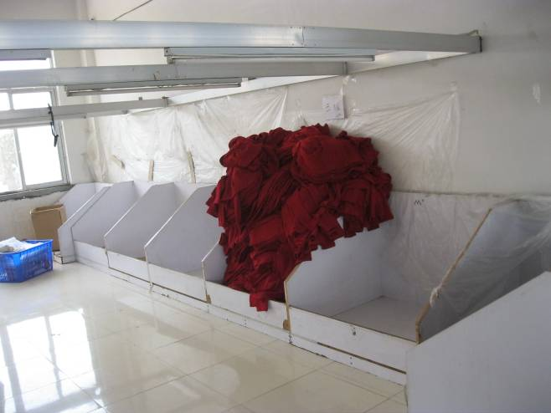
Finished product separating area |  |  |  |  |  | Finished product separating area
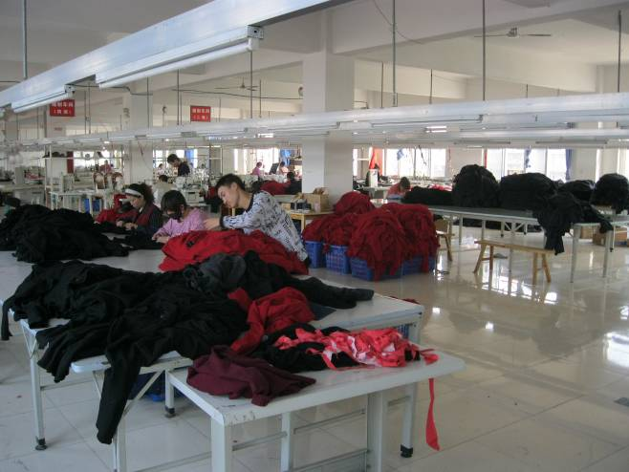 |  |  |  |  |  | 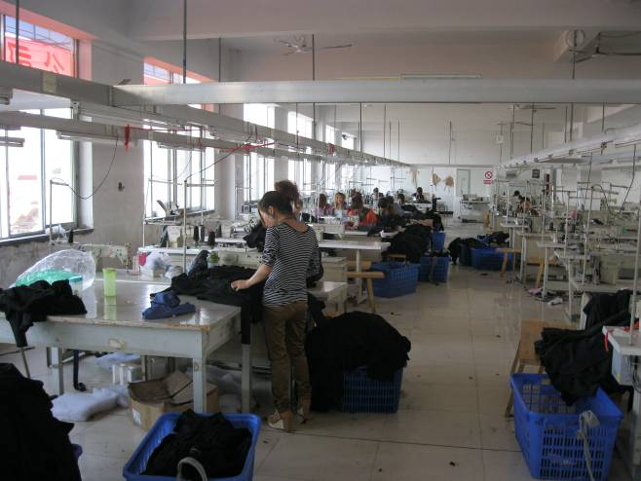
Final trimming and inspection |  |  |  |  |  | Sewing line view
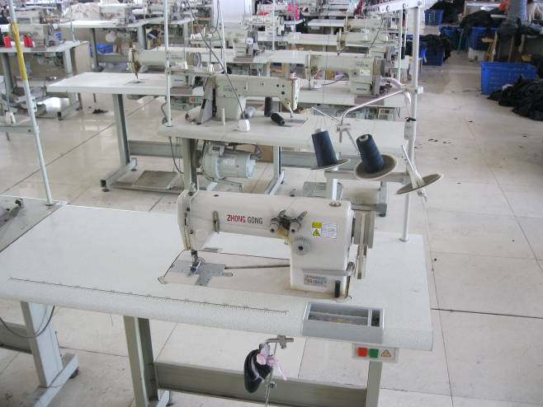 |  |  |  |  |  | 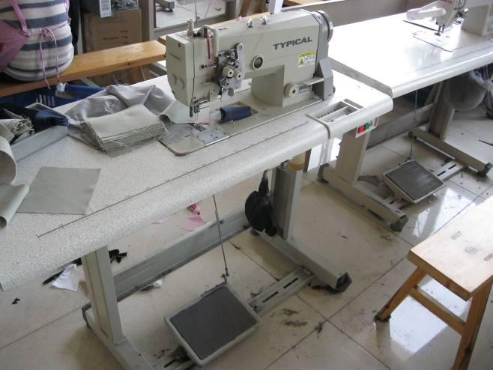
General sewing machine |  |  |  |  |  | Double stitching machine
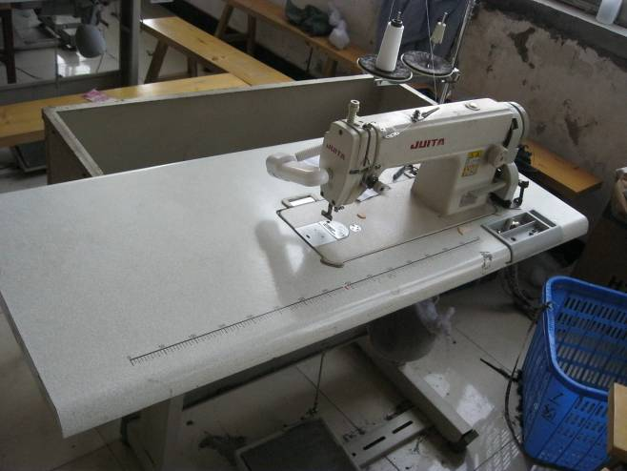 |  |  |  |  |  | 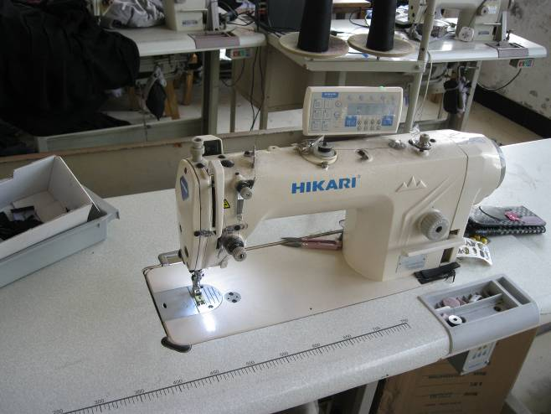
High sewing machine |  |  |  |  |  | Computerized sewing machine
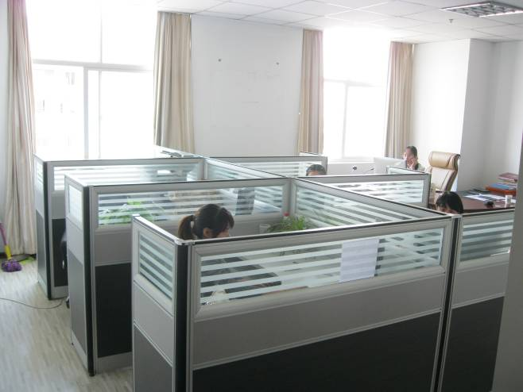 |  |  |  |  |  | 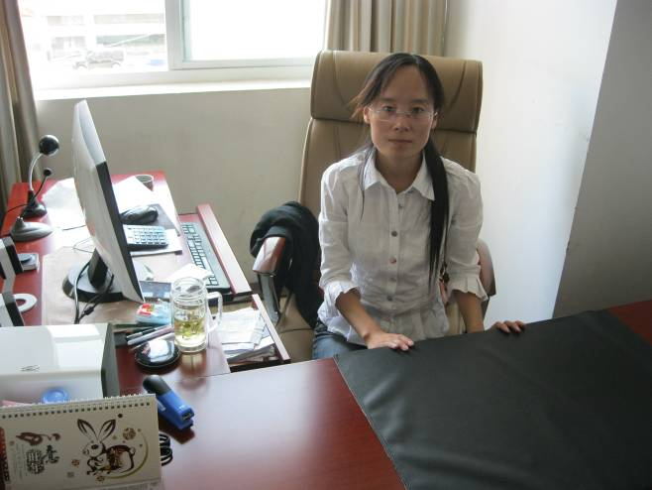
Sale department |  |  |  |  |  | Asa Zhao (sales manager )
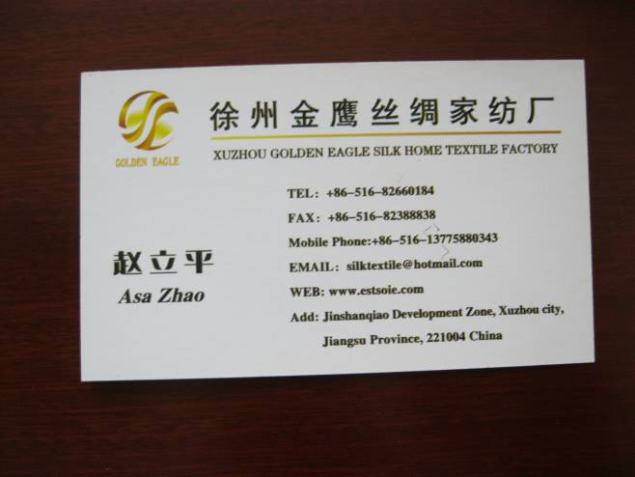 |  |  |  |  |  | Nil
Asa Zhao (sales manager ) |  |  |  |  |  | Nil

Part B Child Labor/Young Labor

Child labor/Young Labor
Child labor: according to Rules Prohibiting the Use of Child Labor ^{[1]} article 2, Child labor means minors under 16 year of age who have formed an employment relationship with work units or individuals to provide services for economic gain or who are engaged in individual labor activities. Minors under 16 years of age who work for their family or youth work-study programs organized by schools, or who do ancillary work which is not harmful to their health, within their ability and permitted by the people’s government of that province, autonomous region or municipality are not subject to the child labor restrictions.
Young labor: according to PRC Labor Law ^{[2]} article 58, “Juvenile workers” hereby refer labourers at the age of 16 but not 18 yet.

Involved laws/International standard
SA8000:2008, Article 1 CHILD LABOUR
PRC Labor Law ^{[2]} article 15;
Rules Prohibiting the Use of Child Labor ^{[1]} article 7, 10, 11, 64, 65;
Regulations for the Special Protection of Juvenile Employees (Document No. 498) ^{[3]} article 3, 6, 7, 8, and 9.

Reference records
Items |  | Legal/Standard | Factory |  | Acceptable |  | Finding/comment
Child labor age |  | Under 16 years old | 20 |  | Yes  No  N/A |  | Acceptable
Young labor age |  | 16~18 years old | 20 |  | Yes  No  N/A |  | No young labor
Minimum age in factory |  | - | - |  | -

Check list
 | Check list |  |  | Acceptable |  | Finding/comment
B.1 | Does the management know the laws concerning child labor OR understand its requirements? |  |  | 1 Yes  0 No  N/A |  | Acceptable
B.2 | Does the factory have effective procedures to verify the age of worker at the time of recruitment? |  |  | 1 Yes  0 No  N/A |  | The ID was verified before employing
B.3 | Is there a written policy that explains the hiring practices for child labor? |  |  | 1 Yes  0 No  N/A |  | Child labor was forbidden in the factory
B.4 | Does the factory keep adequate age documents of workers such as ID copies and personnel records? |  |  | 1 Yes  0 No  N/A |  | No ID copies and personnel records
B.5 | In case of problems, does the factory management investigate further in order to find evidence of fraud? |  |  | 1 Yes  0 No  N/A |  | Acceptable
B.6 | Is there any evidence identified that child labor is now or has been employed in the past at the factory? |  |  | 0 Yes  1 No  N/A |  | No child labor was employed
B.7 | Does the management know the laws concerning young labor OR understand its requirements? |  |  | 1 Yes  0 No  N/A |  | Acceptable
B.8 | Is a separate register required by law for young workers? |  |  | 1 Yes  0 No  N/A |  | N/A
B.9 | Are young workers engaged in hazardous work? |  |  | 0 Yes  1 No  N/A |  | N/A
B.10 | Are young workers employed at night shift? |  |  | 0 Yes  1 No  N/A |  | N/A
Score= |  |  |  |  | 6/7

Part C Forced & Compulsory Labor

Forced & Compulsory labor
According to SA8000, all work or service that a person has not offered to do voluntarily and is made to do under the threat of punishment or retaliation, or is demanded as a means of repayment of debt.

Involved laws/International standard
SA8000:2008, Article 2 FORCED AND COMPULSORY LABOUR;
PRC Labor Law ^{[2]} article 18, 32;
Reply of the General Office of the Ministry of Labor Concerning Certain Questions Regarding the Termination of Employment Contracts by Employees (General Office of the Ministry of Labor Document No. 324 (1995)) ^{[4]};
Notice of the Ministry of Labor, the Ministry of Public Security and the All-China Federation of Labor Unions concerning Strengthening Labor Management in Foreign Investment Enterprises and Private Enterprises and the Effective Safeguarding of the Legal Rights and Interests of Workers – Ministry of Labor Document No. 118 (1994) ^{[5]} article 2 & 4.

Check list
 | Check list |  | Acceptable | Finding/comment
C.1 | Does the factory have a copy of valid laws and regulations on forced labor or understand its requirements? |  | 1 Yes  0 No  N/A | No written valid laws and regulations
C.2 | Are employment contracts unfair or illegal? |  | 0 Yes  1 No  N/A | No employment contracts was singed
C.3 | Are workers required to lodge deposits such as illegal withholding of salary, training fee, employment broker fee, fee for tools, fee for uniforms, or original documents such as ID papers? |  | 0 Yes  1 No  N/A | Acceptable
C.4 | Are employees permitted to leave employment after giving reasonable notice? |  | 1 Yes  0 No  N/A | Acceptable
C.5 | Are workers forced to work overtime? |  | 0 Yes  1 No  N/A | Acceptable
C.6 | Does the facility use any bonded labor? |  | 0 Yes  1 No  N/A | Acceptable
C.7 | Is worker’s permitted time-off with doctor’s certificate or note when sick or for maternity? |  | 1 Yes  0 No  N/A | Acceptable
C.8 | Is any physical method used to limit freedom of workers during working hours such as surveillance cameras or locked exit(s)? |  | 0 Yes  1 No  N/A | Acceptable
C.9 | Is there any evidence of the use of security staff and/or supervision to coerce workers? |  | 0 Yes  1 No  N/A | Acceptable
C.10 | Where dormitories are present, are workers required to live in the dormitories without freedom of choice to live outside the factory? |  | 0 Yes  1 No  N/A | N/A
Score= |  | 7/9

Part D Health & Safety

Health & Safety
According to PRC Labor Law ^{[2]} article 52, The employing unit must establish and perfect the system for occupational safety and health, strictly implement the rules and standards of the State on occupational safety and health, educate labourers on occupational safety and health, prevent accidents in the process of work, and reduce occupational hazards.

Involved laws/International standard
SA8000:2008, Article 3 HEALTH AND SAFETY;
PRC Labor Law;
PRC Fire Service Law;
Fire Safety of Building Design Regulation (GBJ16-87);
PRC Food Hygiene Law;
Design Regulations for Fire Extinguisher Installation (GBJ 140-90);
Rules Concerning Warehouse Safety and Fire Control;
Factory Safety and Sanitary Regulations;
Regulation Concerning Safety Handling of Chemical and Dangerous Goods;
Protective Equipment Management Regulation;
Sanitary Standards for Industrial Enterprise Design (TJ36-79);
Regulations for the Scope of Work Prohibited to Female Employees;
Protection of Female Employees Regulations;
Regulations for the Special Protection of Juvenile Employees (Document No. 498).

Check list
 | Check list |  | Acceptable | Finding/comment
D.1 | Does facility have written policy to adopt the local laws governing the health, safety, environmental, and working conditions in its facilities? |  | 1 Yes  0 No  N/A | No written policy about health, safety, environment and working conditions
D.2 | Is there a senior management representative for health, safety, welfare, and general facilities? |  | 1 Yes  0 No  N/A | The production manager was responsible for that
D.3 | Are all machinery, equipment, and facility maintained in safe working condition and adequately repaired following breakdown? |  | 1 Yes  0 No  N/A | Acceptable
D.4 | Does the factory have a suitable working environment in respect of ventilation, temperature, lighting, cleanliness, and tidiness? |  | 1 Yes  0 No  N/A | Acceptable
D.5 | Has the physical and structural integrity of all buildings been professionally inspected? This may be indicated by the factory having a "Certificate of Occupancy". |  | 1 Yes  0 No  N/A | No certificate from bureau in local
D.6 | If the facility had any citations or penalties from violations of working condition laws in the past 12 months? |  | 0 Yes  1 No  N/A | Acceptable
D.7 | Do all employees have access to potable water for drinking purposes? |  | 1 Yes  0 No  N/A | Acceptable
D.8 | Are adequate toilet facilities available, functional, and in clean condition? |  | 1 Yes  0 No  N/A | Acceptable
D.9 | Are hand-washing facilities available, functional, in clean condition, and located within the toilet facilities area? |  | 1 Yes  0 No  N/A | Acceptable
D.10 | Are security personnel adequately trained? |  | 1 Yes  0 No  N/A | No security personnel
D.11 | Does the factory keep injury / illness records such as daily injury and illness log, clinic records, injury statistics, illnesses report or any other safety statistics? |  | 1 Yes  0 No  N/A | No injury/illness records
D.12 | Are corrective actions taken to prevent recurrence of work related accidents? |  | 1 Yes  0 No  N/A | No corrective actions record
D.13 | Does the factory have valid fire inspection certificates issued by local fire service authority? |  | 1 Yes  0 No  N/A | No fire inspection certificate by local fire service authority
D.14 | Does the factory have adequate number of fire extinguishers at each factory floor? |  | 1 Yes  0 No  N/A | Acceptable
D.15 | Are all fire extinguishers inspected and tested regularly and ready to use at all times? |  | 1 Yes  0 No  N/A | Acceptable
D.16 | Is an effective fire extinguishing system i.e. fire hydrant/fire hose or sprinkler installed at each factory floor and maintained properly? |  | 1 Yes  0 No  N/A | Acceptable
D.17 | Is fire and hazard early warning system such as smoke detector installed and regularly tested? |  | 1 Yes  0 No  N/A | Smoke detector was installed
D.18 | Are documented fire drills conducted regularly at least twice a year? |  | 1 Yes  0 No  N/A | No fire drills was conducted
D.19 | Are fire exits and escape routes adequate at each factory floor? |  | 1 Yes  0 No  N/A | Acceptable
D.20 | Is any fire exit and escape route in workshop blocked or locked? |  | 0 Yes  1 No  N/A | Acceptable
D.21 | Are adequate emergency lights installed at each factory floor? |  | 1 Yes  0 No  N/A | Acceptable
D.22 | Did any fire accident take place in the past 12 months at the factory? |  | 0 Yes  1 No  N/A | Acceptable
D.23 | Does the factory have valid inspection certificates for boilers, elevators, pressure vessels and other equipment per local regulation? |  | 1 Yes  0 No  N/A | N/A
D.24 | Are all electricians, welding operators and forklift drivers trained and qualified per local regulations? |  | 0 Yes  1 No  N/A | Acceptable
D.25 | Are all the electrical wires installed in fully acceptable condition and adequately protected? |  | 1 Yes  0 No  N/A | Acceptable
D.26 | Are all electrical panels with circuit breakers covered? |  | 1 Yes  0 No  N/A | Acceptable
D.27 | Are dangerous/hazardous substances safely and securely stored? |  | 1 Yes  0 No  N/A | N/A
D.28 | Are Material Safety Data Sheets available? |  | 1 Yes  0 No  N/A | N/A
D.29 | Is appropriate personal protective equipment (PPE) such as goggles, glasses, gloves, earplug / muff, boots, or protective clothing provided at factory cost and in fully acceptable condition? |  | 1 Yes  0 No  N/A | No metal gloves for the cutting workers
D.30 | Does the factory arrange regular health examination for workers exposed to hazardous environment? |  | 1 Yes  0 No  N/A | N/A
D.31 | Are adequate first aid kits located at each factory floor and marked with signs? |  | 1 Yes  0 No  N/A | No first aid kits
D.32 | Are adequate workers trained on first aid? |  | 1 Yes  0 No  N/A | No workers were trained for first aid
D.33 | Are the factory kitchen and canteen clean and hygienic with adequate facilities? |  | 1 Yes  0 No  N/A | No kitchen in the factory
D.34 | Are kitchen and canteen subject to local government licensing? |  | 1 Yes  0 No  N/A
D.35 | Are adequate evidences identified (such as health examination) that workers working in kitchen are suitable to food service? |  | 1 Yes  0 No  N/A
D.36 | Is there any food safety program established to ensure all the food and stuffs purchased from reliable sources? |  | 1 Yes  0 No  N/A
D.37 | Is there adequate living space for each worker and meet the requirements of relevant local regulations? |  | 1 Yes  0 No  N/A | No dormitory in the factory
D.38 | Is there an adequate supply of sanitary drinking water available to workers at adequate distance at dormitory? |  | 1 Yes  0 No  N/A
D.39 | Are there adequate toilets with hand basins available to workers at adequate distance at dormitory? |  | 1 Yes  0 No  N/A
D.40 | Are there adequate bathrooms available to workers at dormitory? |  | 1 Yes  0 No  N/A
D.41 | Are the dormitories clean, safe and well lit? |  | 1 Yes  0 No  N/A
D.42 | Are adequate security measures provided to protect workers at dormitory? |  | 1 Yes  0 No  N/A
D.43 | Are dormitory exits unblocked and unlocked for emergency evacuation? |  | 1 Yes  0 No  N/A
D.44 | Are written dormitory rules posted? |  | 1 Yes  0 No  N/A
D.45 | Is any workers’ dormitory located in the building of production and/or warehouse? |  | 0 Yes  1 No  N/A
Score= |  | 18/29
Related Photos:
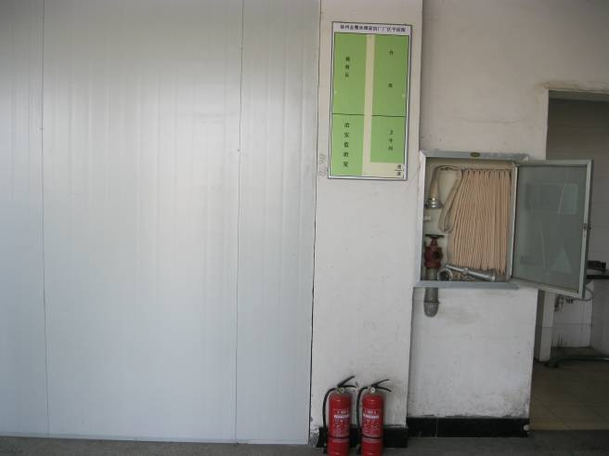 |  | 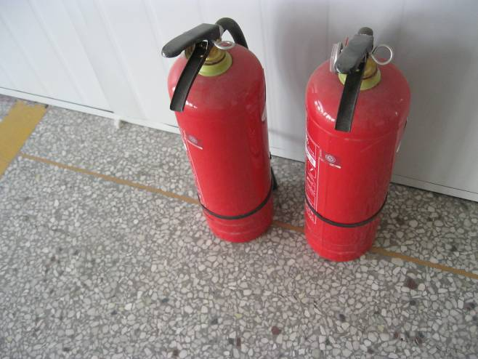
Fire hydrant and extinguisher |  | Extinguishers
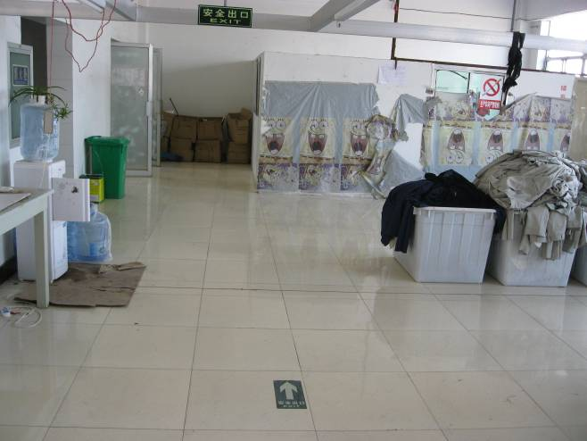 |  | 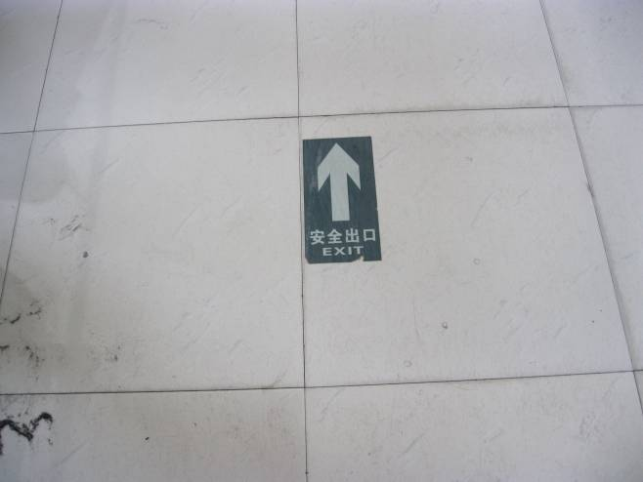
Exit logo |  | Exit logo on floor
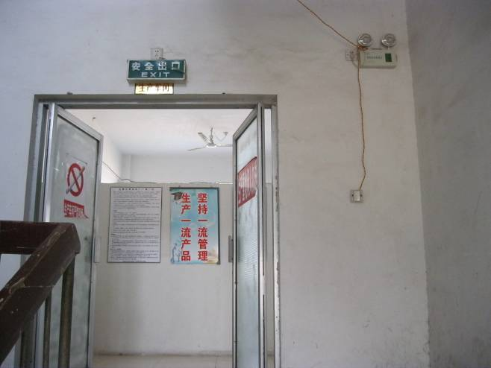 |  | 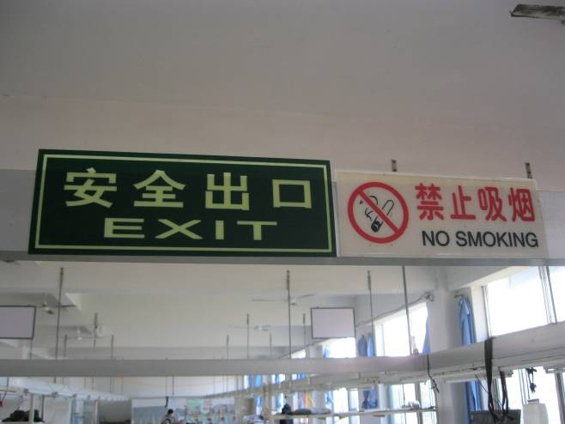
Exit logo and emergency light |  | Exit logo and No smoking label
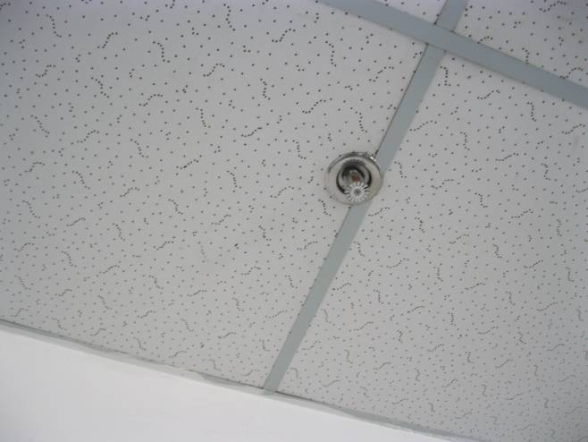 |  | 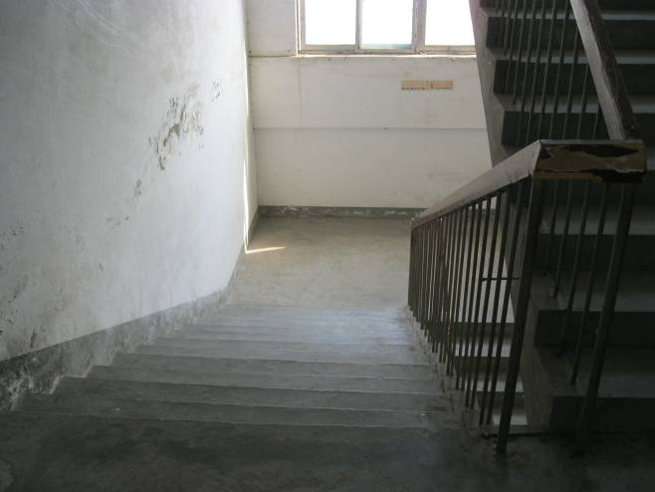
Smoke detector |  | Escape stairs
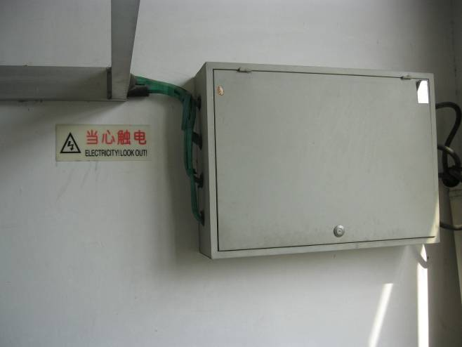 |  | 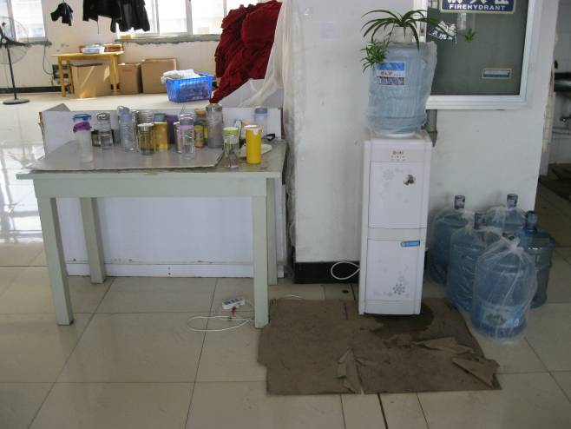
Electrical controlling case |  | Portable water
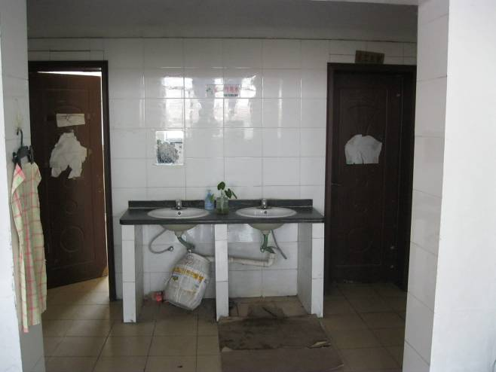 |  | 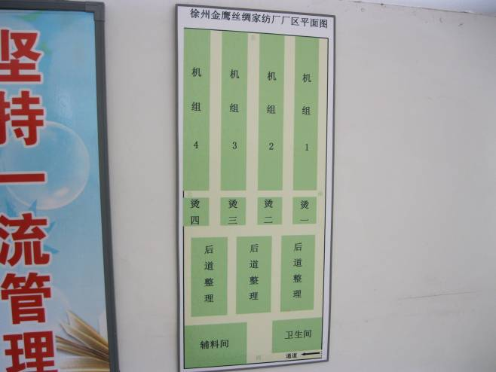
Toilets |  | Sewing workshop plan

Part E Freedom of Association & Right to Collective Bargaining

Freedom of Association & Right to Collective Bargaining
According to SA8000:2008, All personnel shall have the right to form, join, and organize trade unions of their choice and to bargain collectively on their behalf with the company. The company shall respect this right, and shall effectively inform personnel that they are free to join an organization of their choosing and that their doing so will not result in any negative consequences to them, or retaliation, from the company. The company shall not in any way interfere with the establishment, functioning, or administration of such workers’ organizations or collective bargaining.

Involved laws/International standard
SA8000:2008, Article 4 FREEDOM OF ASSOCIATION & RIGHT TO COLLECTIVE BARGAINING;
PRC Labor Law ^{[2]} article 7, 33;
PRC Labor Union Law ^{[16]} article 3;
Notice of the Ministry of Labor, the Ministry of Public Security and the All-China Federation of Labor Unions concerning Strengthening Labor Management in Foreign Investment Enterprises and Private Enterprises and the Effective Safeguarding of the Legal Rights and Interests of Workers – Ministry of Labor Document No. 118 (1994) ^{[5]} article 7.

Check list
 | Check list |  | Acceptable | Finding/comment
E.1 | Does the factory have a copy of valid laws and regulations on trade union and freedom of association or understand its requirements? |  | 1 Yes  0 No  N/A | No written valid laws and regulations
E.2 | Is workers’ right to form and join free trade unions and workers’ associations acknowledged by the management and workers? |  | 1 Yes  0 No  N/A | Acceptable
E.3 | Does the factory have a written policy and procedure to protect worker committee members, union supporters and/or Union representatives from retaliation? |  | 1 Yes  0 No  N/A | No written policy and procedure to protect worker committee members from realization.
E.4 | For non-unionized factory, are fair and effective mechanisms to ventilate and resolve grievances of workers in place? |  | 1 Yes  0 No  N/A | Acceptable
E.5 | Does the factory allow/permit workers to choose a representative from their own group to facilitate communication with senior manager? |  | 1 Yes  0 No  N/A | Acceptable
E.6 | Does the factory encourage workers to formally join and carry out activities like complaints & resolutions of workers’ grievances, health & safety related activities, worker management activities on productivity, etc.? |  | 1 Yes  0 No  N/A | Acceptable
E.7 | Has the factory experienced a strike, walkout, demonstration, or other significant conflict with employees within the last 12 months? |  | 1 Yes  0 No  N/A | No strike, walkout, demonstration, or other significant conflict with employees within the last 12 months
E.8 | Does the facility have a collective bargaining agreement? |  | 1 Yes  0 No  N/A | Acceptable
E.9 | Is there evidence of unequal treatment between employee representative(s) or management and other employees? |  | 0 Yes  1 No  N/A | Acceptable
E.10 | Do interviews with workers and representative(s) confirm the above findings? |  | 1 Yes  0 No  N/A | Acceptable
Score= |  | 8/10

Part F Discrimination

Discrimination
According to SA8000:2008, The company shall not engage in or support discrimination in hiring, remuneration, access to training, promotion, termination, or retirement based on race, national or social origin, caste, birth, religion, disability, gender, sexual orientation, family responsibilities, marital status, union membership, political opinions, age, or any other condition that could give rise to discrimination.

Involved laws/International standard
SA8000:2008, Article 5 DISCRIMINATION;
PRC Labor Law ^{[2]} article 3, 12, 13, 29(3);
PRC Protection of Women Right Law ^{[32]}, article 21, 23, 24;
Opinion of the Ministry of Labor on Several Questions concerning the Implementation of the PRC Labor Law ^{[17]} article 34;
PRC Labor Law ^{[2]} article 46.

Check list
 | Check list |  | Acceptable | Finding/comment
F.1 | Does the facility have a clear and uniform hiring policy, to ensure employees are hired based on skill rather than subjective requirements? |  | 1 Yes  0 No  N/A | No written hiring policy
F.2 | Is any evidence identified on discrimination in employment, promotion, compensation, welfare, dismissal and retirement, etc.? |  | 0 Yes  1 No  N/A | Acceptable
F.3 | Does the worker employment reflect local ethnic/religious breakdown no domination by one group? |  | 0 Yes  1 No  N/A | Acceptable
F.4 | Do the supervisors in the facility reflect the ethnic/religious breakdown of the worker population? |  | 0 Yes  1 No  N/A | Acceptable
F.5 | Do employment records show any evidence of discrimination patterns of dismissal? |  | 0 Yes  1 No  N/A | Acceptable
F.6 | Is equal salary for equal work for male and female workers implemented at the factory? |  | 1 Yes  0 No  N/A | Acceptable
F.7 | Is there any evidence of sexual harassment, especially of young female workers? |  | 0 Yes  1 No  N/A | Acceptable
F.8 | Does the facility maintain the job position, seniority, wage and benefits of women during their pregnancy and maternity leave, as required by local law? |  | 1 Yes  0 No  N/A | Acceptable
F.9 | Do all employees have equal opportunities to work overtime? |  | 1 Yes  0 No  N/A | Acceptable
F.10 | Is any evidence identified on discrimination through interview with workers, individual and collective? |  | 0 Yes  1 No  N/A | Acceptable
Score= |  | 9/10

Part G Disciplinary Practices

Disciplinary Practices
According to SA8000, The company shall treat all personnel with dignity and respect. The company shall not engage in or tolerate the use of corporal punishment, mental or physical coercion, or verbal abuse of personnel. No harsh or inhumane treatment is allowed.

Involved laws/International standard
SA8000:2008, Article 6 DISCIPLINARY PRACTICES;
Rewards and Punishment Regulations ^{[13]} article 11.

Check list
 | Check list |  | Acceptable | Finding/comment
G.1 | Does the facility have a written procedure regarding disciplinary practices which provides freedom from mental or physical abuse? |  | 1 Yes  0 No  N/A | The disciplinary practices only for the workers who break the factory’s regulations
G.2 | Is the disciplinary rules/procedure fair, reasonable and legal or validated by local government authority? |  | 1 Yes  0 No  N/A | Acceptable
G.3 | Are the disciplinary rules/procedure communicated to all workers? |  | 1 Yes  0 No  N/A | Acceptable
G.4 | Is there any evidence of the use of corporal punishment or physical coercion? |  | 0 Yes  1 No  N/A | Acceptable
G.5 | Is there any evidence of the use of excessive mental or verbal abuse or intimidation? |  | 0 Yes  1 No  N/A | Acceptable
G.6 | Is there any evidence of the use of security staff or other nominated staff (other than supervisors) used to discipline workers? |  | 0 Yes  1 No  N/A | Acceptable
G.7 | Are unreasonable disciplinary fines used? |  | 0 Yes  1 No  N/A | Acceptable
G.8 | Do workers have access to appeal in case of infractions / breaking of rules procedure? |  | 1 Yes  0 No  N/A | Acceptable
G.9 | Is the factory free of any citation, penalty from violation of laws and regulations in past 12 month? |  | 1 Yes  0 No  N/A | Acceptable
G.10 | Do interviews with workers confirm above findings? |  | 1 Yes  0 No  N/A | Acceptable
Score= |  | 10 /10
Related Photos:
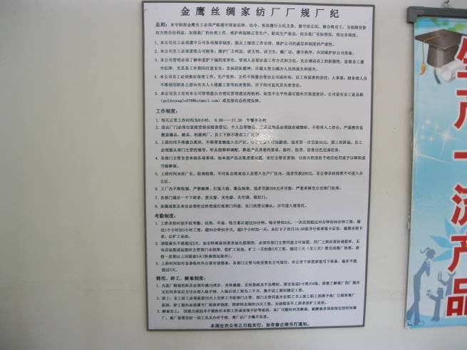 |  | Nil
Factory regulations |  | Nil

Part H Working Hours

Working Hours
According to SA8000, The company shall comply with applicable laws and industry standards on working hours and public holidays. The normal work week, not including overtime, shall be defined by law but shall not exceed 48 hours. Personnel shall be provided with at least one day off following every six consecutive days of working.
According to PRC Labor Law ^{[2]} article 36, The States shall practice a working hour system under which labourers shall work for no more than eight (8) hours a day and no more than 44 hours a week on the average.

Involved laws/International standard
SA8000:2008, Article 7 WORKING HOURS;
PRC Labor Law ^{[2]} article 38~43, 45, 62;
Notice on Issues concerning Employees’ Annual Leave ^{[21]} article 2;
Protection of Female Employees Regulations ^{[11]} article 8.

Reference records
Items |  | Legal/Standard | Factory | Acceptable |  |  | Finding/comment
Regular working hours per day |  | 8 hours | - | Yes  No  N/A |  |  | No time record machine in the factory and no attendance record were kept by the factory, so the working time couldn’t be verified. The interviewed workers reflected that they work 8hours per day and 1daf off per week.
Regular working hours per week |  | 40 hours | - | Yes  No  N/A
Overtime hours per day |  | Max. 3 hours a day | - | Yes  No  N/A
Overtime hours per week |  | Max. 12 hours | - | Yes  No  N/A
Overtime hours per month |  | Max. 36 hours | - | Yes  No  N/A
Holidays |  | 11 days | 11 | Yes  No  N/A

Check list
 | Check list |  |  |  | Acceptable | Finding/comment
H.1 | Does the factory have a written policy on working hours, overtime, rest and vacations in compliance with local law(s)? |  |  |  | 1 Yes  0 No  N/A | No written policy
H.2 | Does the factory communicate the policy on working hours, rest and vacations to all workers? |  |  |  | 1 Yes  0 No  N/A | No written policy
H.3 | Do the factory’s official scheduled/actual working hours per day meet local legal requirements? |  |  |  | 1 Yes  0 No  N/A | No time attendance record and the working time couldn’t be verified. The interviewed worked reflected that they work 8hours per day and overtime working was not usually.
H.4 | Do the factory’s official scheduled/actual working hours per week meet local legal requirements? |  |  |  | 1 Yes  0 No  N/A
H.5 | Do the factory’s official scheduled/actual working hours per month meet local legal requirements? |  |  |  | 1 Yes  0 No  N/A
H.6 | Do the workers have at least one day (24 consecutive hours) off in seven days? |  |  |  | 1 Yes  0 No  N/A | The interviewed worker reflected one day off in seven days.
H.7 | Does the factory have any valid written approval or permit on extra overtime hours from local labor authority? |  |  |  | 1 Yes  0 No  N/A | No extra overtime hours
H.8 | Are hours worked adequately documented (e.g., time cards)? |  |  |  | 1 Yes  0 No  N/A | No time card
H.9 | Do workers have time for meal or rest breaks? |  |  |  | 1 Yes  0 No  N/A | Yes, 1hour for meal or break
H.10 | Do workers work overtime voluntarily? |  |  |  | 1 Yes  0 No  N/A | Yes
Score= |  |  |  | 4/10

Part I Remuneration

emuneration
According to SA8000, The company shall respect the right of personnel to a living wage and ensure that wages paid for a normal work week shall always meet at least legal or industry minimum standards and shall be sufficient to meet the basic needs of personnel and to provide some discretionary income. The company shall ensure that deductions from wages are not made for disciplinary purposes.
According to PRC Labor Law [2] article 48, The State shall implement a system of guaranteed minimum wages. Specific standards on minimum wages shall be determined by the people’s governments of provinces, autonomous regions or municipalities directly under the Central Government and reported to the State Council for the record.
Wages paid to laborers by the employing unit shall not be lower than the local standards on minimum wages.

Involved laws/International standard
SA8000:2008, Article 8 REMUNERATION;
PRC Labor Law ^{[2]} article 44, 50, 72, 73;
Provisional Regulations for the Payment of Wages ^{[14]} article 6, 10, 12, 13, 18;
Regulations on the Minimum Wages (for Employees) of Enterprises (Ministry of Labor Document No 333 (1993)) ^{[22]} article 17;
Notice concerning Implementation of a Minimum Wage Assurance System (Ministry of Labor Document No 409 (1994)) ^{[23]} article 3;
Opinion of the Ministry of Labor on Several Questions concerning the Implementation of the Labor Law ^{[17]} article 56, 57, 58, 59;
Supplementary Regulations concerning Provisional Regulations for the Payment of Wages promulgated by the Ministry of Labor ^{[24]} article 4;

Reference records
Items |  | Legal/Standard | Factory | Acceptable |  |  | Finding/comment
Minimum wage |  | RMB930 | 1000 | Yes  No  N/A |  |  | The interviewed workers know the minimum wage by law and the minimum overtime rate. The average salary in this factory was about RMB1500.
Minimum Hourly Rate |  | RMB7.5 | RMB8 | Yes  No  N/A
Minimum Overtime Rate in normal working day |  | ≥150% | ≥150% | Yes  No  N/A
Minimum Overtime Rate in weekend |  | ≥200% | ≥200% | Yes  No  N/A
Minimum Overtime Rate in holiday |  | ≥300% | ≥300% | Yes  No  N/A
Wage calculating method |  | - | - | - |  |  | Cash
Payment date |  | - | - | - |  |  | 10-15 every month

Check list
 | Check list |  |  |  | Acceptable | Finding/comment
I.1 | Does facility have written policy on wages and compensation which is in compliance with the local laws? |  |  |  | 1 Yes  0 No  N/A | No written policy about wages and compensation
I.2 | Does the policy on wages, compensation and benefits were communicated to all workers and understood by them clearly? |  |  |  | 1 Yes  0 No  N/A | No written policy about wages and compensation
I.3 | Are employees made aware of these withholdings and other deductions prior to employment? |  |  |  | 1 Yes  0 No  N/A | Acceptable
I.4 | Do all workers’ wages meet local minimum wages?(including trainees / apprentices / workers in probation period) |  |  |  | 1 Yes  0 No  N/A | Acceptable
I.5 | Does the factory withhold workers’ wages for any reason other than usual government requirements? |  |  |  | 1 Yes  0 No  N/A | No withholding worker’s wages
I.6 | Are deductions for food and housing reasonable and legal? |  |  |  | 1 Yes  0 No  N/A | N/A
I.7 | Are all workers provided with social insurance per local legal requirements? |  |  |  | 1 Yes  0 No  N/A | No social insurance for the workers
I.8 | Are deductions for company provided items reasonable and legal? |  |  |  | 1 Yes  0 No  N/A | No deductions
I.9 | Are legally required benefits provided (bonus, paid vacation, meal allowances, etc.)? |  |  |  | 1 Yes  0 No  N/A | N/A
I.10 | Is extra work to fulfill production target demanded without payment? |  |  |  | 1 Yes  0 No  N/A | Acceptable
I.11 | Does the overtime work & rework payment compliance with the local laws? |  |  |  | 1 Yes  0 No  N/A | No attendance record and the overtime couldn’t be verified
I.12 | Do employees receive detailed paystubs? |  |  |  | 1 Yes  0 No  N/A | Acceptable
I.13 | Are the workers paid the legally required overtime rates and wages? |  |  |  | 1 Yes  0 No  N/A | No attendance record and the overtime couldn’t be verified
I.14 | Is all compensation paid to workers themselves in cash/check/direct to bank or any other method convenient to workers? |  |  |  | 1 Yes  0 No  N/A | Acceptable
I.15 | Are employees paid in a timely manner? |  |  |  | 1 Yes  0 No  N/A | Acceptable
Score= |  |  |  | 8/13
Related Photos:
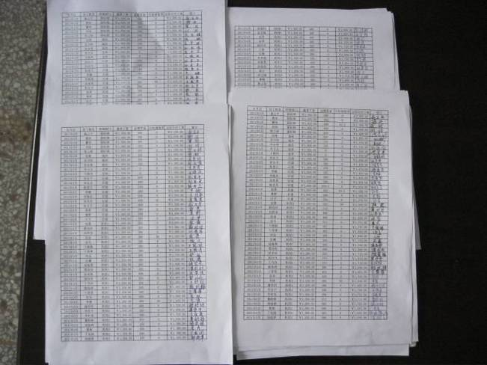 |  |  |  | 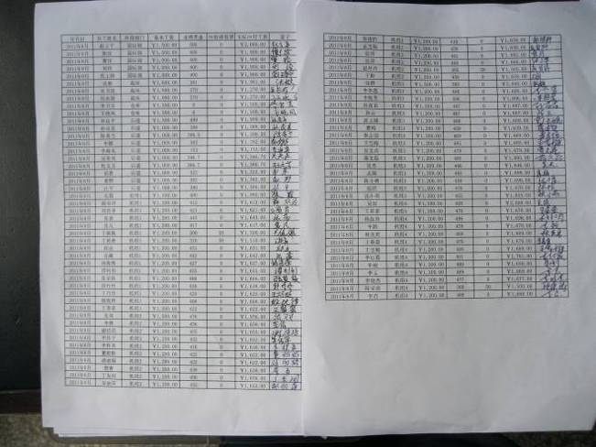
Salary paying rolls |  |  |  | Salary paying rolls
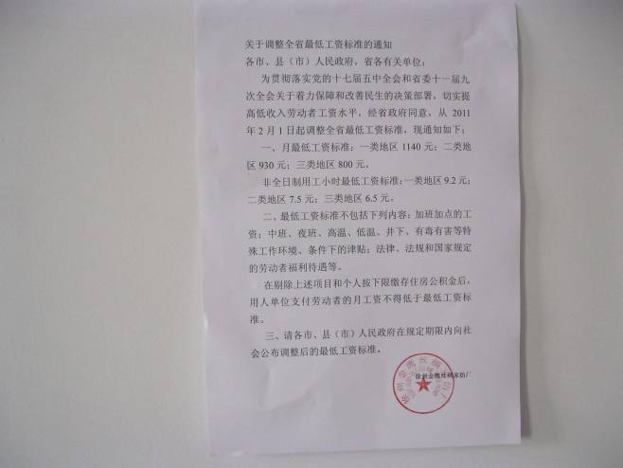 |  |  |  | Nil
Minimum wages policy from local government |  |  |  | Nil

Part J Environmental

Environmental
According to PRC law, waste materials and waste water shall be handled properly, and shall not endanger workers and nearby residents.

Involved laws/International standard
Air Pollution Prevention and Protection Law ^{[40]} article 11;
Water Pollution Prevention and Protection Law ^{[41]} article 14;
Factory Safety and Sanitary Regulations ^{[8]} article 58, 64.

Check list
 | Check list |  | Acceptable | Finding/comment
J.1 | Does the factory have all permits and licenses required by local laws or regulations? |  | 1 Yes  0 No  N/A | No permit or license required by the local laws of regulations for textile factory
J.2 | Does the factory generate wastewater? |  | 1 Yes  0 No  N/A | No wastewater
J.3 | Is hazardous waste managed properly? |  | 1 Yes  0 No  N/A | No hazardous waste
J.4 | Is the factory in compliance with local law or regulation regarding wastewater discharge? |  | 1 Yes  0 No  N/A | No wastewater
J.5 | Is all hazardous waste disposed of at an approved government site? |  | 1 Yes  0 No  N/A | No hazardous waste
J.6 | Does the factory have a Waste Management Plan? |  | 1 Yes  0 No  N/A | No waste management plan
J.7 | Does the factory keep records of waste handling and disposal? |  | 1 Yes  0 No  N/A | No waste handling record
J.8 | Are exhaust hoods effectively used on operations that emit chemical odor and/or fumes? |  | 1 Yes  0 No  N/A | N/A
J.9 | Does the facility conduct annual air sampling to ensure air emission levels meet the country requirement? |  | 1 Yes  0 No  N/A | N/A
J.10 | Have there been any notices of deficiencies issued by government agencies in the past year? |  | 0 Yes  1 No  N/A | N/A
Score= |  | 1/3
Related Photos:
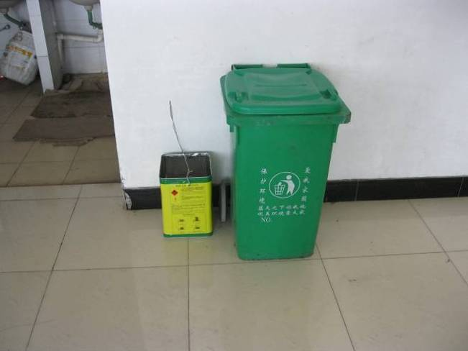 |  | Nil
Waste trash at each floor |  | Nil

HPT

Part K C-TPAT

Check list
 | Check list |  | Acceptable | Finding/comment
K.1 | Does facility aware and have written policy/procedure on C-TPAT? |  | 1 Yes  0 No  N/A | No written policy /procedure on C-TPAT
K.2 | Are building designed and constructed to prevent unlawful entry? |  | 1 Yes  0 No  N/A | Acceptable
K.3 | Are there procedures for visitor access to the facility? |  | 1 Yes  0 No  N/A | No written procedure
K.4 | Are all employees required to show identification when entering the facility? |  | 1 Yes  0 No  N/A | Acceptable
K.5 | Are visitors, truck, delivery van drivers required to present valid identification before entering the facility? |  | 1 Yes  0 No  N/A | Acceptable
K.6 | Does the facility have internal and external lighting in all required areas (e.g. cargo handling and storage areas, fence lines and parking areas)? |  | 1 Yes  0 No  N/A | Acceptable
K.7 | Is there a designated security officer to supervise the introduction and removal of cargo to and from the facility? |  | 1 Yes  0 No  N/A | Acceptable
K.8 | Does the company provide security awareness training to employees? |  | 1 Yes  0 No  N/A | No security awareness training was conducted
K.9 | Is there fencing or walls on all sides with a minimum height of 2m to prevent intrusion? |  | 1 Yes  0 No  N/A | Acceptable
K.10 | Does the company have documented procedure in place to protect information security (computer access, documents, and forms)? |  | 1 Yes  0 No  N/A | No documented procedure
Score= |  | 6/10
Related Photos:
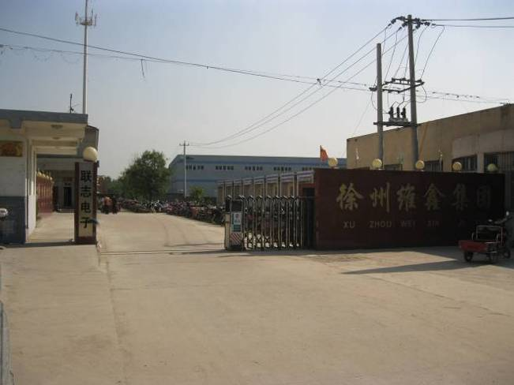 |  | 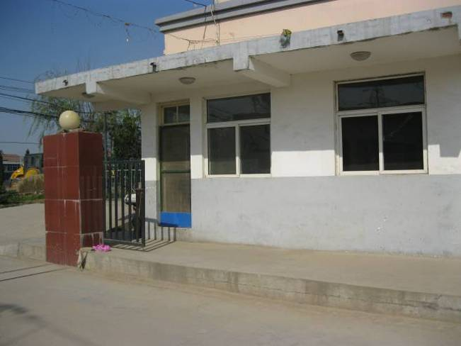
Gate |  | Guard room

Part L Worker Interview Summary

Worker Interview Summary
Number of Worker Interviews Conducted? |  | 6
Does Interviews done in private and the confidentiality of the interview process was communicated to the workers? |  | Yes
In general, the attitude of the workers towards their workplace was? |  | Favorable Non-favorable Indifferent N/A
Does each worker record (punch) his/her own timecard? |  | Yes No
What was the most common worker complaint? |  | No complaints
What did the workers like the most about working at this facility? |  | Yes
Any additional comment (s) regarding interviews: |  | No
Related Photos:
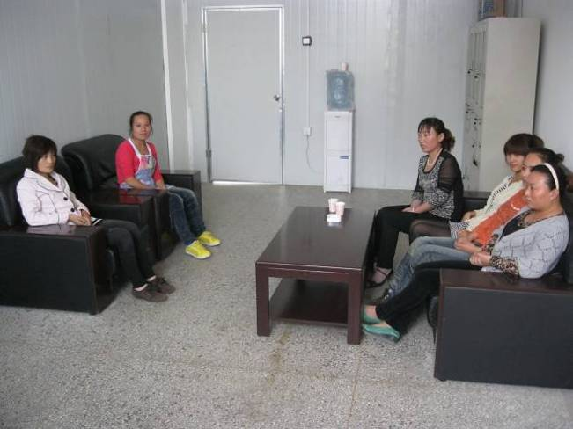 | Nil
The interviewed workers | Nil

************************************************** This is The End of the Report ***********************************************

The above reflects our findings for the particular factory in concern on the date of our service only. This report does not certify, confirm or imply: a) compliance with any government, industry or association regulations or standards, unless stated otherwise; or,) the quality of any specific products manufactured by the factory/sellers/suppliers; or, c) the shipment of any specific products. This report does not discharge or release the factory/sellers/suppliers from their commercial, legal or contractual obligations with buyers in respect of products manufactured by the factory/sellers/suppliers. Our services, including reports and certificates, are subject to the General Conditions of Service of V-Trust which have been sent to your company. They can be resent upon written request. This report cannot be partially copied.

