HUNAN KONTAK TECHNOLOGY CO., LTD
Add:No. 59, Second Section, Furong Middle Road, Furong, Changsha City, Hunan Province, China
Tel:+86 731 85860892
E-mail:kontak@kontak-cn.com Website:www.kontakledlight.com

Model: KTSL6303B (70-250W STREET LIGHTING)
PICTURE | DESCRIPTION
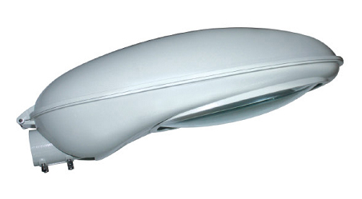  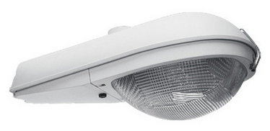  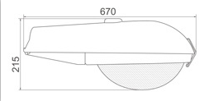  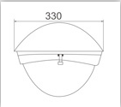  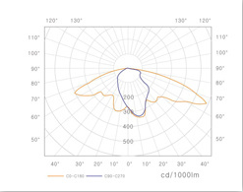 | Model: KTSL6303B
 | 70W---250W HPS/MH
 | Product size: 670x330x265MM
Packing size:
680x340x275MM
Die casting aluminum weight:
2.2KG
 | Net Weight: 5.3KG
 | Gross weight: 6.3KG
 | Lamp holder: E27/E40
Rated voltage and frequency:
230V±10/50-60HZ
 | Reflector thickness: 0.6MM
 | Glass thickness: 5MM
 | Installation diameter: 60MM
 | For height: 5M-9M
 | Corrosion silicone rubber seals
 | IP65
Loading quantity:
720PCS/20 feet container; 1500PCS/40HQ
 | 1. Body: Die-cast aluminum body with high strength,compact structure and smooth profile.
 | 2. Reflector: High purity anodized aluminum.
 | 3. Cover: High transparent tough Glass in 5mm thickness
 | 4. Stainless steel screws and clips. Steel gear plate.
 | 5. Top-lift cover, easy repair and maintenance. Easy access to lamp and gear.
 | 6. Vertical and horizontal installation
 | 7. Application places: applicable to the illumination of different levels of roads.
 | Remark: offering the bigger size (400W) also, pls kindly check the item KTSL6303A

