100KG/h French fries complete equipment quotation

Equipment List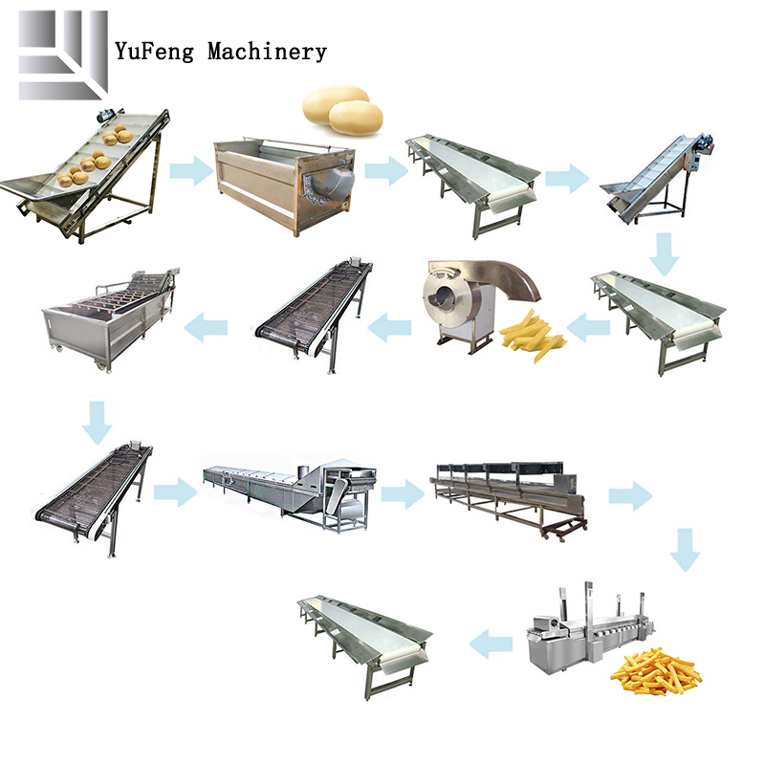
Equipment model | Device name | Equipment pictures | Device parameters
SSJ-3000×600 | Lifting conveyor | 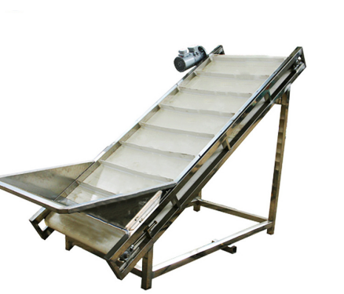 | Device Configuration:  - Size：3000*900*900mm  - Power；1.5kw  - Material：304SUS  - Transmission method: mesh belt transmission
QXJ—2400 | Automatic cleaning and peeling machine | 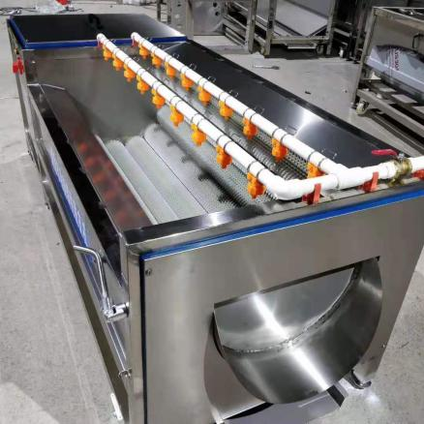 | Device Configuration:  - Size：2400*1000*2000mm  - Power：3kw  - Material：304SUS  - Transmission method: mesh belt transmission
TXJ—2000 | Picking conveyor line | 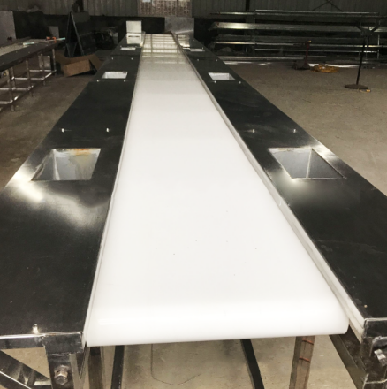 | Device Configuration:  - Size：2000*900*900mm  - Power：1.5kw  - Material：304SUS  - Transmission method: mesh belt transmission
TSJ—3500 | Lifting conveyor | 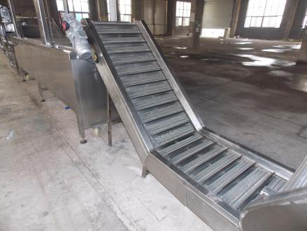 | Device Configuration:  - Size：2000*800*850mm  - Power：0.55  - Material：304SUS  - Transmission method: mesh belt transmission
BLJ-100 | Picking conveyor line |  | Device Configuration:  1.Size：2000*900*900mm  2.Power：1.5kw  3.Material：304SUS  4.Transmission method: mesh belt transmission
QPJ-1000 | Slicer | 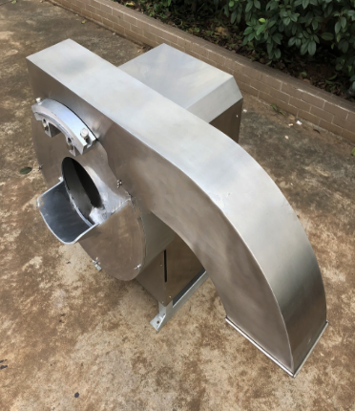 | Device Configuration:  - Size：700*780*1200mm  - Power：0.75  - Material：304SUS
SSJ-2500×600 | Lifting conveyor |  | Device Configuration:  - Size：2500*800*850mm  - 功率：0.55kw  - Material：304SUS  - Transmission method: mesh belt transmission
QXJ-4200 | Turbine washer | 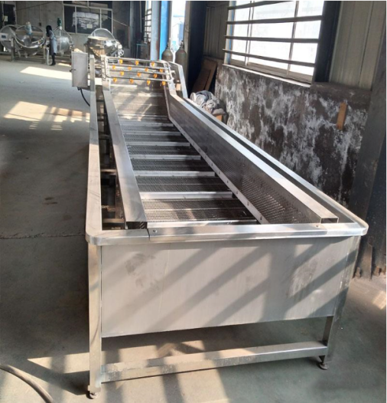 | Device Configuration:  - Size：5000*1000*1200mm  - Power：5.5kw  - Material：304SUS  - Transmission method: mesh belt transmission
SSJ-3000×600 | Conveyor | 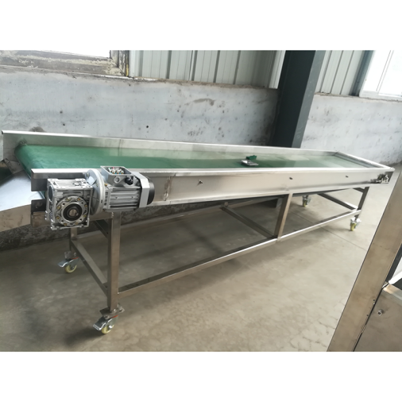 | Device Configuration:  - Size：2000*800*850mm  - Power：0.55kw  - Material：304SUS  - Transmission method: mesh belt transmission
PTJ-3500×800 | Blanching line | 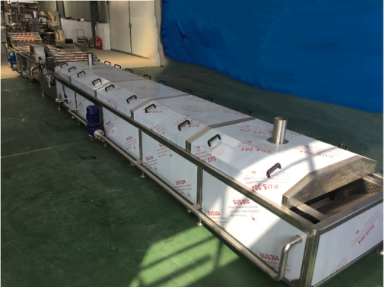 | Device Configuration:  - Size：3500*800*1200mm  - Power：50kw  - Material：304SUS  - Transmission method: mesh belt transmission
SSJ-4000×800 | Air knife type drain conveyor | 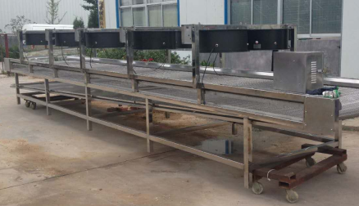 | Device Configuration:  - Size：6500*1100*1200mm  - Power：12kw  - Material：304SUS  - Transmission method: mesh belt transmission
YF-6500×800 | Frying line | 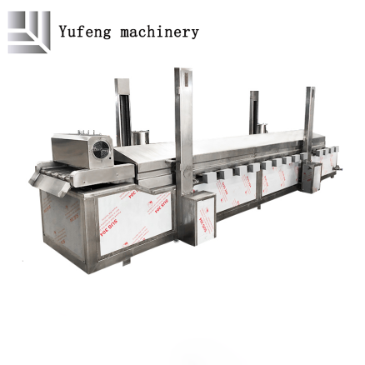 | Device Configuration:  - Size：6500*1000*2500mm  - Power：144kw  - Material：304SUS  - Price includes oil filter equipment  - Transmission method: mesh belt transmission
SSJ-3000×800 | Picking conveyor line |  | Device Configuration:  1.Size：2000*900*900mm  2.Power：1.5kw  3.Material：304SUS  4.Transmission method: mesh belt transmission

